Example Mutation Telephone Instructions
Drawing instructions are the most simple for this modeling activity since students can easily look at the final result next to the original instructed drawing in order to compare. The instructions are also easy to lengthen or shorten in order to obtain a reasonable mutation. The examples below are likely to result in one or two mutations each for a focused ninth-grade class.
Example 1: Draw a triangle, above the triangle draw a square, to the right of the square draw a circle.
Example 2: In a vertical line, draw a circle, then a triangle, then a circle, then a square.
Example 3: Draw a large square, inside the square draw a circle, inside the circle draw a square.
Example possible mutations:
- Substitution: one shape is substituted for another shape, but three are still drawn
- Insertion: an extra shape is drawn
- Deletion: one shape is not drawn

Example drawing instructions and possible mutations:
Original instructions:
Final instructions showing a substitution mutation:
Final instructions showing a deletion mutation:
Final instructions showing an insertion mutation:

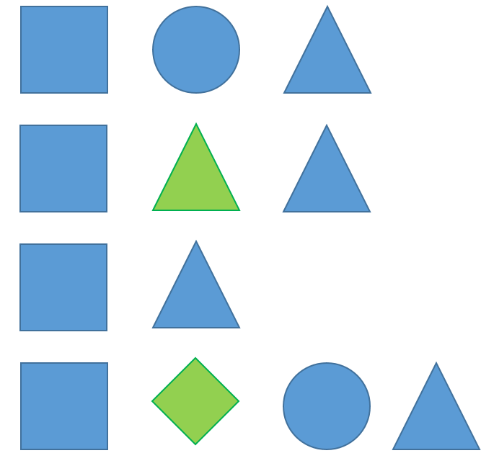

For students who like to move a lot, use a series of physical action instructions.
Example 1: Jump 3 times, pat your head twice, sit down.
Example 2: Do 2 push-ups, jump 5 times, high-five the teacher.
Example possible mutations:
- Substitution: one action is substituted for another action, for example, a student does jumping jacks instead of just jumping
- Insertion: an extra action is performed
- Deletion: one action is not performed

