Atmospheric Distortion Worksheet Answer Key

Objective: You will be able to describe the causes of atmospheric distortion in a conceptual way, and explain the effects this phenomenon has on images seen by cameras or human eyes.

Activity 1: Human-scale Distortions
- After being sorted into a group of approximately 8 students (your group plus another group), follow your teacher’s instructions to walk through a section of the room or hallway as shown in the diagram below. You must link arms with your classmates and all walk at a fairly slow and very constant pace straight ahead.
  - If you happen to walk over a blue poster board, you must slow your walking pace by half (only for the duration that you are walking on the poster board).
  - If you happen to walk over a red poster board, do the opposite--speed up to walk twice as fast (only when you are actually walking on the board).

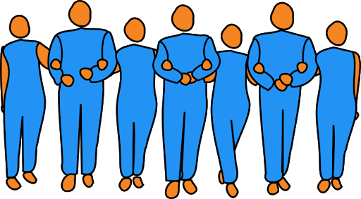

Finish line

Once you have completed the above activity, answer the following questions:

- When you and your classmates started walking with arms linked together, you were all walking parallel to each other (like all the arrows in the diagram above). What happened to some of your paths as some students walked over the poster boards? Be specific.

Some students got pulled in different directions and ended up walking at different angles, no longer parallel to each other. Hot pockets pulled nearby students (just outside the pocket) to face away, while cold pockets pulled students back/tending to face each other.

- Did all of your classmates reach the finish line at the same time? No, some got there earlier or later.

- Was this activity more or less difficult than you expected when you were first instructed to do it?
[Student answers will vary]

- The activity we just did is intended to “model” the reality of how light from the Sun or distant stars is affected as it travels through Earth’s atmosphere. Below are the parts of our model, and what they represent.
Model (with students) | Reality
Students walking with linked arms in a single line, all moving at the same speed, forward and parallel to each other | Parallel light rays of a single wavefront, all moving forward at the same speed
Red poster boards | Pockets of hot air
Blue poster boards | Pockets of cold air
Finish line | Camera (or human eye)

- Based on the table above AND on your observations from actually doing this activity, come up with three statements about how light moves through the atmosphere. A sentence starter is provided.

When a light ray encounters a pocket of hot air…, and this results in …
- Light moves in “wavefronts”, a set of parallel rays moving at the same speed as long as the medium is of a constant temperature or density
- Hot air pockets will cause light to move slightly faster, while cold air pockets will cause light to move slightly slower (results in the refraction/bending of light rays relative to their original parallel orientation)
- Light rays are “observed” when they cross the camera or human eye line
- Light rays that hit the camera (or human eye) at a slightly different angle or time, or are overlapped on other rays, will cause distortions and blurriness in the final image
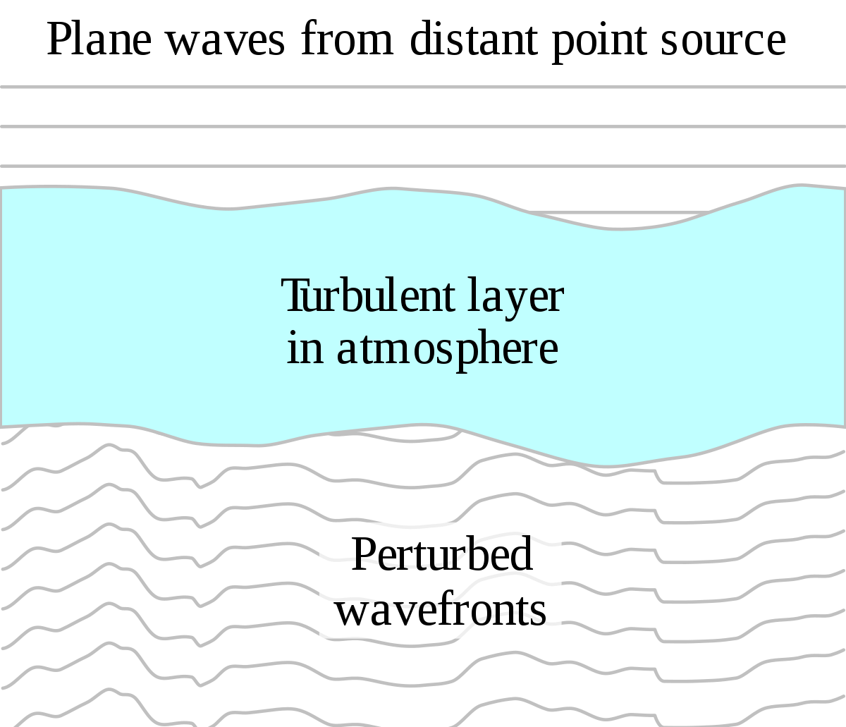

- Finally, recall what you know about the refraction of light as it goes through different mediums. How is this phenomenon shown in Activity 1, and why do you think this happens?

Light is refracted by the hot and cold air pockets, being bent by different temperature air. Temperature is second order--a more important effect is due to different density, which is tied to the air temperature. Optical density of the medium is what determines index of refraction, which determines the degree to which light is bent.

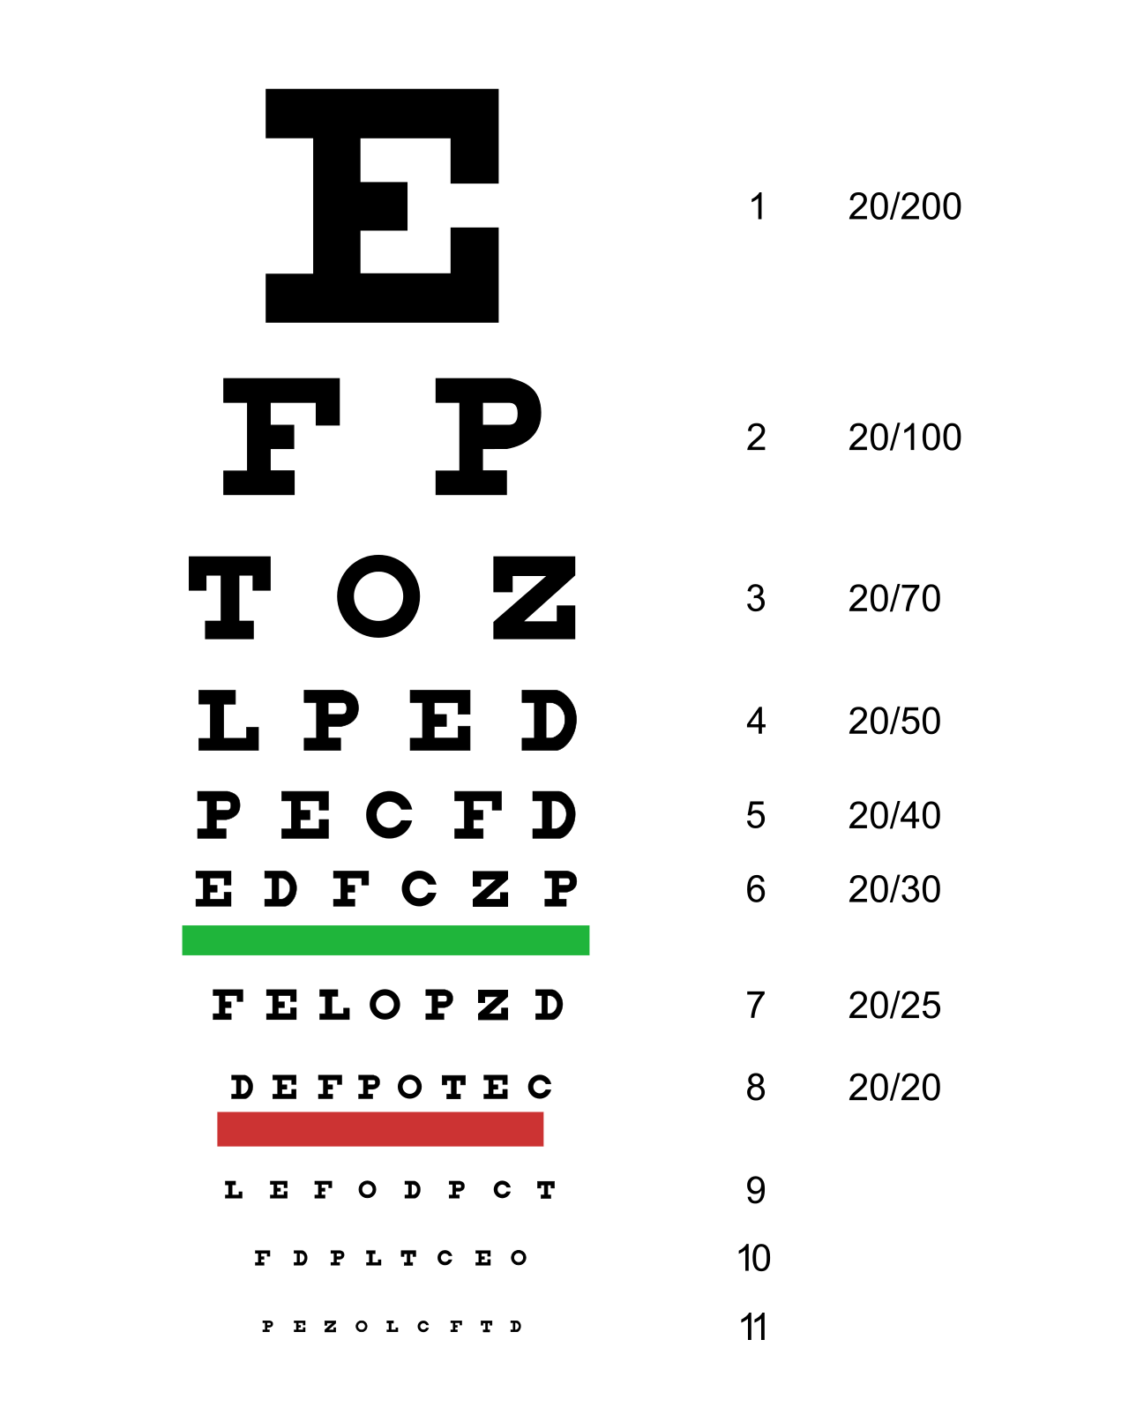
Activity 2: Distortion of Light with Oil
- Get an eye chart and a cup of mineral oil from your teacher. Tape the eye chart to a wall.
  - Standing about 6 m from the eye chart, have each of your group members attempt to read off the letters as far down as they can go (without squinting!).
  - After everyone has gone, place the cup of mineral oil at such a height and distance that it obscures the eye chart. Have everyone try to read the chart again through the oil. How is the image you see affected by the bottle of oil?

The image should be blurry, distorted, and much more difficult to read (although the brightness should not change much).

- Finally, call your teacher over (be patient!). They will shine a laser at the wall, and then shine it through the cup of mineral oil. Observe the pattern on the wall carefully, from a distance and from closer up. How does the pattern change when it is shined through the oil? Why do you think this happens?

The pattern should become blurry and “move” a lot more, bubbling in a sense. This happens because the oil has pockets of slightly different temperatures and densities and has some bubbles in it, which causes refraction of the light along the way, resulting in distorted laser light on the wall.

- Write two conclusion sentences relating your observations from Activities 1 and 2. What similarities and differences did you notice? Is the physics fundamentally the same, or are the distortions in light caused by different things?

Both activities show how parallel light rays are distorted by fluids (atmosphere and mineral oil). Both activities require an understanding of refraction and basic rules of optics--light travels in straight, parallel rays of equal speed unless perturbed by pockets of the fluid which have different densities, causing refraction of light and ultimately a distorted image on the wall/camera/eye.

