Atmospheric Distortion Worksheet

Objective: You will be able to describe the causes of atmospheric distortion in a conceptual way, and explain the effects this phenomenon has on images seen by cameras or human eyes.

Activity 1: Human-scale Distortions
- After being sorted into a group of approximately 8 students (your group plus another group), follow your teacher’s instructions to walk through a section of the room or hallway as shown in the diagram below. You must link arms with your classmates and all walk at a fairly slow and very constant pace straight ahead.
  - If you happen to walk over a blue poster board, you must slow your walking pace by half (only for the duration that you are walking on the poster board).
  - If you happen to walk over a red poster board, do the opposite--speed up to walk twice as fast (only when you are actually walking on the board).

Finish line

Once you have completed the above activity, answer the following questions:

- When you and your classmates started walking with arms linked together, you were all walking parallel to each other (like all the arrows in the diagram above). What happened to some of your paths as some students walked over the poster boards? Be specific.

- Did all of your classmates reach the finish line at the same time? ________________________

- Was this activity more or less difficult than you expected when you were first instructed to do it?

- The activity we just did is intended to “model” the reality of how light from the Sun or distant stars is affected as it travels through Earth’s atmosphere. Below are the parts of our model, and what they represent.

Model (with students) | Reality
Students walking with linked arms in a single line, all moving at the same speed, forward and parallel to each other | Parallel light rays of a single wavefront, all moving forward at the same speed
Red poster boards | Pockets of hot air
Blue poster boards | Pockets of cold air
Finish line | Camera (or human eye)

- Based on the table above AND on your observations from actually doing this activity, come up with three statements about how light moves through the atmosphere. A sentence starter is provided.

When a light ray encounters a pocket of hot air…, and this results in …

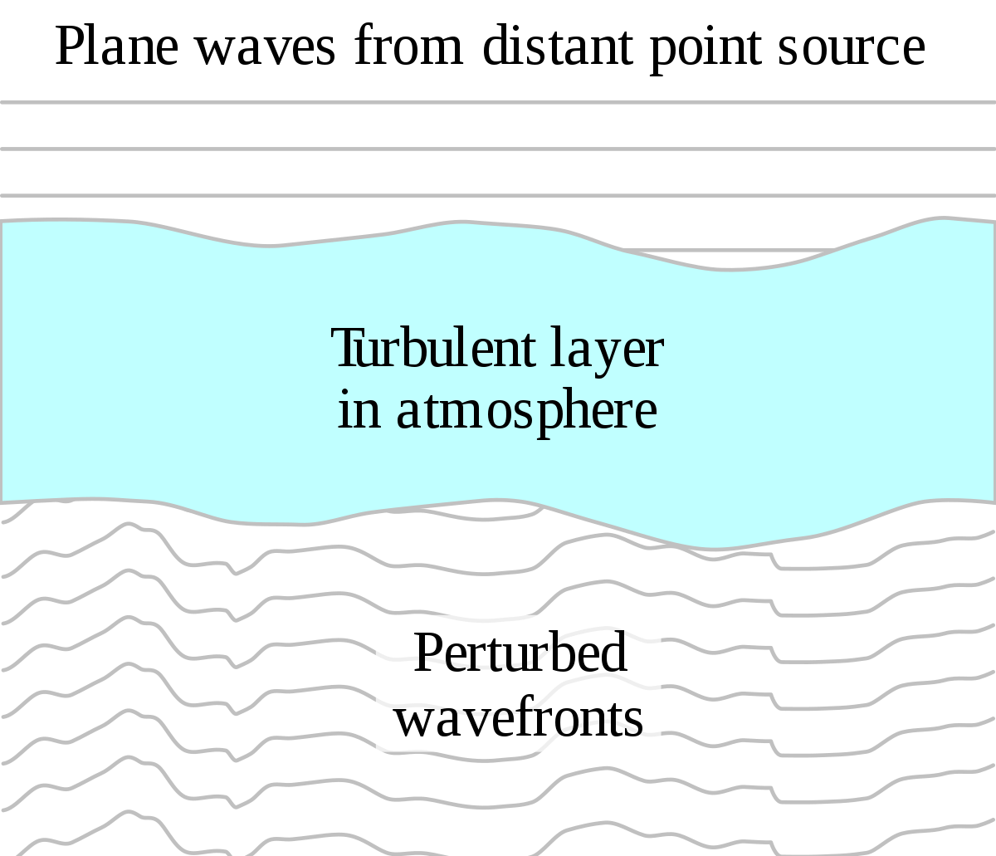

- Finally, recall what you know about the refraction of light as it goes through different mediums. How is this phenomenon shown in Activity 1, and why do you think this happens?

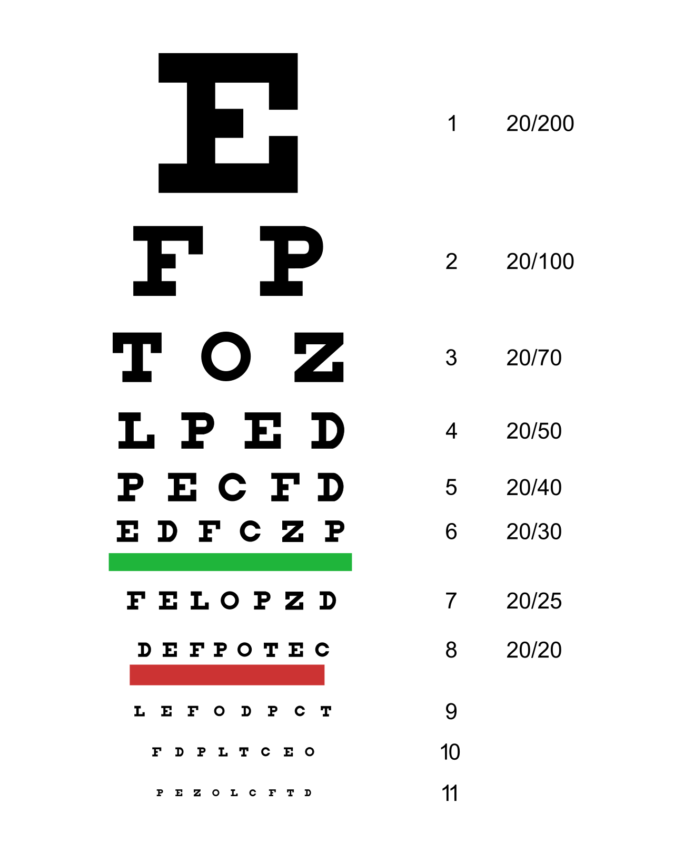
Activity 2: Distortion of Light with Oil
- Get an eye chart and a cup of mineral oil from your teacher. Tape the eye chart to a wall.
  - Standing about 6 m from the eye chart, have each of your group members attempt to read off the letters as far down as they can go (without squinting!).
  - After everyone has gone, place the cup of mineral oil at such a height and distance that it obscures the eye chart. Have everyone try to read the chart again through the oil. How is the image you see affected by the bottle of oil?

- Finally, call your teacher over (be patient!). They will shine a laser at the wall, and then shine it through the cup of mineral oil. Observe the pattern on the wall carefully, from a distance and from closer up. How does the pattern change when it is shined through the oil? Why do you think this happens?

- Write two conclusion sentences relating your observations from Activities 1 and 2. What similarities and differences did you notice? Is the physics fundamentally the same, or are the distortions in light caused by different things?

