Smart Solar? Worksheet
Engage:
Many people assume that building solar panels is always a smart idea. But is it?
Your engineering task is to analyze solar energy data from the Renewable Energy Living Lab to determine if solar panels are always a smart choice.
In the space below, explain what you know about solar energy.
_____________________________________________________________________________________
_____________________________________________________________________________________
_____________________________________________________________________________________
Why do you think it is good/bad to build solar panels?
_____________________________________________________________________________________
_____________________________________________________________________________________
_____________________________________________________________________________________
Explore:
- Go to the Renewable Energy Living Lab at http://www.teachengineering.org/livinglabs/index.php.
- Enter the Renewable Energy Living Lab and choose age group K-12.
- Check the boxes under the Resources folder (located on the left under the Data Layers tab) to switch between the maps depicting the potential for the five different forms of renewable hydropower, biomass, geothermal, wind and solar. Use the icons in the lower left corner to read more information about each form of energy.

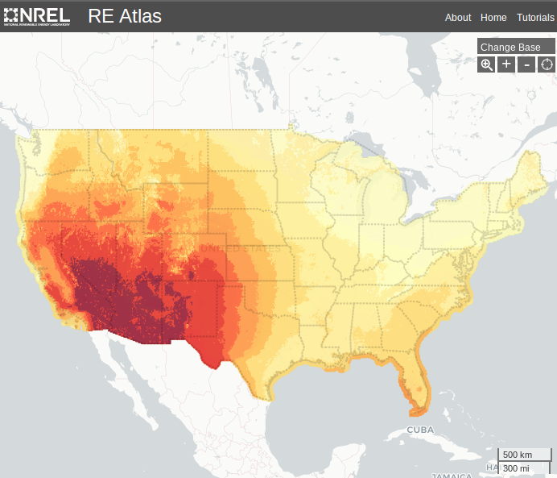
- Use the “Zoom to a location” icon in the upper right
corner of the map to zoom in and find your home town.
What is the solar potential in your town? (Include units!)
___________________________________
Explain:

Part 1: Solar Potential
Zoom in on the following locations and determine their potential for solar power.
Location | Potential for Solar Power
Minneapolis, Minnesota
Las Vegas, Nevada
Portland, Oregon
San Antonio, Texas

Stop and think!
Of the cities listed above, which is the most likely candidate for solar? Why do you predict that one?
_____________________________________________________________________________________
_____________________________________________________________________________________
_____________________________________________________________________________________
What criteria do you think you need to consider in order to determine if each of these cities is a good candidate for solar panels? Explain your thinking.
_____________________________________________________________________________________
_____________________________________________________________________________________
_____________________________________________________________________________________
_____________________________________________________________________________________
_____________________________________________________________________________________
Elaborate:
Part 2: Energy Generation
For each of the locations above, calculate the amount of energy that will be produced in one month. Base your calculations on the following design parameters:
- You have room on the roof of your building to install 200 m² of solar panels.
- Average solar panels on the market today are able to convert 12% of the potential energy into electricity.
Location | Amount of electricity generated per month
Minneapolis, Minnesota
Las Vegas, Nevada
Portland, Oregon
San Antonio, Texas

Stop and Think!
Explain how you calculated the amount of energy generated per month.
_____________________________________________________________________________________
_____________________________________________________________________________________
_____________________________________________________________________________________
Part 3: Energy Offset
Now it is time to think about the money needed to install the solar panels. The cost of installation per square meter of solar panels is $1,075.
How much would it cost to install 200m² of solar panels?
_____________________________________________________________________________________
The government in each of the states above helps to subsidize the cost of installing the solar panels. Assume that the government subsidizes 60% of your initial investment.
How much of the cost will the government subsidize?
____________________________________________________________________________________
How much of the cost will you have to cover?
____________________________________________________________________________________
The average cost for energy in your area is $0.15/kWh. How much savings will solar panels in each of the cities above save per year?
City | Amount Saved
Minneapolis, Minnesota
Las Vegas, Nevada
Portland, Oregon
San Antonio, Texas
How many years will it take for you to “save” back the portion of your costs you had to pay to install the solar panels?
City | Years
Minneapolis, Minnesota
Las Vegas, Nevada
Portland, Oregon
San Antonio, Texas

Looking at your cost analysis, do you think that solar is a smart solution everywhere? Why or why not?
_____________________________________________________________________________________
_____________________________________________________________________________________
_____________________________________________________________________________________
_____________________________________________________________________________________
_____________________________________________________________________________________
_____________________________________________________________________________________
Evaluate:
Part 4: Alternatives
Return to the Renewable Energy Living Lab. For each city, determine if an alternative form of energy might be a better choice to pursue. Explain your reasoning.
City | Is there an alternative form of energy that is  a better choice? Which one(s)? Why or why not?
Minneapolis, Minnesota
Las Vegas, Nevada
Portland, Oregon
San Antonio, Texas

