Physics of Sound Quiz Answer Key
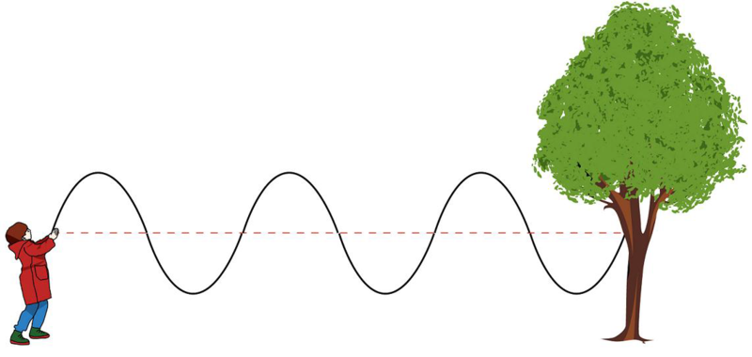
- Label the transverse wave and the longitudinal wave.

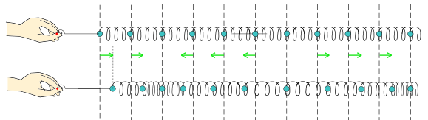
transverse wave longitudinal wave

- Draw a transverse wave with axes of displacement and time.
  - Label the amplitude.
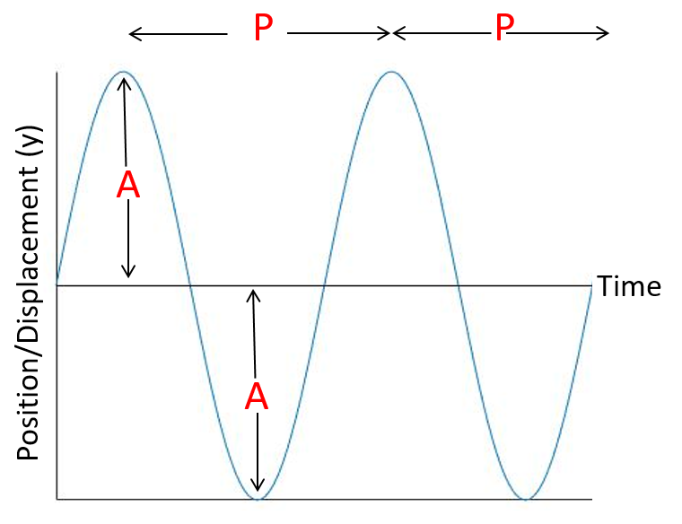
  - Label the period.

- Calculate the speed of a wave with amplitude of 2 meters, frequency of 200 Hz,
and wavelength of 4 meters.
$$f=\frac{v}{λ}$$
200 Hz x 4 meters = v
v = 800 meters/second because Hz = 1/s

- What is the difference between sound and noise?
Sound consists of vibrations that travel through air or other media that can be heard when they reach the ear. Noise is unwanted or unpleasant sound, and is subjective.

- How does sound move through different media?
Sound travels through media by vibrating molecules in the matter. Closely packed molecules, like in solids, transfer sound faster than loosely packed molecules, like in liquids and gases.

- Speakers, 1 meter away, produce a sound intensity of 0.01 W/m².
Calculate the sound intensity level of the speakers.
$$I_{0}={10}^{-12}\frac{watts}{m^{2}} β\left(dB\right)=10log⁡\left(\frac{I}{I_{0}}\right)$$
$β$= 10 log (.01 W/m² ÷ 10⁻¹² W/m²)
$β$ = 100 dB
Image sources:
Transverse wave (boy, rope, tree): 2010 CK-12 Foundation, Wikimedia Commons CC BY-SA 3.0 https://commons.wikimedia.org/wiki/File:Wave_in_a_rope.png
Longitudinal wave (hands, springs): 2015 Wikimedia Commons CC0 1.0 universal public domain dedication https://commons.wikimedia.org/wiki/File:Longitudinal_wave_jp.svg
Graph: 2016 Kent Kurashima, ITL Program, College of Engineering and Applied Science, University of Colorado Boulder (author)

