Physics of Sound Quiz
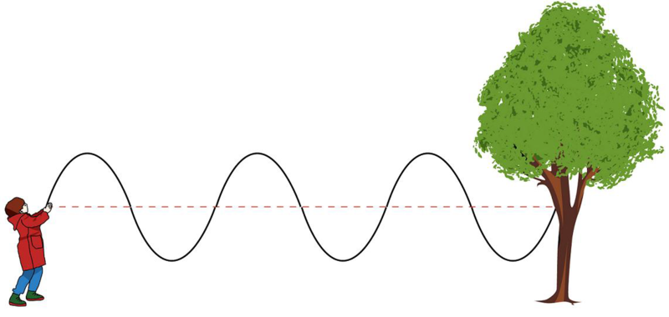
- Label the transverse wave and the longitudinal wave.

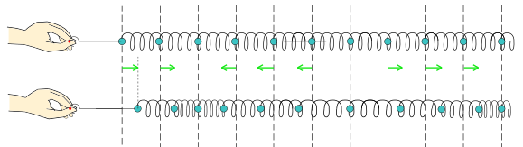

- Draw a transverse wave with axes of displacement and time.
  - Label the amplitude.
  - Label the period.

- Calculate the speed of a wave with amplitude of 2 meters, frequency of 200 Hz,
and wavelength of 4 meters.

- What is the difference between sound and noise?

- How does sound move through different media?

- Speakers, 1 meter away, produce a sound intensity of 0.01 W/m².
Calculate the sound intensity level of the speakers.
$$I_{0}={10}^{-12}\frac{watts}{m^{2}} β\left(dB\right)=10log⁡\left(\frac{I}{I_{0}}\right)$$

