Engineering Identities Worksheet

The diagram below shows the range of roles engineers play within our society. An education in engineering builds a foundation of skills applicable to problem solving in nearly any area of life you can imagine—from everyday technologies to research on the major challenges facing human kind.
Look at the diagram below and answer the questions that follow. The axes illustrate how engineering can shift between theoretical and practical work as well as between projects that directly involve the public vs. projects that deal with matter, energy and information.
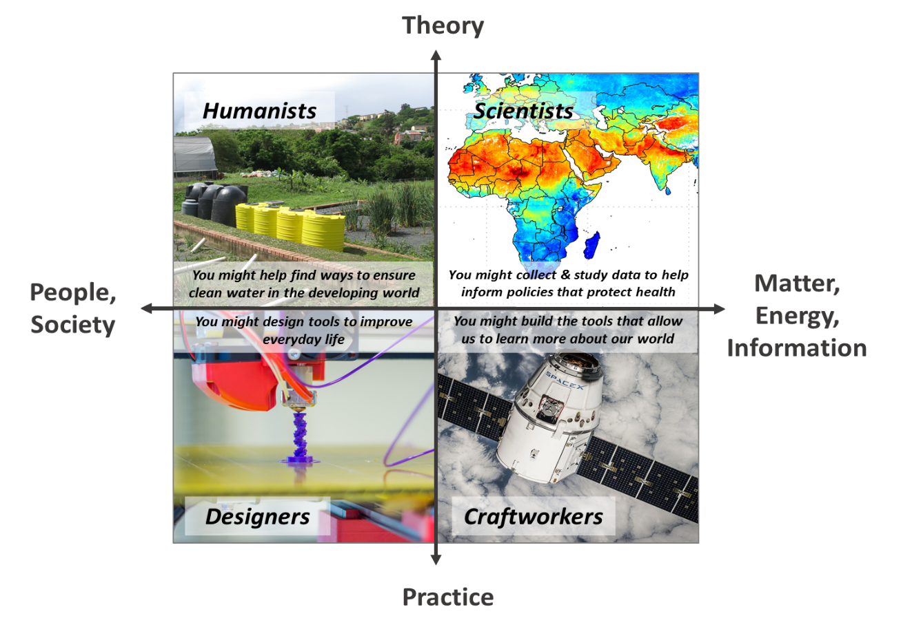

Diagram designed after “Four Dimensions of Engineering” diagram
Tolbert , D., Hynes, M., Dickerson , D., & Cardella, M. (2015). "Transitioning Students Navigating Engineering Identities." Proceedings, Frontiers in Education, pp. 431-435. http://dl.acm.org/citation.cfm?id=2879885
Image sources:
(top left) constructed wetland: 2012 SuSanA Secretariat (Sustainable Sanitation Alliance), Wikimedia Commons https://commons.wikimedia.org/wiki/File:The_research_site_in_Durban_for_the_ABR_with_constructed_wetlands_(wetlands_currently_not_in_use)_(8152048825).jpg
(top right) satellite image of global PM_{2.5} distribution data: 2010 Aaron van Donkelaar, Dalhousie University, NASA, Wikimedia Commons https://commons.wikimedia.org/wiki/File:483897main_Global-PM2.5-map.JPG
(bottom left) 3D printer print head: 2014 Jonathan Juursema, Wikimedia Commons https://commons.wikimedia.org/wiki/File:Felix_3D_Printer_-_Printing_Head.JPG
(bottom right) 2014 SpaceX-Imagery, Wikimedia Commons https://commons.wikimedia.org/wiki/File:Satellite-693216_960_720.jpg

Questions
- Name (optional, may be used to build groups later)

- Do you feel like you have a good understanding of what engineers do? (circle one number)
No |  | Maybe |  | Yes
1 | 2 | 3 | 4 | 5
- Do you have a parent or family member who is an engineer? Yes No
- Rank the quadrants, number them 1 – 4, with 4 being most interesting to you:
Engineers as…. | Rank
Scientists
Humanists
Designers
Craftworkers
- Mark as many of the following topics that seem interesting to you:
- Mechanical engineering
- Environmental engineering
- Civil/architectural engineering
- Biomedical engineering
- Aerospace engineering
- Electrical engineering
- Computer science/programming
- Public and environmental health
- Policy making
- Writing/communication
- Graphic design/aesthetics
- Education/outreach with the public
- Are you considering studying engineering in college? (circle one number)
No |  | Maybe |  | Yes
1 | 2 | 3 | 4 | 5
- Is there anything you would like to learn about engineering as a profession or about studying engineering in college?

