Excel Reference Sheet

Formulas
Excel formulas are useful shortcuts for calculating equations and statistical parameters. They are equations that perform calculations on values in your spreadsheet by selecting the cells (for example, A2, A3:A30) that contain those values.
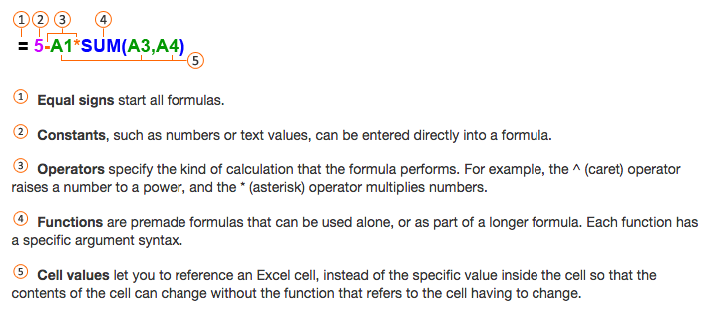
How to use a formula:

(Microsoft Office Online 2014)
Below are some commonly used formulas, with definitions of the terms:
Mean =AVERAGE()
The mean, or the average, is the sum of all values divided by the number of values.
Median =MEDIAN()
The median, or 50th percentile, is the central value of the distribution
when the data are ranked in order of magnitude.
Minimum =MIN()
The smallest value in the data set.
Maximum =MAX()
The largest value in the data set.
Standard deviation =STDEV.S()
A measure of the spread of a data set, calculated as the square root of the sample variance. (The spread is how close or far apart the data points are, for example if the data points are clustered along a clear line or in a clear pattern, there is little spread.)
Interquartile range =PERCENTILE (values, 0.25) – PERCENTILE (values, 0.75)
Another measure of the spread of the data set. It measures the range of the central 50% of the data.
Graphing in Excel
The easiest way to graph in Excel is to highlight your data and headings, then find “insert,” then “charts” and select the one appropriate for your application. In most cases, Excel plots your data correctly and adds in the labels. However, if it does not, you can add your data in manually. This is done by right clicking on a chart and choosing “Select data.” From here, you can direct what Excel plots.
Graph Types
- Bar charts are ideal for comparing statistics.
- Scatter are ideal for time series plots and scatter plots; choose from various options that include and exclude lines between data points and markers to designate data points; remember, definitions and examples of these plots are available in the Pre-Activity Reading.
  - To apply a linear regression to examine relationships (a detailed explanation of these concepts is also available in the Pre-Activity Reading):
    - Click on the data points themselves; they should appear selected.
    - Right click and choose “Add Trendline.”
    - Under options, select “linear” and “display R-squared value on chart.”
To add a plot, either:
- Go to “Insert,” choose the plot type, then right click on the blank plot and choose “Select Data.”
- From here, click “Add,” then select the x and y data.
Or, first highlight the data, and then go to “Insert,” and choose the plot type, although Excel may not correctly interpret how you would like the data to be displayed.

Excel Shortcuts
On a PC, follow the instructions below; for a Mac, the shortcuts are the same except use the “command” key instead of the “control” key. These shortcuts are especially useful for plotting your data.
- To highlight a column:
  - Click on the top cell of your column.
  - Use the combination “ctrl’ “shift” “down.”
  - This also works from the bottom cell.
- To highlight multiple columns next to each other:
  - Drag your mouse to highlight multiple top cells.
  - Then use the same combination “ctrl’ “shift” “down.”
- To highlight multiple non-consecutive columns:
  - Choose the top cell of your first column, and use the combination of key strokes.
  - Hold the “ctrl” key and click on the top cell of your next column.
  - Keep holding “control” and add “shift” “down.”

“Enter a formula.” Microsoft Office Online. 2014. Web. Accessed December 1, 2014.

