Example Case Study Worksheet 1
Use this real-world example to learn how to plan a study.
Instructions: First, watch a video provided by your teacher, then read the text below. Then fill in the template that follows to plan how you would tackle this research problem.
Cooking over open fires is a serious problem for human health and well-being, so cook stove intervention studies are conducted to test new, improved cook stoves. Improved cook stoves are designed to improve combustion by achieving more complete combustion and less incomplete combustion. The objective of this technology is to improve health and quality of life by reducing harmful pollutants, as well as the amount of fuel needed to cook and heat homes. One trade-off is the higher cost of improved stoves.
A cook stove intervention study involves identifying a group of participants and providing some of them with improved cook stoves, while the rest of them continue to use traditional cook stoves. Researchers then collect data to determine the benefits of improved stoves over traditional stoves, as well as the barriers to widespread implementation. Improved cook stoves must lower harmful emissions and be cost effective and easy to use. These studies can be complex because researchers need to study the problem from many different angles.
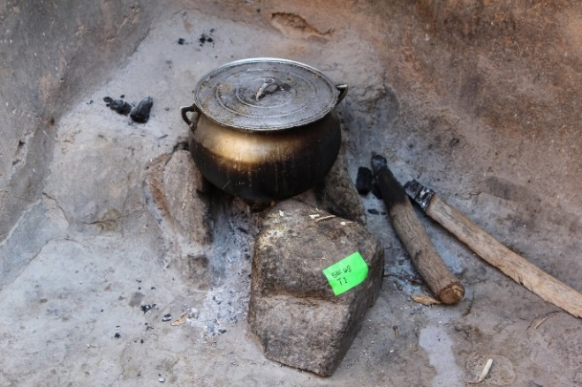
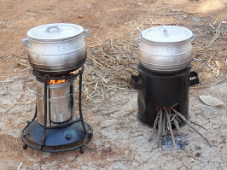
Traditional cook stove.
Improved cook stoves:
(left) high-cost and (right) low-cost.

Imagine that you have been awarded a grant to conduct a cook stove intervention study to investigate the impact of different stove types. You randomly sort 200 identified homes into groups; some homes will continue to use traditional methods while other homes will use the improved cook stoves. Use the template below as a guide to plan how you would conduct this study.
*Note, you have the capacity to measure all of the pollutants in the diagram below with small portable sampling devices, and you can also collect other data using interviews for instance. The diagram serves as a reminder of how these pollutants form and why they matter.
Source of text and information on Worksheets 1 and 2:
Dickinson, K.L., et al. Research on Emissions, Air quality, Climate, and Cooking Technologies in Northern Ghana (REACCTING): Study Rationale and Protocol, BMC Public Health, 2015, 15:126, doi:10.1186/s12889-015-1414-1. http://www.biomedcentral.com/1471-2458/15/126
Source of all photos on Worksheets 1 and 2: http://www.reaccting.com/
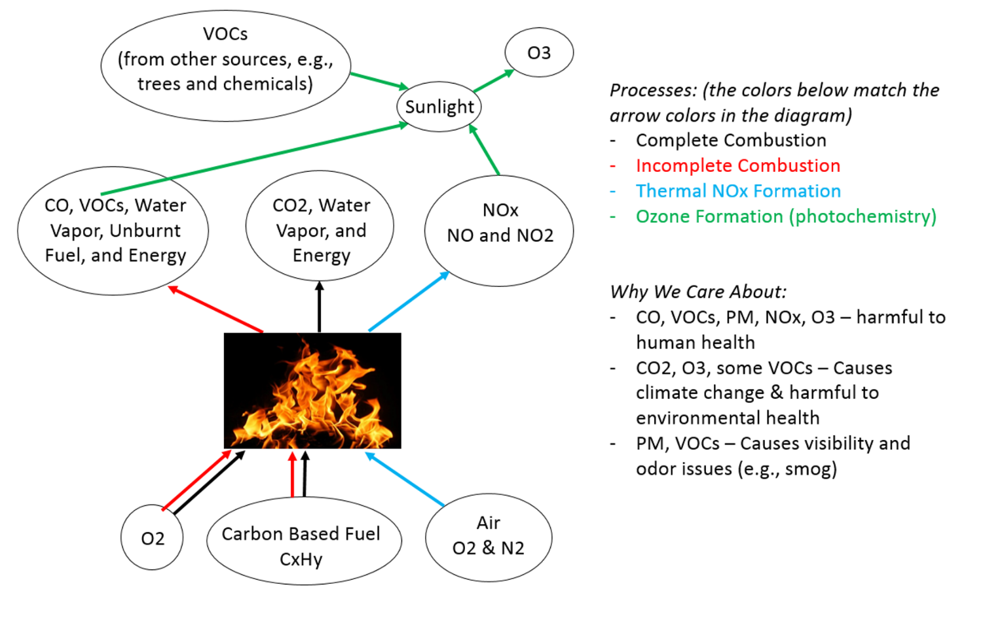
Study Template

Hypothesis
If individuals use improved cook stoves, their exposure to __________________________________, ________________________ and ______________________ will be decreased/increased (circle one) because improved cook stoves cause more complete/incomplete combustion (circle one) to occur.

Methods: How will you conduct your study?
Determine your variables and what you need to control.
Independent Variables (This variable is defined by you and manipulated in order to examine its impact.)
Stove type (traditional stove vs. improved stove)
Dependent Variables (What you are measuring/observing as you manipulate your independent variable.)
Pollutants (List at least three that are important to this study.)

Health impacts (List one way in which health might change that you could observe or measure.)

Other (List two other factors you would measure or observe, such as economic factors.)

Controls (These are other factors that can impact our understanding of the final data. When possible, minimize their impact and if not possible, at least be aware of how they affect the data.)
Example 1: If you were to sample two homes, each from a different area and one area was more polluted than another (perhaps from vehicle traffic), this might affect your ability to isolate the impacts of cooking and accurately compare the impact of cooking in each of the two homes. Therefore, you would want to control for this effect by sampling homes closer together (perhaps in the same village) because the ambient air around them would be fairly similar, making the baseline in each home fairly similar.
Example 2: Different foods may have different cooking times, temperatures and preparation instructions, therefore you would want to compare preparation of the same dish or meal across the different stoves. You would want to control for the food type and only change the stove type.
List one more variable or condition you would want to control for or keep similar across sites.

Outline Your Procedure
(What) For which pollutants will you collect data?

(Where) Describe where you will place your monitors (assume you have as many as you need).

(Who) Are you most interested in the exposure of any specific individuals or family members?

List one other piece of data that would be helpful to have.
(Example: participant health prior to and after the study – you could request that participants report any health issues or respiratory problems that may be impacted by the change in stove type)

Data Analysis Plan
List two ways you will examine/analyze your data after collecting it. (Example: Compare the average CO in homes with traditional stoves vs. homes with improved cook stoves during a cooking event.)

