Arch Calculations Worksheet Answer Key
- Given the shape of the block below, which is needed to construct a semicircular arch, how many blocks would you need to finish the arch? What would the inner radius of the arch be? What about the outer radius?
- Note: Since the block shape being used is a trapezoid and does not have rounded edges, use the radii based on the center of the base and the top of the trapezoids for the calculations of inner and outer radius, respectively.
- Remember that in order for the arch to be a perfect semicircle, the base and tops of the blocks coming into contact with the ground need to be perpendicular to the ground
- Hint: Add a cut from the middle of the top to the middle of the base so that when it rests on its cut edge, the top and base are perpendicular to the ground.
- Final thought: Calculating the dimensions of the arch is not supposed to be easy. Make sure you are extending edges and connecting them as well to form other shapes that will give you the information necessary to find the dimensions of the arch.

Answer: You need a total of 6 blocks in order to make the arch. The 2 blocks on the bottom of the arch will be half blocks in order to make sure the outside and inside of the arch at the ends are perpendicular to the ground.
Calculate the inner radius of the arch by extending the edges of the trapezoid outwards and forming triangles. Then use trigonometric identities to calculate the dimensions of the triangles and add the correct ones together to give you the inner and outer radius of the arch.
The inner radius is calculated to be 0.933 feet.
The outer radius is calculated to be 3.733 feet.
Note that since it is a perfect semicircle, the height is the same as the radius.

- The blocks you will be working with for this next problem are perfect squares (cubes) rather than trapezoidal blocks. A block dimension is ½ x ½ x ½-inches. Do the same process as above, but for these square blocks, so that you can design a support bridge for your arches such as the one shown below, use 7 blocks since you will not be cutting the base blocks of the arch in half as you did when solving problem #1. Note that because you will not be cutting the blocks in half, the height of your support structure will be slightly larger than its base, meaning it will not be a perfect semicircle.
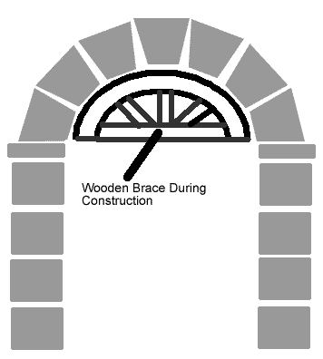

Answer: Calculate the radius of the support structure by using the same method as problem #1. For this problem, the outer radius of the arch is not needed, but note that students may want to calculate that later.
The base radius of the arch is calculated to be 1.866 inches.
The height of the arch is calculated to be 2.366 inches since all you need to do is add half the width of one block to the base radius.

