Name: Date:

What Is a Circuit? Worksheet Answers
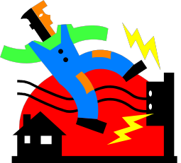
1. Vocabulary Words
Using complete sentences, write a definition for the following words:

Charge Current Voltage
Resistance

The electrical energy of an atom The flow of charge or electrical energy
The amount of charge or electrical energy that is able to flow

Something that keeps the charge electrical energy from flowing

2. Drawing the Path of Electrons
Draw a picture of the circuit created in class. Label the light bulb, switch and
battery. Use arrows to show the direction the electrons flowed.

light bulb

battery

switch

Energy: Lesson 4, The Path of Electrons Activity — What Is a Circuit? Worksheet Answers

