Putt Worksheet
Instructions
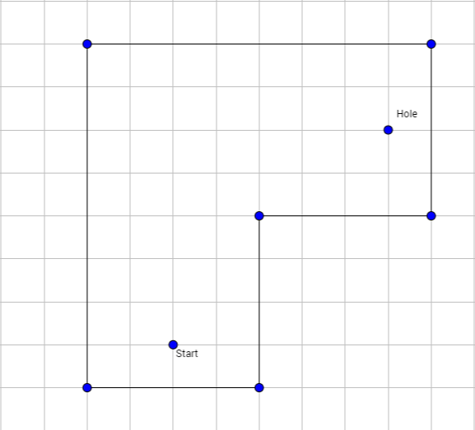
You will be given a set of different mini putt courses. For each hole, you must solve how to score a hole-in-one by bank shots (bouncing the ball off of a wall) using different strategies.
Banking off One Wall
Make sure to have a piece of graph paper to draw the hole to the same dimensions and then construct/find the points of reflection.
- Locate the hole and beginning position of the ball (start).
- Pick a wall to bank the ball off of and label it W1.
- With equal spaces or Mira, reflect the hole (H) over wall 1 and mark it H1.
- With a straight edge, connect the ball (B) with H1 using a dotted line to locate where on the wall the ball needs to reflect.
- Connect the hole (H) to the point of intersection of the wall and the line from the ball to H1 to complete the path of the ball. The solid lines show the path the ball will take to make the hole-in-one. Realize that ball speed, hole surface type, golfer accuracy, and other factors may influence the success of the hole-in-one!
- Measure the angles of incidence and reflection, and solve for the remaining angle.
Bank off One Wall

Angle of Incidence | Angle of Reflection | Remaining Angle

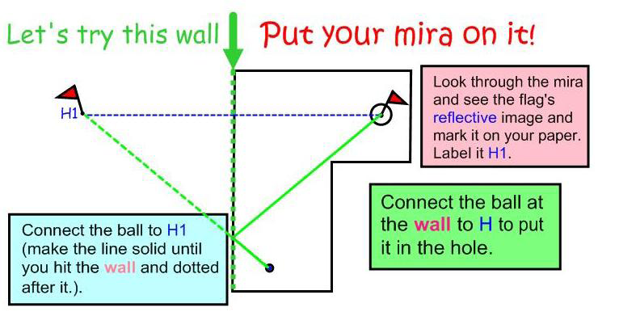

Banking off Two Walls
- Locate the hole (Hole) and beginning position of the ball (start).
- Pick and label the walls starting at the hole and working backwards from the hole. Mark the walls W2 for the second wall the ball will hit before landing in the hole, and W1 for the first wall to bank it off to send it to the second wall (in this case the first wall hit by the ball).
- Using the graph paper squares and properties of a reflection, reflect the hole (H) over wall 2 (W2 on this example) and mark it H2 by counting squares.
- Now, reflect H2 over wall 1 (W1) and mark it H1. You may need to extend a wall to be able to complete a reflection. Use the graph paper squares to locate the H1.
- With a straightedge, connect the ball (B) with H1 to locate where on the wall the ball needs to hit. Then connect that point of contact/intersection with H2 to locate where on wall 2 the ball needs to hit.
- Finally, connect the point of contact/ intersection on the wall 2 with the hole (H) to complete the path of the ball (see the diagram.)
- Notice that at each point of contact with the wall, the angle of incidence = angle of reflection!
- Now measure the angles of incidence and reflection and solve for the remaining angles.
Bank off Two Walls
Bank | Angle Of Incidence | Angle Of Reflection | Remaining Angle
1
2

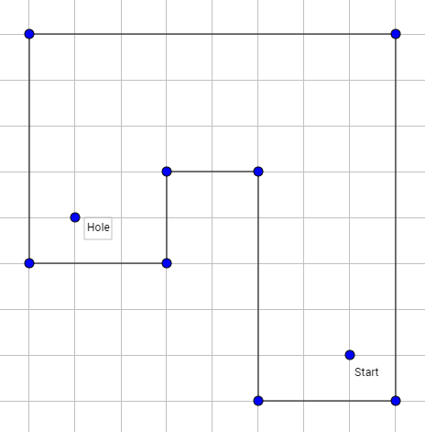
Challenge!
If you have completed the 1- and 2-bank shot problems, your challenge is to find the solution to get a hole-in-one in 3-bank shots.
After you have completed the 1-, 2- and 3-bank shot problems, try out your solutions on the real-life hole. Use a marker on the wood where you predict the bank will occur and see if your answer works.
When finished, staple your calculations to this!
Hole 2:
- Redraw the hole on your graph paper with the same dimensions or same scaled dimensions.
- Solve the hole for a 1-, 2- and 3-bank shot.
- Fill in the tables with the angles of incidence and reflection and then solve for the remaining angle.

Bank off One Wall
Bank | Angle of Incidence | Angle of Reflection | Remaining Angle
1

Bank off Two Walls
Bank | Angle of Incidence | Angle of Reflection | Remaining Angle
1
2

Bank off Three Walls
Bank | Angle of Incidence | Angle of Reflection | Remaining Angle
1
2
3

Staple your graph paper to this worksheet when you finish!

