Corn For Fuel?! – Designing a Biofuels Plant Worksheet

Instructions: Your task today is to pretend you are a biochemical engineer designing a way to create biofuels. This worksheet guides you through various steps of the engineering design loop to help you come up with a solution.
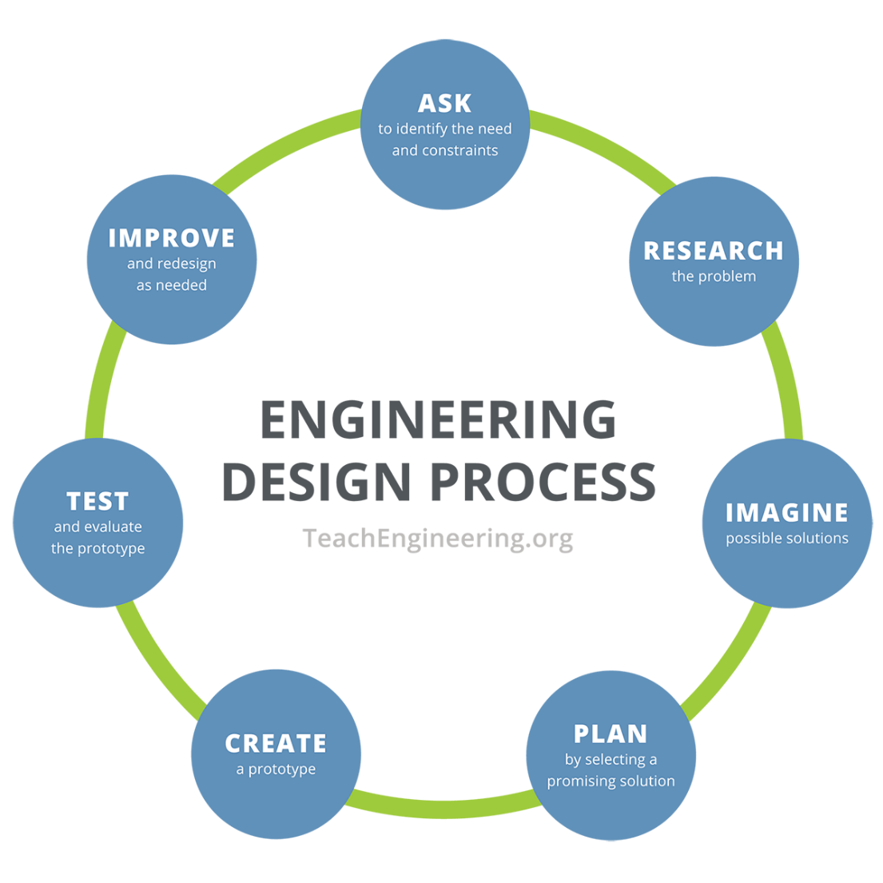

Research and Investigate

Method: Describe your control and experimental groups. Then explain how you plan to carry out the investigation.
Control Group: Experimental Group:

In this investigation, we will…

Hypothesis: Write down a prediction. Justify your answer based on what you’ve learned about plants (including photosynthesis).

Observations: Write down what you observe for each group of plants.
Control Group: Experimental Group:

Conclusion: Based on the observations above, what can you conclude from your experiment?

Design Application: Explain how you can apply this to the design of your biofuels production plant.

