Headphone Design Planning Sheet

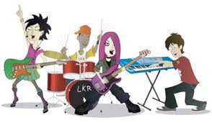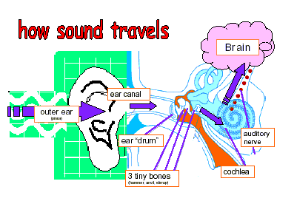
Problem: Sometimes being in a rock band can be pretty fun, and other times all of the loud noise can take a toll on your body! A one-time exposure to extremely loud sounds or listening to loud sounds for a long time can cause hearing loss. The band “The Enginrz” has hired your team to design a pair of noise-canceling headphones so that they can continue to jam safely on stage without hurting their ears! The band will choose their new headphones based on the best looking, the best feeling, and the best noise reduction (blocks the most sound).
Constraints: The bandmates have agreed upon a budget of $50 to spend for each pair of headphones. Your team can spend less money than this, however, you cannot spend more. Also, the band doesn’t want to give up style for safety so make sure your team’s design rocks!
Materials: Remember, your team cannot afford all the materials, so choose wisely!

- Paper cup - $4
- Egg carton cup - $3
- Cupcake wrapper - $2
- Coffee filter - $3
- Paper bag - $3
- Bubble wrap - $8
- Cotton stuffing -$8
- Mesh netting - $2
- Marshmallow (2) - $5
- Masking tape (6 in.) - $3
- Pipe cleaner - $5
- Rubber band - $1
- Plastic straw - $2
- Sponge/foam - $7
- Paper bag - $3
- Felt - $6
- Ball of clay - $10
- Tissue paper - $5
- Aluminum foil (6 in.) - $3
- Decorations (each) - $2
- Paper towel roll - $4
- Toilet paper roll - $2
- Plastic bottle - $9
Imagine (define): As a team, brainstorm several ideas on how to use the above materials to make your headphones. Which design idea does your team think is best?

Design (ideate): Draw out your team’s best design. Be sure to label where you will use all of the different materials in your design!

Build (prototype): List how much of each material you will need to build your design. Once your design sketch and materials list is complete, you may collect materials from the activity leader.

Test (prototype feedback): How well did your design work? What ideas do you have to change and make your design better?

