Cars and Air Quality Connections Worksheet Answer Key (K-2)
Do gas-powered and electric cars affect our air?

Together, we are going to find out:
- Do cars change how clean the air is?
- Does dirty air affect our health?
- Can certain cars help make the air cleaner?

1. Watch the video of vehicles in traffic. Draw or write about what you saw:
Answers vary

Class Reflection: Do you think cars affect how clean the air is? Share your thoughts as a class.

2. Let’s find out about one type of air pollution that comes from vehicles.
Particulate Matter (PM)
Particulate Matter, also called PM, is a type of air pollution. Let’s learn more about air pollution in this video (watch up to 2:24).
Particulate Matter is a pollutant made up of very tiny particles and droplets that float in the air.
- PM comes from natural sources like dirt, dust, and wildfire smoke.
- PM comes from human-made sources like soot from burning fuels for energy and heat.
- PM can make the air hazy.
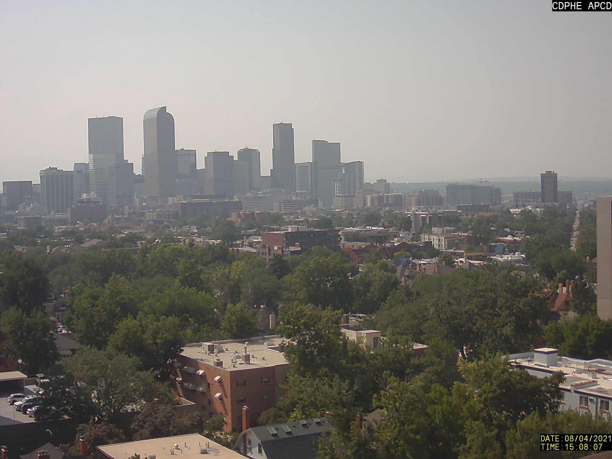
Minus sign, happy face Plus sign, sad face
Look at two photos that were taken on the same day at different times.

What looks the same? What looks different? Describe what you observe.
- Write a plus sign “+” on the photo that has more PM.
- Tell why you think this photo has more PM.
- Write a minus sign “−” on the photo that has less PM.
- Tell why you think this photo has less PM.
- Draw a “” on the photo that has dirtier air.
- Tell why you think this photo has dirtier air.
      - Draw a “” on the photo that has cleaner air.
- Tell why you think this photo has cleaner air.

3. How does air pollution affect our health?
Draw a line to match the words and pictures to explain how breathing PM affects our health:
Words:  - Irritates the eyes, nose, and throat  Middle image  - Gets into the lungs and bloodstream  Bottom image  - Triggers asthma and allergies  Top image | Pictures:  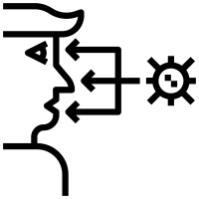  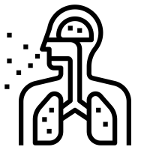

4. Let’s figure out how gas-powered cars and electric cars work.
Now, let’s put together what we now know about PM air pollution and its health effects to learn how different types of vehicles affect how clean the air is.
- First, watch the video about how a gas-powered car works.
- Now, watch the video about how an electric vehicle, also called an EV, works.
How are electric cars and gas-powered cars the same? Draw or write your answer:

EV and ICE vehicles both use a source of energy to power the vehicle. EV and ICE vehicles both range in size from personal cars and trucks to buses to semi-trucks. ICE and EV meet people’s transportation needs.

How are electric cars and gas-powered cars different? Draw or write your answer:

EVs have a battery motor that must be charged to run. EVs do not release any emissions or air pollution into the atmosphere when they are on or driving. EVs have a shorter driving range than ICE. EVs can be charged using renewable energy sources but are mainly charged by plugging into the power grid.

ICE vehicles have an engine that burns gas to run. ICE vehicles release emissions and air pollution into the atmosphere when they are on and driving. ICE vehicles have a longer driving range than EV. ICE vehicles use non-renewable fossil fuels that release greenhouse gases when burned, which contribute to climate change.

Class Reflection: Share your thoughts on the following questions as a class:
- Is clean air important?
- Do gas-powered or electric cars make our air dirtier?
- Do gas-powered or electric cars make our air cleaner?

