Catapult Quiz Answers

1. The term “projectile” means _________________.
(a) an object that is launched or thrown, usually in the air, by a force
(b) A ping pong ball
(c) a small catapult
(d) an object that orbits around the earth

TeachEngineering.org – Free STEM Curriculum for K-12
2. The strongest and most sturdy polygon to use in constructing a base for a catapult is a ____________.

(a) square
(b) quadrilateral
(c) triangle
(d) rhombus

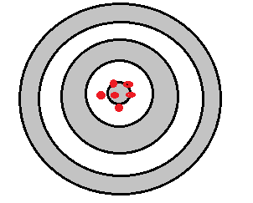
3. The picture on the right is an example of __________________.

(a) accuracy AND precision
(b) accuracy but NOT precision
(c) precision but NOT accuracy
(d) NEITHER precision NOR accuracy

4. In order for a projectile to travel the furthest distance possible, what angle should it be launched from?

(a) 30°
(b) 45°
(c) 60°
(d) 90°

5. Engineers design and create things that can

(a) save peoples’ lives
(b) help people communicate and learn
(c) make peoples’ lives more fun and enjoyable
(d) all of the above

