Design Process Overhead
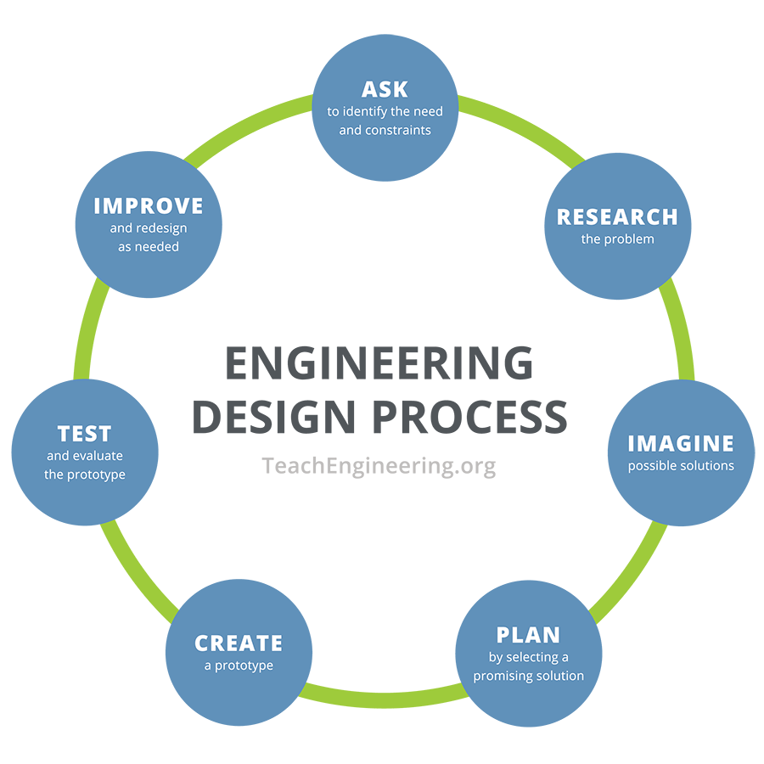

Scientists investigate what is; they discover new knowledge by peering into the unknown...
Engineers create what has not been; they make things that have never existed before...
─ Joseph Bordogna, Deputy Director, National Science Foundation

Brainstorm Guidelines
No negative comments are allowed.
Encourage wild ideas.
All ideas are recorded.
Stay focused on topic.
One conversation at a time.
Build on the ideas of others.

