Tracking a Virus Worksheet

Part 1: Please answer questions 1-6 in complete sentences.
1. What do the letters A-I-D-S stand for?

2. What do the letters H-I-V stand for?

3. What is the difference between AIDS and HIV?

4. How does a virus survive and reproduce in the human body?

5. Why is HIV especially deadly compared to other viruses?

6. How is HIV transmitted from one person to another?

7. Circle the correct answers:
AIDS / HIV causes AIDS / HIV

Part 2: Fill in the Blanks

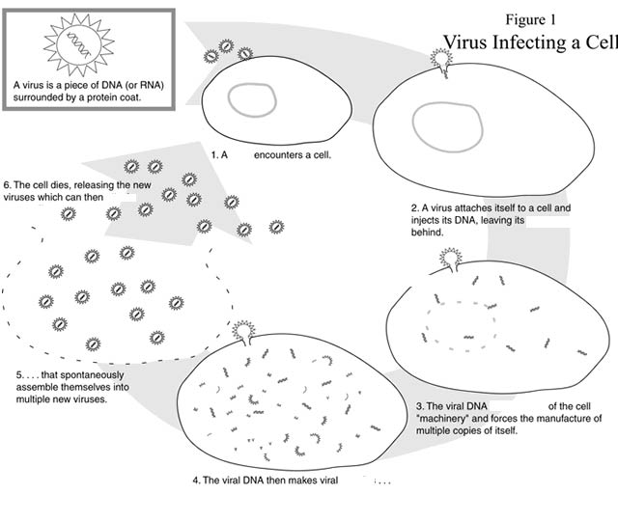

2.
