Galactic Perspectives Worksheet Answer Key
Our galaxy, the Milky Way, is an example of a spiral galaxy. Figure 1 (below) shows the Milky Way as it would appear if we were floating above it, facing the center of the galaxy. An imaginary x-y axis has been added to Figure 1 that will help us find distances between places in our own galaxy and even a nearby one!
Figure 1. Our galaxy, the Milky Way, as viewed from above and shown
with an imaginary x-y axis. (units: light years)

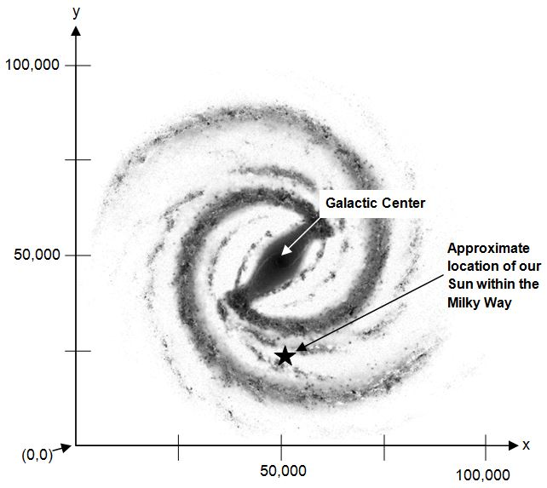

Question 1. Assume that each tick mark is one inch apart. How much distance in light years is represented by each tick mark on the x and y axes in Figure 1? (write your answer in the space below, you’ll need it later):

distance between 2 adjacent tick marks
= 1 inch = ___25,000______ light years

This image was adapted under the Creative Commons license from http://www.enderra.com/2012/02/01/milky-galaxy-black-white/

Question 2. The center of the Milky Way is also known as the Galactic Center. What are the approximate x,y coordinates of our Sun as well as the Galactic Center in Figure 1? Write your answers in the space provided below:

Answer: Coordinates of the Sun: (50,000, 25,000)
Answer: Coordinates of the Galactic Center: (50,000, 50,000)

Question 3. About how many light years away from the Galactic Center is our Sun?

Answer: about 25,000 ly

Question 4. About how wide is the Milky Way?

Answer: about 100,000 ly
Figure 2 (below) illustrates how the Milky Way would look if viewed from the side; somewhat flat like a dinner plate with a slight bulge in the center.
Figure 2. Representation of the Milky Way viewed from the side (ly = light years):
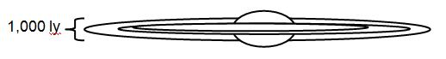

Question 4. How many times more wide is the Milky Way than it is thick?

Answer: about 100,000/1,000 = 100 times wider

The nearest spiral galaxy to our Milky Way is the Andromeda galaxy, which is about 2.5 million (2,500,000) light years away.
Question 5. How far in inches would the Andromeda galaxy be from the Milky Way if we used the same scale as in Figure 1, above? [Hint: you will need to use your answer to Question 1 to figure this out]
Answer: 2,500,000 / 25,000 inches = 100 inches (8 and 1/3 feet)

Now your team will imagine a third axis, the z-axis, that shoots directly out of the page and away from the origin (0,0) point of the x-y axis in Figure 1. Have one member of your group hold this worksheet up so that it is perpendicular to the floor. Using the ruler, the other member(s) should measure out the length in inches that you just calculated (above) representing the distance from Andromeda to the Milky Way. One team member should follow the straight, invisible line that points directly away from the origin on Figure 1 and stand in the spot representing the distance to the Andromeda galaxy, have them stand in the spot for a moment and then answer the following questions:
Question 6. How does our scale 3-D model of the Milky Way and a neighboring galaxy affect the way you think about distances in space?
Answers might include that students can better visualize the relative distance of Andromeda to the Milky Way, or that even though the Milky Way is very large, even neighboring galaxies are much further away compared to the size of our galaxy
Question 7. What ways can you think of in which we use 3-D coordinate systems in our daily lives? Can you imagine any ways that 3-D graphing could help scientists or engineers do their jobs?
Answers might include describing where a person is inside a building, how tall an object is and where it is located, etc. Scientists and engineers use 3-D graphing in many ways, including 3-D printing, product design, visualizing data, etc.

