Sounds Like Music Worksheet
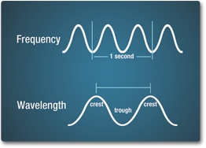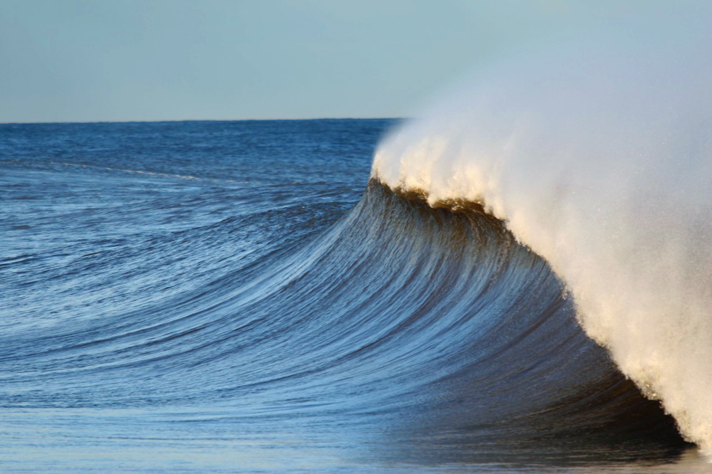
Frequency is how often the wave occurs. Wavelength is how far apart the waves are.
Amplitude is how large the wave is. The greater the amplitude, the more energy!
1) For the two waves below, use your ruler to measure the wavelength and amplitude.
2) To find the frequency, we will assume all the waves happen in one second. Divide one
second by the number of waves to find the frequency.

Longer wavelength Less Frequency Lower Pitch Lower Amplitude (Less Energy)
a) How many waves are there in this wave train? _____________
b) Wavelength _____________ cm
c) Amplitude _____________ cm
d) Frequency _____________ Hz

Shorter wavelength Higher Frequency Higher Pitch Higher Amplitude (More Energy)
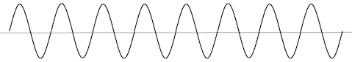
a) How many waves are there in this wave train? _____________
b) Wavelength _____________ cm
c) Amplitude _____________ cm
d) Frequency _____________ Hz

