Maze Preparation Instructions & Photos
For the teacher
Maze Construction
A maze may be created in many ways. Below is one example. Keep in mind that the remote control signal needs to be able to reach the robot, so avoid using thick materials for the walls.
Instructions for an example maze: Push together three large tables and cover them completely with tablecloths. Place about 10 boxes and foil pans randomly under the tables. Hide “alien” or “signs of life” stickers (or paper cutouts or drawings that indicate alien life) randomly in the maze by taping them on the boxes or pans. Also modify the “mission data log” handout to reflect these aliens/signs of life so students know what they are looking for. Also modify the “maze map” handout so the maze outline matches the overall footprint shape of the classroom maze. For greater impact and if time and budget permit, wrap the obstacle boxes with silver wrapping paper (available inexpensively at dollar stores).
Materials
- Thin, plastic tablecloths, to completely cover the tables from the tabletop to the floor
- ~10 variously sized boxes and foil pans, to serve as obstacles and landforms
- Tape, to keep the tablecloths in place and adhere alien images to the boxes/pans
- Alien stickers or other printed images to serve as the “signs of life”
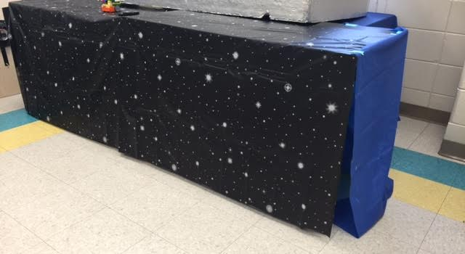

Example outside of a maze.

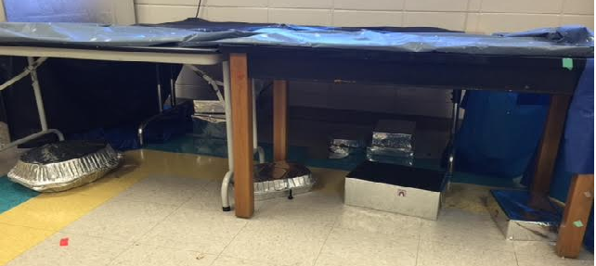

Inside the maze.
(It originally looked nicer, but this photograph was taken after the activity was conducted with students!)
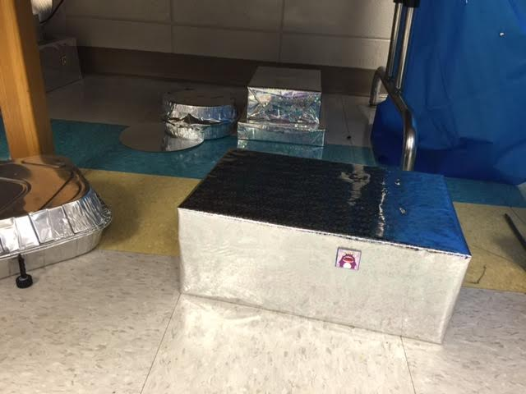

Example of a hidden alien.

