**Area and Volume Pre-Quiz Key**

1. Find the area of the next quadrilaterals. Write the formula used:

(a).

5

4

7

60o

7

6

60o

36

36

(b).

Using special right triangles

60o

7

6

60o

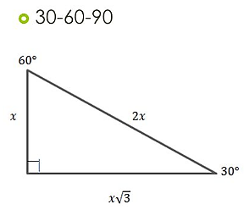



45o

8

10

10

8

(c).

45o

8

10

10

8



Using special right triangles

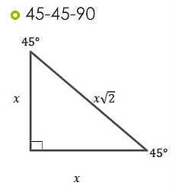



2. Find the volume of the prisms.

Using special right triangles

(a).

8

12

8

60o

60o



8

12

8

60o

60o



8

Using special right triangles

6

6

6

6

6

6

10

(b).



6

6

10





60o