Students Activity Guide
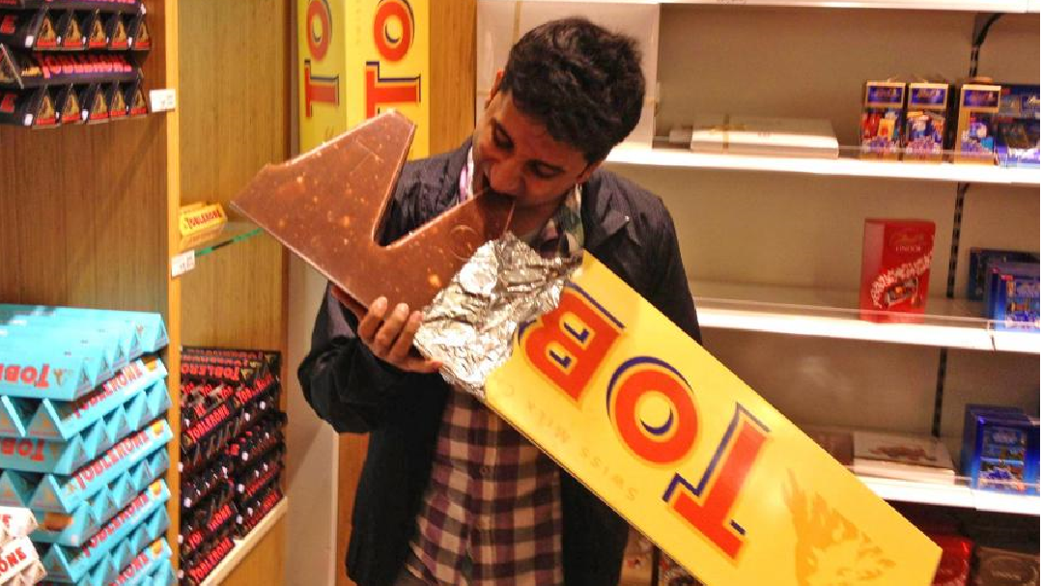

A Sweet Volume
A Sweet Volume

The purpose of this project is to use polynomials to design a container for a jumbo chocolate bar. The container must be built using a 56 cm x 71 cm (~22 in x 28 in) cardstock sheet and must use the extent of the sheet’s dimensions to ensure the maximum volume possible with minimal waste. The container has be a trapezoidal prism, and the trapezoidal face must be an isosceles trapezoid that contains acute angles of 60 degrees. The constructed container should be decorated as it were a real chocolate bar. Calculations and graphs may be performed in Excel, Google Sheets, or on a TI-Nspire calculator.
After building the container, you will create a poster that includes the geometric net used, procedures, calculated dimensions, and pictures of the finished product. You should expect to present the model and explain the results in class. Alternatively, you can deliver a video presentation with the procedure as an assignment.

Project Guidelines
- You will work in groups of three.
- The first part of this project consists in the design of the container. You have to express the prism’s volume formula as a function of a single x-variable. One recommendation is to use the length of the non-parallel sides of the trapezoidal face as the x. Use a regular prism net to determine the volume’s function (see Fig. 1a or Fig. 1b below) and select one from the two net options: the vertical or the horizontal.
- Document the mathematical steps performed to determine the prism’s volume formulas.
- Once the prism’s volume formula has been determined, you will graph it. From this graph, determine the x-value for which the volume is maximum. With this x-value, determine the dimensions of the model.
- The next step is build the container. Justify your choice based on an aesthetic or on a mathematical argument. On a 56 cm x 71 cm (22 in x 28 in) cardstock sheet, draw the net corresponding to your chosen prism. Be aware that tabs to glue the model must be included in the net (see Fig 1a or 1b below). Cut and glue (or tape) your model with precision!
- Decorate your design and give it a brand name. Be creative— don’t just copy a commercial brand!
- Create a video or a standalone slideshow to present every step of your work and results.
- If you like, share the video presentation of your results to mramirez2@gpapps.galenaparkisd.com.
Notes
Project Checklist

Process and Results | Points |  | Evaluation
- Title of the project, and students’ names | 5
- Objective and brief description of work completed | 5
- Prism selected and net prism used | 10
- Explanation of the math behind the problem’s solution, the equations used, and the math process used to find the prism’s volume polynomial function | 30
- Graphs of the prisms’ volume formula, displaying its maximum point and its coordinates | 15
- Dimensions of the optimized prism and its volume (in inches and centimeters) | 10
- Pictures of the construction process | 10
- Pictures of finished model | 10
- Bibliography and references | 5 |  | _________
Total Points:

Results Presentation Checklist | Points |  | Evaluation
- PowerPoint slideshow or video (mp3, wma, mpeg), containing information and results listed in points 1 – 9, and recorded explanations | 75
- Proficient explanation and presentation of mathematical process, and construction | 10
- Artistic design and originality in completed model | 10
- Overall professionalism during presentation | 5
Total Points:
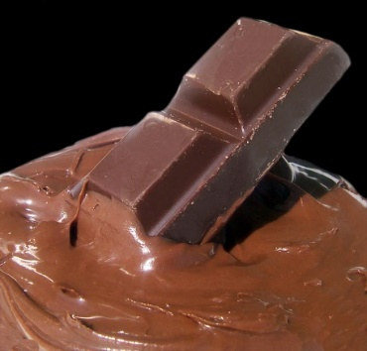
Notes: | - There will be help for the Math concepts, Graphs and Excel, Google Sheets, or TI-Nspire calculations, Physical Model construction, and presentation elaboration, during tutorial’s time.  - No project will be accepted after: {Date} (point deduction policy for late submission will apply)

Fig 1.a. Vertical Net

x

60º

x

71
cm

or

28
in

56 cm or 21 in

Fig 1.b. Horizontal Net

71
cm

or

28
in

60º

x

x

56 cm or 22 in

Additional Support:

Pre-Calculus:
- Demana - et al: Precalculus, Graphical, Numerical algebraic, Texas Edition. Pearson 2016

https://www.sophia.org/playlists/precalculus-graphical-numerical-algebraic-demana-waits-foley-kennedy-bock
- Larson - Hostetler: Precalculus with Limits, Houghton Mifflin 2007

https://www.humbleisd.net/cms/lib/TX01001414/Centricity/Domain/8416/precalculus_7th_-_larson_hostetler_2.pdf

TI-Nspire:
- Getting Started with the TI-Nspire CX Handheld

https://www.usna.edu/MathDept/_files/documents/resources/TI-Nspire_CX_Handheld_GettingStarted_EN.pdf
- Programming with TI-Nspire:

https://www.tinspireapps.com/resources/How_to_program_the_TI-Nspire.pdf

PowerPoint:
- Microsoft PowerPoint Tutorials:

http://www.electricteacher.com/tutorial3.htm
- Office Tutorials: MS PowerPoint – How to create a Standalone Presentation: http://www.officetutes.com/ms-powerpoint-how-to-create-a-standalone-presentation-ppt-to-exe-hd/
- National Conference of State Legislatures: Tips for Making Effective PowerPoint Presentation: http://www.ncsl.org/legislators-staff/legislative-staff/legislative-staff-coordinating-committee/tips-for-making-effective-powerpoint-presentations.aspx

Project Support:
- Sophia Tutorials
https://www.sophia.org/tutorials/optimization-first-semester-project#recommend_rating_block

Chocolate:

- Mam’ Mahgul Jakany – Nazish Bukhari: Analysis of Chocolate.
https://www.slideshare.net/NazishBokhari/chocolate-analysis-51676357
- Divya Chandra – Jash Jaswani: Analysis on Chocolate Brands
https://www.slideshare.net/saurabh2somu/project-report-on-chocolate
- CLEMSON Cooperative Extension: When it Comes Chocolate, Choose Dark
https://www.clemson.edu/extension/hgic/food/pdf/hgic4090.pdf

Other:
- Trapezoidal Prism Volume Calculator
https://www.easycalculation.com/area/volume-of-trapezoidal-prism.php
- Trapezoidal Prism Volume
https://math.tutorvista.com/geometry/volume-of-a-trapezoidal-prism.html
Annex A. Maximum Volume Calculation Example

Cut a rectangular box with a lid from a 56 cm x 71 cm (~22 in x 28 in) cardstock sheet (Fig. 2). Remove two equal squares for the corners of one of the 56 cm (22 in) side, and two equal rectangles from the other corners. Find the dimensions of the cuts to give the box the maximum value possible for this cardstock sheet. Remember to include tabs so the box can be assembled.
71cm or 28 in
56cm

or

22 in

Fig. 2

On the prism’s net, include the tabs to assemble the prism. However, only one tab affects the amount of cardstock used to construct the box—the tab on the 56 cm (22 in) side (Fig. 2). If a 1 in width tab is considered, the available cardstock will be 56 cm x 71 cm (~22 in x 27 in). Note: for the purposes of the following calculations, we will use inches as the measurement.
27”

x
x

y
y
x
x

z
22”

Fig. 3

Calculated the volume of the rectangular prism with the well-known formula V = xyz. From Fig.3, the variables x, y and z can be related to the dimensions of the cardstock sheet:
x + y + x + y = 27
2x + 2y = 27 (1)

and

=x + z + x = 22
2x + z = 22 (2)

Solve equation (1) for y and equation (2) for z:

With these values, the volume of the prism will be a function of the variable x only:

Graphing this function, it is possible to determine the x-value for which the volume is a maximum:

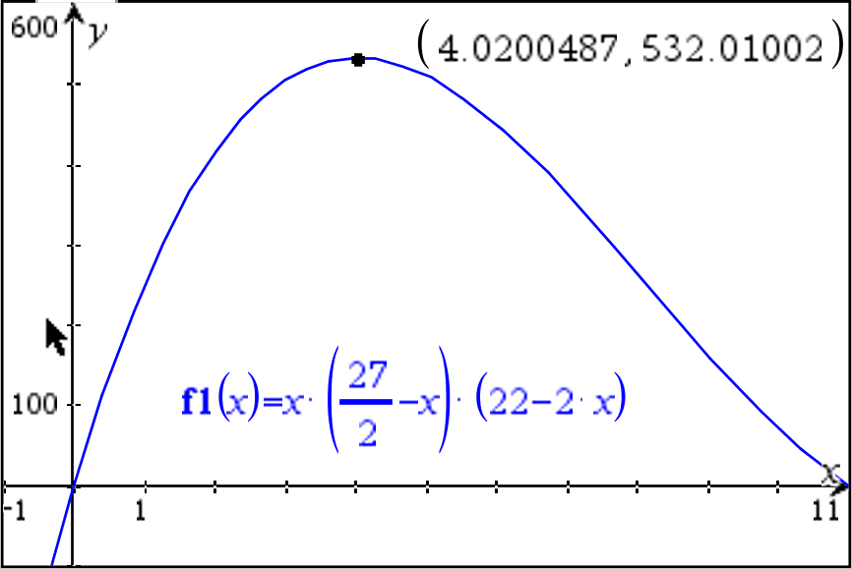

Fig. 3

The rectangular prism has the maximum volume of 532.01 cubic inches when x = 4.02 inches, Using equations (1) and (2), determine the other dimensions of the rectangular prism:

In case of a different configuration in the rectangular prism net (Fig, 4), such as if the tab sits on the 28 in side, do the corresponding equations of y and z in terms of x:

y

x
x
21”

y

x

x
z

28”

Fig. 4

x + y + x + y = 21
2x + 2y = 21 (3)

and

x + z + x = 28
2x + z = 28 (4)

From (3) and (4):

The polynomial for the volume of the rectangular prism is now:

From the graph of this polynomial (Fig. 5), the maximum volume is for:

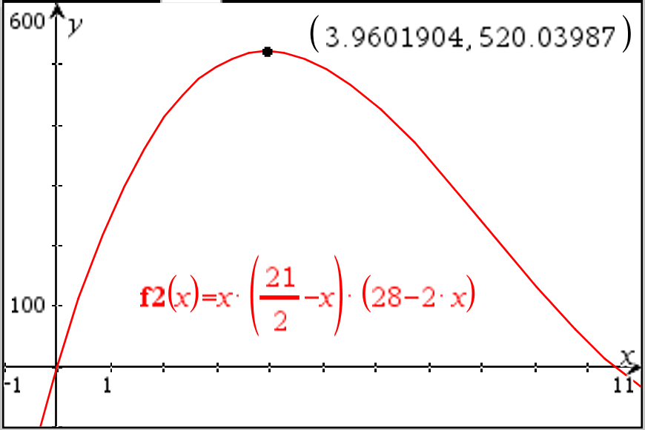

Fig. 4

For this configuration, the rectangular prism has the maximum volume of 520.04 cubic inches when x = 3.96 inches, Use equations (3) and (4) to determine the other dimensions of the rectangular prism:

In-Class Presentation or Video Presentation Rubric

 | Non-Professional | Quite professional | Professional
Body Language | - Reading notes or slides  - Eyes not on audience or camera  - Lacks poise during the whole presentation  - No natural movements or gestures | - Sometimes refers to notes or slides  - Some eye contact with audience or camera  - Some awkward movement and gestures  - Some confidence and poise | - Mostly engages eye contact with audience or camera  - Little or any reading of slides or notes  - Natural movements and gestures  - Expresses confidence during the presentation
Voice | - Speaks too softly to be understood  - Speaks too quickly or slowly  - Frequently uses filler words or sounds such as: Ok, so…, you know…,uh, umm, I mean …  - Does not use proper technical language or formal English | - Speaks clearly most of the time  - Sometimes speaks too quickly or slowly  - Speaks loudly enough for most of the audience  - Occasionally uses filler words or sounds like: Ok, so…, you know…,uh, umm, I mean…  - Uses proper technical language or formal English during most of the presentation | - Speaks clearly during the whole presentation  - Speaks at uniform volume and at a normal pace  - Speaks loudly enough for everyone to hear  - Rarely uses filler words or sounds like: Ok, so…, you know…,uh, umm, I mean …  - Uses proper technical language or formal English during the whole presentation
Overall Presentation | - No main idea present, wrong, or incomplete  - Ideas presented in the wrong sequence  - Missing important steps in the topic development  - Missing, incorrect, or incomplete introduction or conclusion  - Bad presentation time management  - Did not answer questions | - Main idea present, but not proficiently explained  - Ideas presented in the right order, but not proficiently connected or missing important points  - Introduction and conclusion present  - Presentation done in the allotted time  - Answers most of questions in context | - Main idea communicated in a clear and effective manner  - Ideas presented in the right order with an emphasis on main points  - Effective introduction and conclusion  - Presentation done in the allotted time and with good time management  - Answers questions in context; enrichs answers with relevant information

