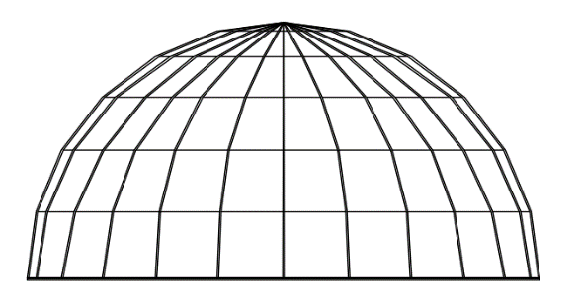
Activity Pre-Quiz
The problem: A 25-m diameter semispherical segmented dome is going to be constructed (see Figure 1). Six equal-length segments will be used to create the revolving line (see Figure 2). Table 1 shows the relative positions of the revolving line vertices. Assuming the dome is a solid of revolution, find the dome’s volume. Show your work and give the result with three decimal places.

Figure 1
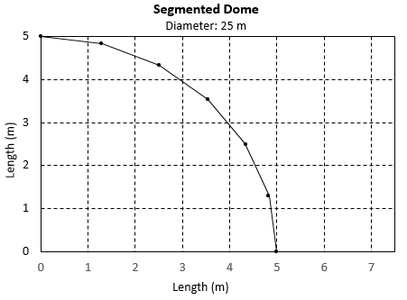
x (m) | y (m)
0.00000 | 5.00000
1.29410 | 4.82963
2.50000 | 4.33013
3.53553 | 3.53553
4.33013 | 2.50000
4.82963 | 1.29410

Table 1
Figure 2

