Data Sensing Glove Lab
This lab will allow you to create a data sensing glove and test it out while measuring the electrical resistance in the strain sensors.
You will need to gather the materials for the lab:
- Two 3D printed sensors made from Conductive PLA
- Two 3D printed sensors made from ETPU
- One strand of wire that is 2 feet long
- Superglue
- Two gloves
- Scissors
- Sharpie
- 3D printed prosthetic hand
- Digital multimeter

The first step will be to construct the strain sensors.

- Cut the length of wire into eight segments.

- Strip about an inch off each end of every wire segment.

- Use the soldering iron to melt the exposed end of the wire into the end of one of the 3D printed sensors.

- Repeat this for the other end of the sensor.

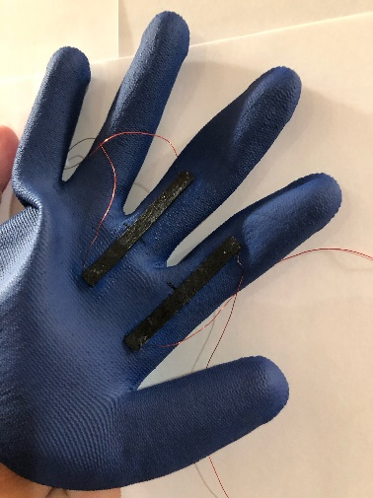
- Repeat this method for the other three sensors.

The next step will be to construct the data sensing glove.

- Cut the glove about an inch below the thumb all the way across.

- Attach a conductive PLA sensor to the index finger on the rubberized side of the glove in the spot shown in the picture using superglue.

- Attach the second conductive PLA sensor to the middle finger on the rubberized side of the glove in the spot shown in the picture using superglue.

- Label this glove with the Sharpie as “PLA”.

- Make the second glove in the same manner using the ETPU sensors and label the glove as “ETPU”.

The next step will be to construct the experimental setup.

- Put the glove on the 3D printed prosthetic hand with the rubberized side (the side with the sensors) on the back of the hand.

- Attach the digital multimeter leads to the wires so that a completed circuit is made.

- The electrical resistance will need to be recorded when the sensor is at 0° of bending, 45° of bending, and 90° of bending. This needs to be recorded in the data tables that are provided.

- This will be need to be repeated two more times for the same glove.

- This method will be repeated for the other sensor on the glove.

- This method will be repeated for the other glove.

- See the Data Collection table on the next page.

After the data has been collected, you will need to graph it using graph paper or Excel.
 | Electrical Resistance at 0° of bending  (Ohms) | Electrical Resistance at 45° of bending  (Ohms) | Electrical Resistance at 90° of bending  (Ohms)
Conductive PLA
Sensor One
Trial One
Conductive PLA
Sensor One
Trial Two
Conductive PLA
Sensor One
Trial Three
Conductive PLA
Sensor Two
Trial One
Conductive PLA
Sensor Two
Trial Two
Conductive PLA
Sensor Two
Trial Three
ETPU
Sensor One
Trial One
ETPU
Sensor One
Trial Two
ETPU
Sensor One
Trial Three
ETPU
Sensor Two
Trial One
ETPU
Sensor Two
Trial Two
ETPU
Sensor Two
Trial Three

