Identifying Cultured Bacteria
Bacteria are unicellular microorganisms found in every habitat on Earth. Nearly all have cell walls composed of peptidoglycan and reproduce by binary fission (cloning of cells). Although many of these microbes are harmless or beneficial to humans, others are pathogenic, causing infectious diseases.
Identification by Shape
Some of the first steps in identifying bacteria are to examine according to shape:
- bacillus (pl. bacilli) = rod-shaped
- coccus (pl. cocci sounds like cox-eye) = spherical
- spirillum (pl. spirilla) = spiral
Some bacteria have more unusual shapes:
- coccobacilli = elongated coccal form
- filamentous = bacilli that occur in long threads
- vibrios = short, slightly curved rods
- fusiform = bacilli with tapered ends
* Prokaryote arrangement of cells *Bacteria sometimes occur in groups, rather than singly, and the single cell’s shape influences the cell arrangements that they form as the bacterial cells divide.
Bacteria grow tremendously fast when supplied with an abundance of nutrients. Different types of bacteria produce different-looking colonies, some colonies may be colored, some colonies are circular in shape, and others are irregular. A colony’s characteristics (shape, size, pigmentation, etc.) are termed the colony morphology. Colony morphology is the way scientists identify bacteria. In fact, a book called Bergey’s Manual of Determinative Bacteriology (commonly termed Bergey’s Manual) describes most bacterial species identified by scientists so far. This manual provides descriptions for the colony morphologies of each bacterial species.
Although bacterial and fungi colonies have many characteristics and some are rare, a few basic elements enable you to identify for all colonies: (1)
- Form: What is the basic shape of the colony? For example, circular, filamentous, etc.
- Elevation: What is the cross sectional shape of the colony? Turn the Petri dish on end.
- Margin: What is the magnified shape of the edge of the colony?
- Surface: How does the surface of the colony appear? For example, smooth, glistening, rough, dull (opposite of glistening), rugose (wrinkled), etc.
- Opacity: For example, transparent (clear), opaque, translucent (almost clear, but distorted vision, like looking through frosted glass), iridescent (changing colors in reflected light), etc.
- Chromogenesis (pigmentation): For example, white, buff, red, purple, etc.
Please note that three additional elements of morphology should be examined only in a supervised laboratory setting: consistency, emulsifiability and odor.

Refer to the diagram below for illustrated examples of form, elevation and margin: (2)
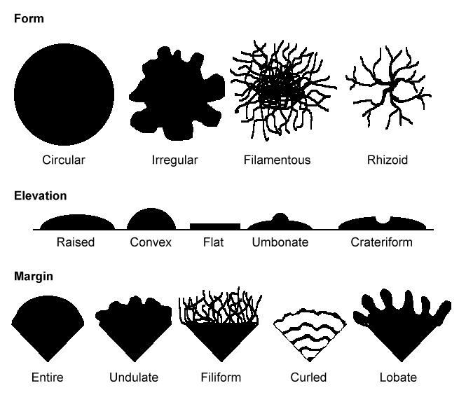

What can grow on a nutrient agar plate?
Bacteria: Each distinct circular colony should represent an individual bacterial cell or group that has divided repeatedly. Being kept in one place, the resulting cells have accumulated to form a visible patch. Most bacterial colonies appear white, cream, or yellow in color, and fairly circular in shape. For example:
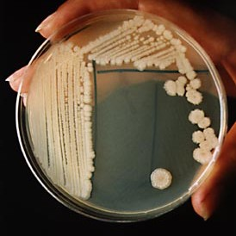

Bacillus subtilis (3)

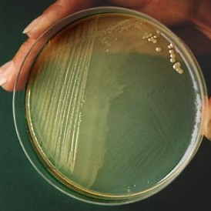
Proteus vulgaris (4)

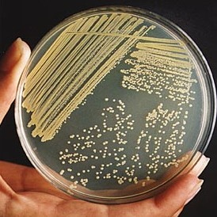
Staphylococcus aures (5)

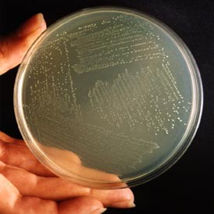
Streptococcus pyogenes (6)

Yeasts: Yeast colonies generally look similar to bacterial colonies. Some species, such as Candida, can grow as white patches with a glossy surface. For example:

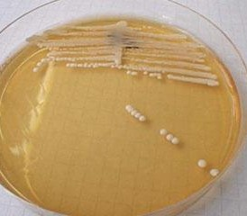
Candida Albicans is a type of yeast that
can grow on the surface of skin (7)

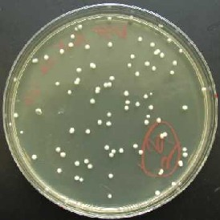

Round yeast colonies (8)

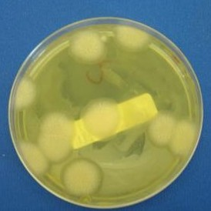
Pink yeast colonies (9)

Molds: Molds are fungi, and they often appear whitish grey, with fuzzy edges. They usually turn into a different color, from the center outwards. Two examples of molds:

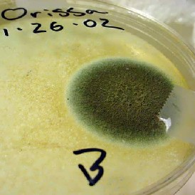
Green mold (Trichoderma harzianum) (10)

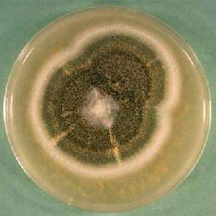
Black mold (Aspergillus nidulaus) (11)

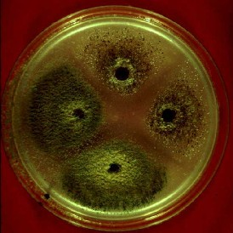
Other Fungi: Moss green colonies, a white cloud, or a ring of spores can be attributed to the growth of Aspergillus, which is common in such fungal infections as athlete's foot. Here is an example of what Aspergillus looks like: (12)

Finally, whenever a thorough, visual identification is not possible, examples of additional tests are gram stains (http://www.austincc.edu/microbugz/gram_stain.php), growths on selective media, and enzymatic tests.

References Cited
(1) “Microbiology 101 Laboratory Manual.” Washington State University. Accessed January 14, 2005. http://www.rlc.dcccd.edu/mathsci/reynolds/micro/lab_manual/colony_morph.html
(2) “Microbiology 101 Laboratory Manual.” Washington State University. Accessed January 14, 2005. http://www.slic2.wsu.edu:82/hurlbert/micro101/pages/101lab4.html
(3) “Bacterial Colony Morphology.” Austin Community College. Accessed January 14, 2005. http://www.austin.cc.tx.us/microbugz/03morphology.html
(4) “Bacterial Colony Morphology.” Austin Community College. Accessed January 14, 2005. http://www.austin.cc.tx.us/microbugz/03morphology.html
(5) “Bacterial Colony Morphology.” Austin Community College. Accessed January 14, 2005. http://www.austin.cc.tx.us/microbugz/03morphology.html
(6) “Bacterial Colony Morphology.” Austin Community College. Accessed January 14, 2005. http://www.austin.cc.tx.us/microbugz/03morphology.html
(7) Silvermedicine. Accessed January 14, 2005. http://www.silvermedicine.org/Candidaalbicans.jpg
(8) Biology at the University of Cincinnati Clermont College. Accessed January 14, 2005. http://biology.clc.uc.edu/fankhauser/Labs/Microbiology/Yeast_Plate_Count/07_yeast_0.2mL_plate_P7201181.jpg
(9) Teachers Experiencing Antarctica and the Arctic. Accessed January 14, 2005. http://tea.rice.edu/Images/stoyles/stoyles_pinkJPG.JPG.jpg
(10) The Shroomery. Accessed January 14, 2005. http://www.shroomery.org/images/23418/green5.jpg
(11) The Shroomery. Accessed January 14, 2005. http://www.shroomery.org/images/23418/Aspergillus_nidulaus.jpg
(12) ETH Life International. Accessed January 14, 2005. http://www.ethlife.ethz.ch/images/aspergillus-l.jpg
Credits
Beatrice Leung, Genentech, Inc.
Shijun Liu, Science Buddies

