Overcoming Glaucoma: Dennis Howard’s Story Handout
- Mark up the photograph below to show how Dennis Howard would see the image.
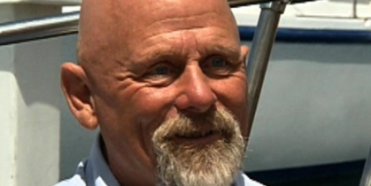

- What percentage of Dennis’s vision does your picture above represent? ___%

- What caused Dennis’s vision loss?

- Why did many surgeons refuse to operate on Dennis?

- Briefly explain the surgery that took place to reduce the excess fluid in Dennis’s eye.

- What could engineers do to monitor the pressure in Dennis’s eye so that if another surgery needs to take place, it can be done earlier?

