Under Pressure WebQuest Worksheet Answer Key
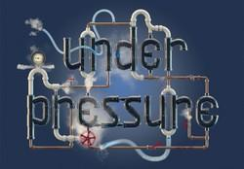
Instructions: Use the prompts on this document to complete the Under Pressure WebQuest found at http://underpressurewebquest.weebly.com/.
The responses you provide will help you to identify a suitable pressure gauge for your intraocular pressure sensor prototype.
- Read the introduction under the BEGIN button.
- Click BEGIN.
- You will design and 3D print a prototype of an intraocular (implanted in the eye) pressure sensor. Read the definitions provided for the term “pressure” and answer the questions below:
  - Which definition would you use to define the word “pressure” in the phrase intraocular pressure sensor?
“The weight or force that is produced when something presses or pushes against something else.”

  - Why did you select this definition?
Answers may vary. Example answer: I selected this definition because the pressure in an eye needs to push against our pressure sensor. If this happens, then we will know the pressure in the eye.
  - Since we would like to measure the pressure within the eye, what should at least one part of your design do?
Answers may vary. Example answer: At least one part of the pressure sensor should push against another part.

- Go back to the WebQuest tab and press NEXT.

- Before you decide which part of your pressure sensor will “push” when pressure is applied, let’s explore the ways in which certain pressures are measured. Watch the slideshow and answer the questions below:
- In the slideshow, what kinds of pressure are shown? For example, “air pressure.”
Air pressure, blood pressure and tire pressure

- Click on ONE picture of your choosing within the slideshow.
  - Define the pressure you selected.
Answers may vary depending on item selected. Example answer: Tire pressure is the amount of air pressure in tires.

  - Explain why it is necessary to measure this form of pressure.
Answers may vary depending on item selected. Example answer: Measuring and maintaining the correct tire pressure is important to make tires last longer, the car safer and to save money on gas.

- Return to the WebQuest tab and click NEXT under the slideshow.
- Read the page and then click NEXT.

- What is the name of the pressure gauge you will first explore? _manometer_
- Click on the speaker icon and listen to the pronunciation of this pressure gauge.
Say this term five times to your partner.
- Read the page and watch the video. Then answer the questions that follow.
- This pressure gauge would be most effective in measuring the pressure of (circle all that apply):
  - nitrogen gas
  - lead
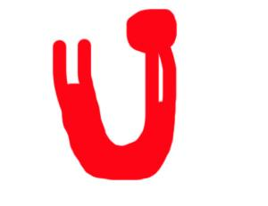
  - blood
  - water vapor
- Draw the shape of this pressure gauge in the space here.

- How is this pressure gauge used in the medical field?
This pressure gauge can measure blood pressure.

- Would you recommend the use of this pressure gauge in an intraocular pressure sensor?
Why or why not?
Answers may vary. Example answer: I do not recommend using the manometer in an intraocular pressure sensor. First, it would be too large to fit in a human’s eye. Second, most of them use mercury, which is poisonous to people. Third, one end would have to be exposed to the air and the other closed, so it would be hard to get air in the eye.
- Click NEXT under the video.

- What is the name of the second pressure gauge you will explore? _Bourdon tube__
- Read the page and watch the video. Then answer the questions that follow.
- This pressure gauge would be most effective in measuring the pressure of (circle all that apply):
  - heat
  - water vapor
  - water
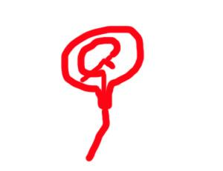
  - air
- Draw the shape of this pressure gauge in the space here.

- How is the pressure of a gas or liquid determined with this pressure gauge?
The gas or liquid travels into a flat tube. The pressure from the gas or liquid straightens out the tube. This causes the needle to move. That’s how you know the amount of pressure.

- Would you recommend the use of this pressure gauge in an intraocular pressure sensor?
Why or why not?
Answers may vary. Example answer: I do not recommend using the Bourdon tube for the pressure sensor. It is really big and measures high amounts of pressure. It would be really hard to put this into an eye.

- Click NEXT underneath the video.

- What is the name of the third pressure gauge you will explore? _diaphragm__
- Read the page and watch the video. Then answer the questions that follow.
- This pressure gauge would be most effective in measuring the pressure of (circle all that apply):
  - heated water vapor
  - heated water
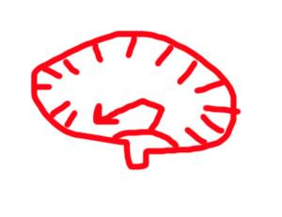
  - ice
  - carbon dioxide
- Draw the shape of this pressure gauge in the space here.

- Why would someone use this pressure gauge?
Answers may vary. Example answer: This pressure gauge would be useful if there were extreme temperatures or if working with corrosive materials.

- The average body temperature of a human is 98.6 °F. Would this cause someone to consider a diaphragm seal pressure gauge for an intraocular pressure sensor? Why or why not?
Answers may vary. Example answer: Yes, someone might consider a diaphragm to be good pressure sensor for the high temperature found in a human body, but the seal is only one part of the entire gauge. The rest of it is very large.

- Would you recommend the use of this pressure gauge in an intraocular pressure sensor?
Why or why not?
Answers may vary. Example answer: No, I would not recommend using a diaphragm seal. It would be too big for the eye because the diaphragm connects to a device that moves the needle. It would be better to have a gauge that does not require so many parts.

- Click NEXT under the video.

- What is the name of the LAST pressure gauge you will explore? _bellow_
- Read the page and watch the video. Then answer the questions that follow.
- Why would someone use this pressure gauge?
Answers may vary. Example answer: A bellow would be used if the pressure change might be small, or the place where pressure is being measured might be very small, too.

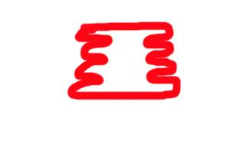
- Draw the shape of this pressure gauge in the space here.

- How is this type of pressure gauge used?
A barometer uses a bellow to determine the changes in air pressure, which help meteorologists to forecast the weather.

- Would you recommend the use of this pressure gauge in an intraocular pressure sensor?
Why or why not?
Answers may vary. Example answer: I think the bellow would be the best choice for the pressure sensor because it is small and measures small changes in pressure.

- Click NEXT

- Follow the instructions on the page. What is the name of the pressure gauge you will use in your intraocular pressure sensor? ___bellow____
- Answer the questions below with “yes” or “no” and then explain how you know.
  - For the pressure gauge you selected:
    - Is it able to be designed small enough to fit in the eye? __yes__. How do you know? Bellows can come in all kinds of shapes and sizes.

    - Could it act as a tag in an RFID system? __Maybe__. How do you know? Since it can measure pressure, I think it can store that information.

    - Will it have a low mass? __Yes__. How do you know? Bellows can be made from any type of material. If it is made with plastic it will have a low mass.

    - Does it require the use of a battery to function? __No__. How do you know? Bellows move up and down due to the pressure of a substance. Only pressure causes it to move.

- Click FINISH.

- BEFORE READING THE WEBPAGE: Re-read your answers to #3 on this document.
- What must happen in order for your pressure gauge to successfully measure pressure?
It must to push against something else.

- Read and watch the video on the webpage.
- The tuning forks in this video were placed on spruce wood boxes between the years of 1870 and 1900. The spruce wood boxes act as resonators. When the forks are struck, the energy from the vibrations in the forks is transferred to the boxes, which vibrate. The spruce wood boxes were selected for their ability to form sound waves due to vibrations. When watching the video, what evidence exists to prove that the sound waves can also transfer their energy to another object?
The energy from the sound waves transferred to another tuning fork that was placed in front of the spruce box. The tuning fork began to vibrate and sound waves formed. You know that it did because you could hear the sound of the new tuning fork.

- In the space below, draw a diagram of the parts an intraocular pressure sensor must include.
Label each part and briefly describe the function of each.
