The 12 Bacteria
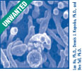

Campylobacter Clostridium Clostridium Escherichia coli O157:H7
jejuni botulinum perfringens (aka E. coli 0157:H7)

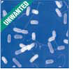
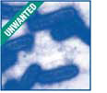
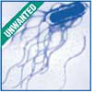

Listeria Salmonella Salmonella Shigella
monocytogenes Enteritidis Typhimurium

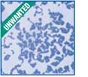
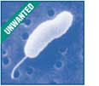

Staphylococcus Vibrio cholera Vibrio vulnificus Yersinia
aureus enterocolitica

BE ON THE LOOKOUT FOR ONE OF THESE CREEPY CRITTERS.
Below are some questions to help you develop a profile on your assigned “bad bug.”
BACTERIUM NAME (pathogen): __________________________________________
- What does it need to thrive?
- What are the foods/sources associated with it and possible contaminants?
- What is the implicated illness?
- What is the incubation period for the illness?
- What are the symptoms associated with the illness?
- What is the duration of the symptoms?
- What are the steps for prevention?
- Draw a picture or make a model of your bacterium.
- What is your bacterium's implication in the farm-to-table continuum?
(How does your bacterium spread? How can spreading be prevented at each step?)
farm processing transportation retail home (your table)

