Checking Your Understanding
Section 1: RFID Technology
- RFID stands for:
  - regular-frequency identification
  - radio-frequency identification
  - radio-frequency identification device
  - repetitive frequencies in devices
- Define the purpose of RFID technology.

- What are the advantages of RFID technology?

- Would you recommend this form of technology in the development of a pressure sensor intended for implantation in a human eye? Why or why not?

Section 2: Electromagnetic Waves and Sensor Structures
- Radio waves are:
  - sound waves
  - microwaves
  - infrared waves
  - electromagnetic waves
- Define electromagnetic waves and provide an example.

- How are electromagnetic waves detected? Provide at least one example.

The antenna receives _________ waves, which are electro_____________ waves. The antenna converts the energy from these waves into _______________ power.

- Looking at the radio below, fill in
the missing information.
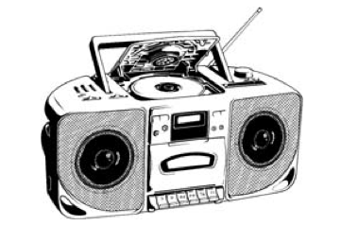

The speakers vibrate, which causes _____________ waves to form. These waves can be heard.

The dial tunes a radio to a specific _____________.
Each radio station has a specific _____________
so that we can hear different music.

- Which structure within a pressure sensor would best receive and transmit frequency signals?
  - the antenna
  - the RFID reader
  - the resonator
  - the RFID tag
- Which structure would best interpret and analyze the information within the tag of a pressure sensor?
- the antenna
- the RFID reader
- the resonator
- the RFID tag
- Which structure within the pressure sensor would best store information about pressure in the eyes?
- the antenna
- the RFID reader
- the resonator
- the RFID tag

