Solar Farm Cost-Benefit Analysis Worksheet Answer Key
Solar panels use energy from the sun to create electricity. The systems are called photovoltaic panels because they use semiconducting materials to convert photons (light) into electricity. Solar panels are considered dispatchable energy generators, which are electricity sources that can be turned on and off when needed. These forms of energy are easily inserted into the power grid as needed. Other forms of dispatchable energy include wind and natural gas. While not relied on for extended periods of time, they have the benefit of being able to produce electricity on short notice to supplement traditional means of electricity production.
One challenge to solar panel farms is the amount of land required. In this engineering analysis exercise, we will conduct a cost-benefit analysis for different solar farm scenarios that takes into consideration any ecosystem disruption impacts.
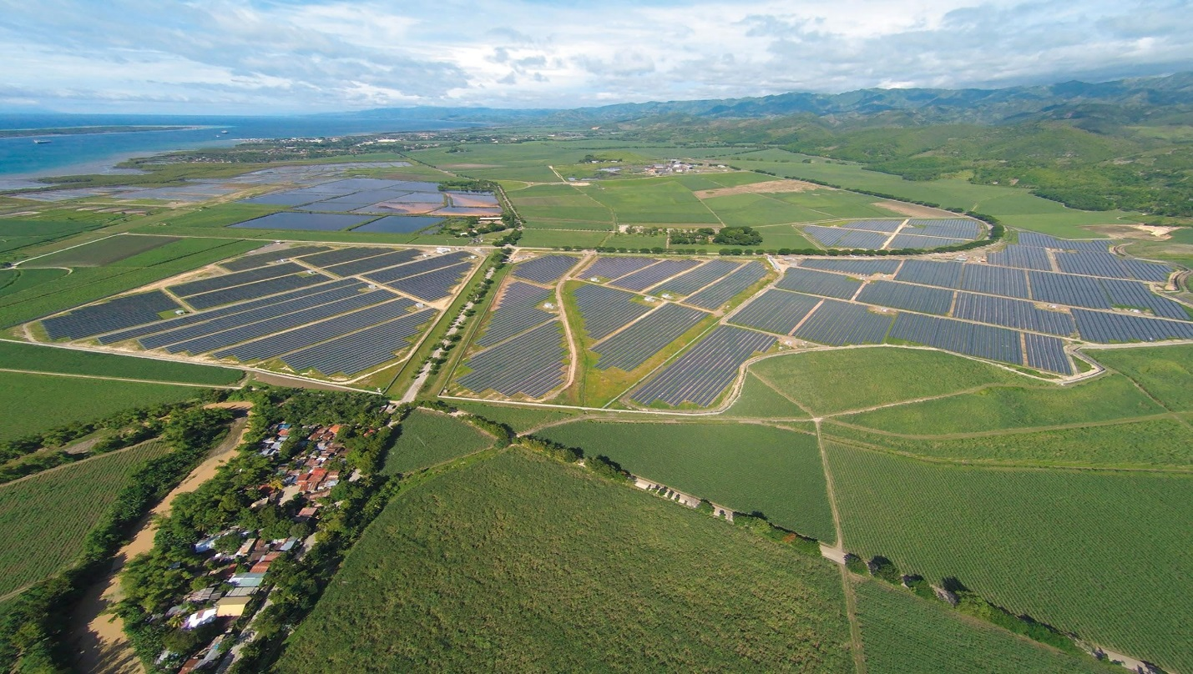

A solar farm in the Philippines. Photo source: 2015 Kanadaurlauber, Wikimedia Commons CC BY-SA 4.0
https://commons.wikimedia.org/wiki/File:San-Carlos-Solar-Energy-I-SaCaSol-I_Full-Area_1.jpg
Your engineering task: To design your own solar panel farm that meets the following constraints:
- You have at most 100 available plots to fill with solar panels (see grid below).
- Currently each plot is home to a family of sheep that supplies the local wool industry, which requires a $200 compensation to the rancher for each plot removed from raising sheep.
- You have at most $15,000 to spend.
- You must generate at least 400 watts of energy per day using any mix of two types of solar panels:
- The basic model costs $100 each and generates 7 watts of energy per day while occupying one plot, but it eliminates all plant growth due to the shade it creates, which displaces the sheep.
- The deluxe model costs $450 each and generates 13 watts of energy per day while occupying two plots, but it is elevated so that plants can survive under it, which means the sheep can remain.

On the grid below, mark with a “B” the plots that contain the basic model, a “D” those containing the deluxe model, and “X” those that remain undisturbed. Explain your reasoning and demonstrate your calculations of cost and energy produced.
Grid of available plots for solar panels:
*Expect a variety of responses above based on groups using different scales to quantify importance.
Analysis Questions
1. What are some other impacts that solar farms might have on ecosystems?
Solar farms might displace plants and species in an ecosystem, which could throw off the trophic levels (or food chains or feeding patterns) for other organisms. They could reduce the ability for photosynthesis to occur in an area of land by the removal of trees (which would shade the panels).
2. Brainstorm some potential design solutions to decrease the reliance on open land for solar panels.
Creative design might include placing solar panels on the tops/roofs of existing buildings; on the top panels of cars, trucks and trains; making them carport-like coverings in parking lots, and integrating them into the design of new structures, or maybe placing them vertically instead of horizontally.
3. Why are dispatchable energy sources beneficial as components of the electrical grid system?
They reduce our dependence on fossil fuels and traditional energy sources. They enable us to supplement when the supply of other energy resources is low. They give us more flexibility in electricity production to meet varying demand.
4. Consider your final product, which is a solar farm design. If you were real-world engineers, how would you go about conducting a comprehensive cost-benefit analysis for your final design? What specific information would you need?
Answers will vary, depending on team design choices.

