An example data logging experimental setup to determine the angular velocity of gears.
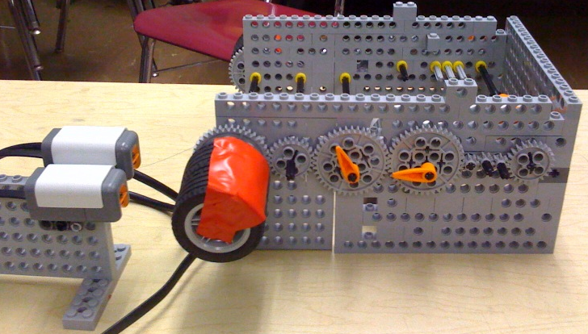

LEGO light sensor mounted
on a stand and aimed at
wheels with tape on them.
(only need 1 light sensor)

A LEGO structure to hold a gear train, which will be modified throughout the experimental testing.

