**C:\Program Files (x86)\Microsoft Office\MEDIA\CAGCAT10\j0293570.wmf Test-A-Beam Worksheet**

For each set of axes, plot the recorded data and connect each point in order. (NOTE: The units on the y-axis depend on calculated area moments of inertia values. The students are free to pencil mark the y-axis as they wish, as long as consistency in spacing and units is kept.)

Part 1: For different-sized wooden beams

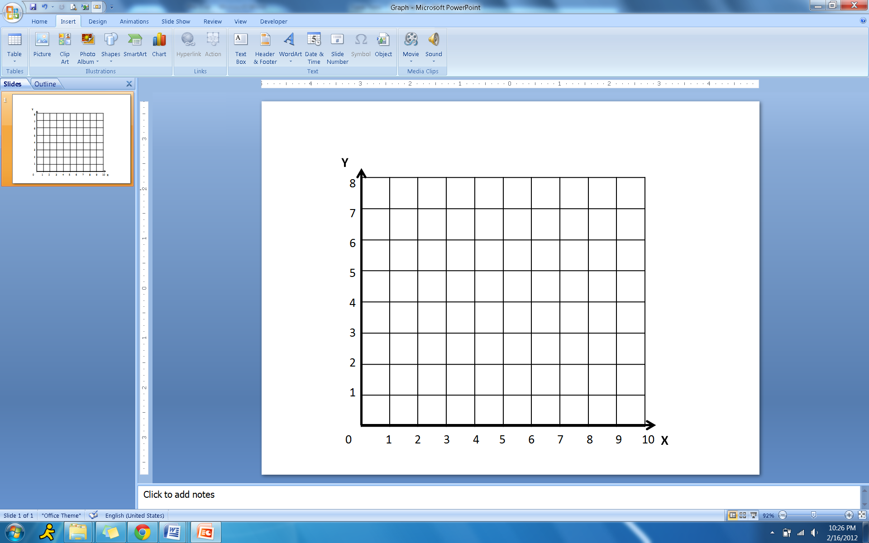

|  |  |  |
| --- | --- | --- |
| Beam number | Area Moment of Inertia (Y) in cm4 | Deflection (X) in cm |
| 1 |  |  |
| 2 |  |  |
| 3 |  |  |
|  |  |  |
|  |  |  |
|  |  |  |
|  |  |  |

For Part 2: Wooden beam and steel beam

|  |  |  |
| --- | --- | --- |
| Material Type | Area Moment of Inertia in cm4 | Deflection in cm |
| Wood |  |  |
| Steel |  |  |

**Comment:** How different are the area moment of inertia and deflection values for the two beams? Why do you think they are different?

**REFLECTION QUESTIONS**

1.) **The formula:**



**Is used for what kind of cross section? (Pick one.)**

a) Square b) Circular c) Triangular

2.) **What is the moment of inertia of the beam you were using?**

3.) **What defines a beam from any other basic structure?**

a) A beam must be strong, sturdy, and made of a hard material

b) A beam must be square in shape along its cross-section

c) The length of the beam must be several times longer than any of its cross-sectional dimensions.

**4.) As the area moment of inertia of a beam increases, the amount of deflection that the beam will allow:**

a) Decreases b) Increases c) Stays the same/Does not change

**5.) Calculate the deflection in the beam you were using given that the elastic modulus E=10000 psi (lb/in^2)?**

**6.) What kind of cross-section are any beams allowed to have?**

a) Square or rectangular cross-section

b) Any rounded cross-section

c) I-beam cross section

d) All of the above and more, depending on design