Activity Worksheet
In this activity, you will simulate a bungee jump for Washy at a height of 130 cm using a different number of rubber bands to determine the maximum length of the bungee cord, in order to give Washy a safe bungee jump with the most thrill, that is, a jump closest to the ground without hitting it.
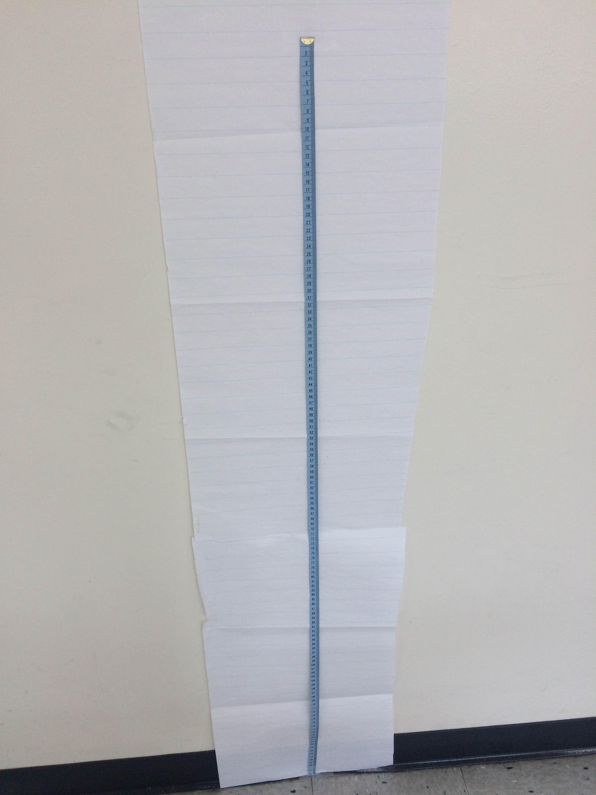
Before you perform the experiment, formulate a hypothesis:
I predict that the maximum number of
rubber bands that will enable Washy to
bungee jump safely at a height of 130 cm is ____________________.
Perform the following experiment to test your hypothesis.
Procedure
Test your hypothesis by dropping Washy at a height of 130 cm with different lengths of bungee cord.
- Tape a large piece of chart paper to the wall from the floor to a height of about 4.5 feet.
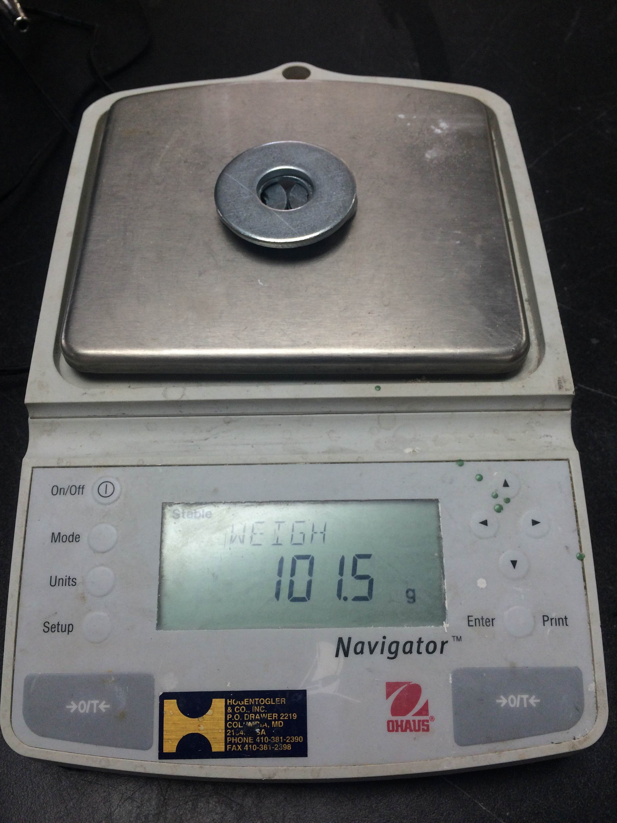
- Tape a measuring tape to the chart paper with 1 cm at the top and the other end on the floor. (See photo to the right.)
- Use a scale to weigh Washy. (See photo to the right.)
- If your scale measures in grams, convert the weight into kilograms by dividing by 1,000.
Example: 101.5 g / 1,000 = 0.1015 kg
- Record the weight in Table 2, located in the data collection section, below.
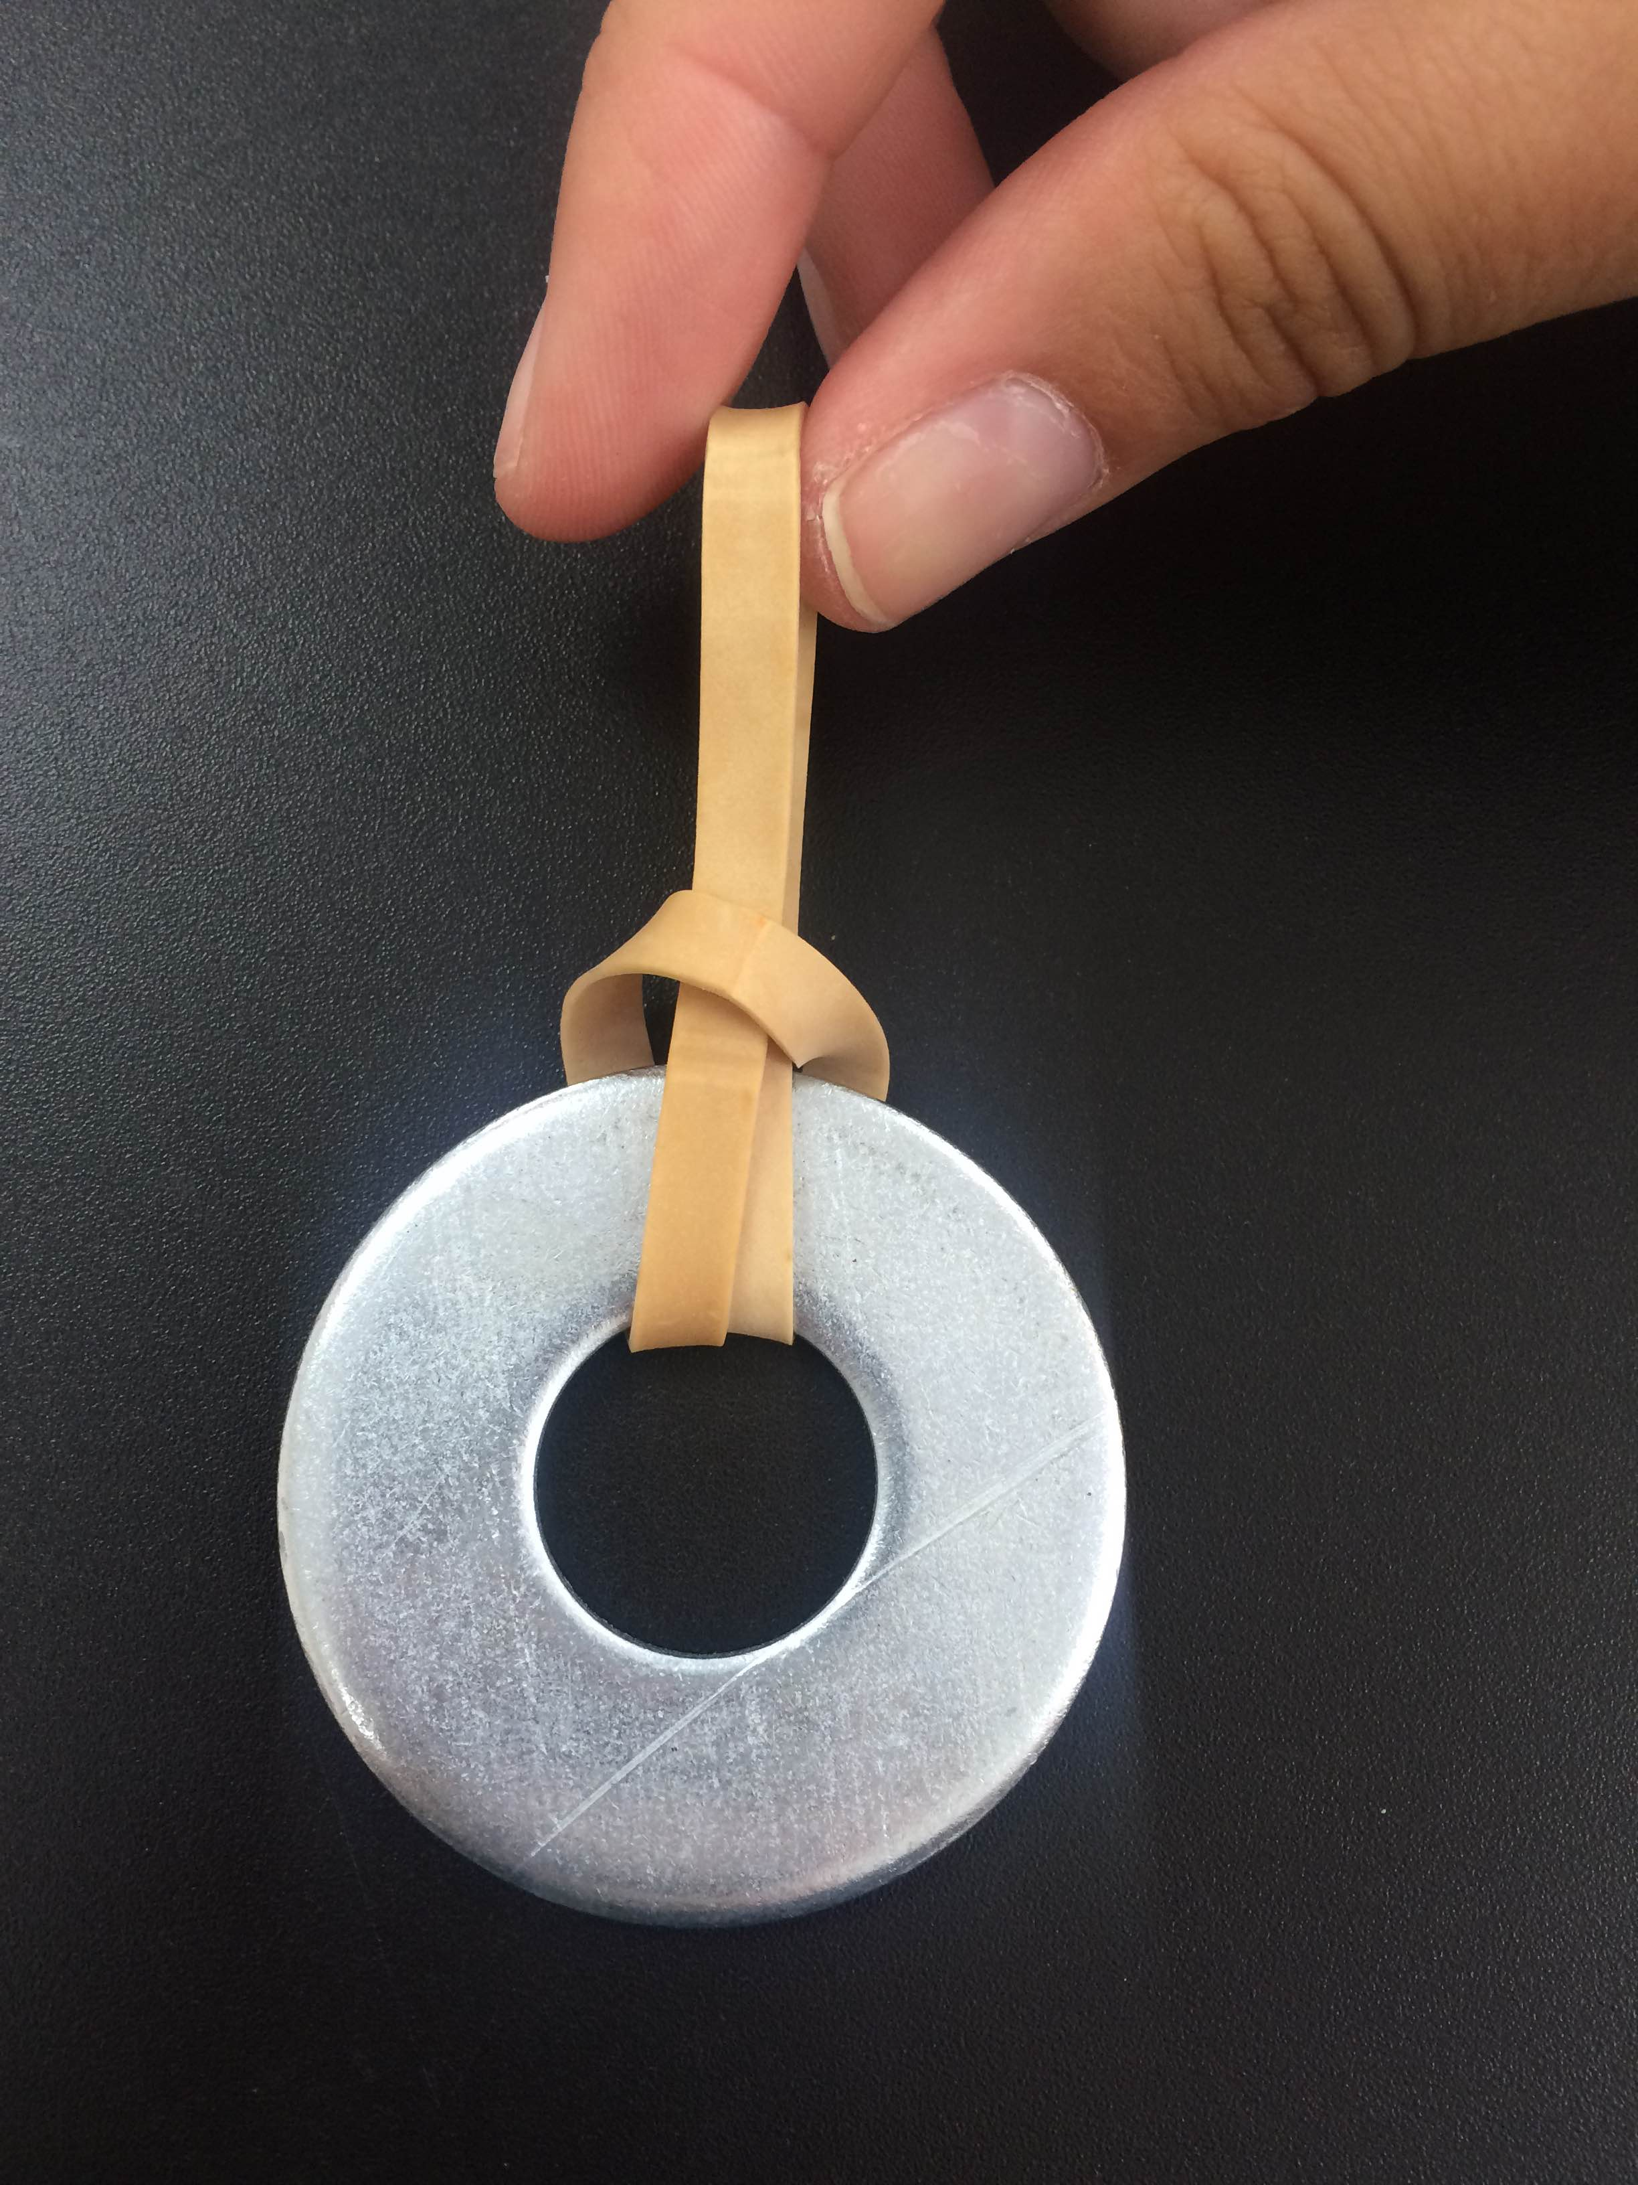
- Tie a rubber band to Washy by running it through the hole and then back through the rubber band loop. Pull it tightly. (See photo to the left.)
- Attach a second rubber band to Washy using the same method. (See photos below.) To help visualize this process, think of a Venn diagram. Create overlapping circles with the rubber bands and pull one through the other and then itself. Pull the rubber bands tightly.

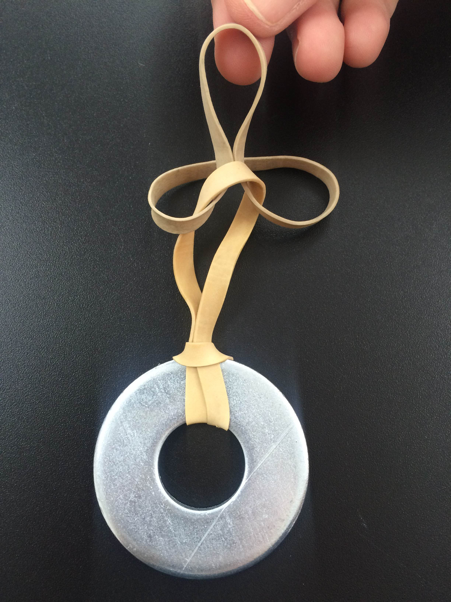
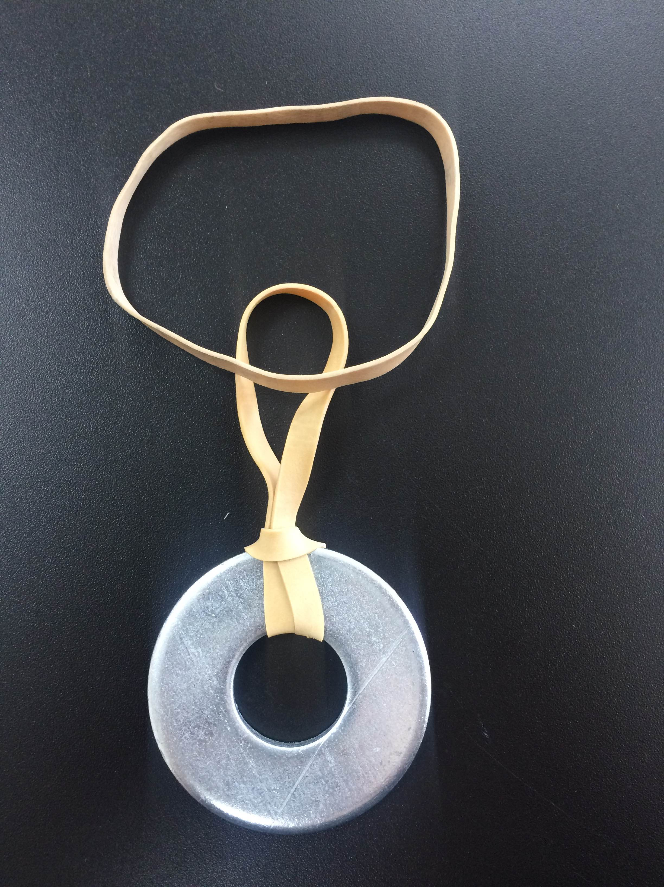
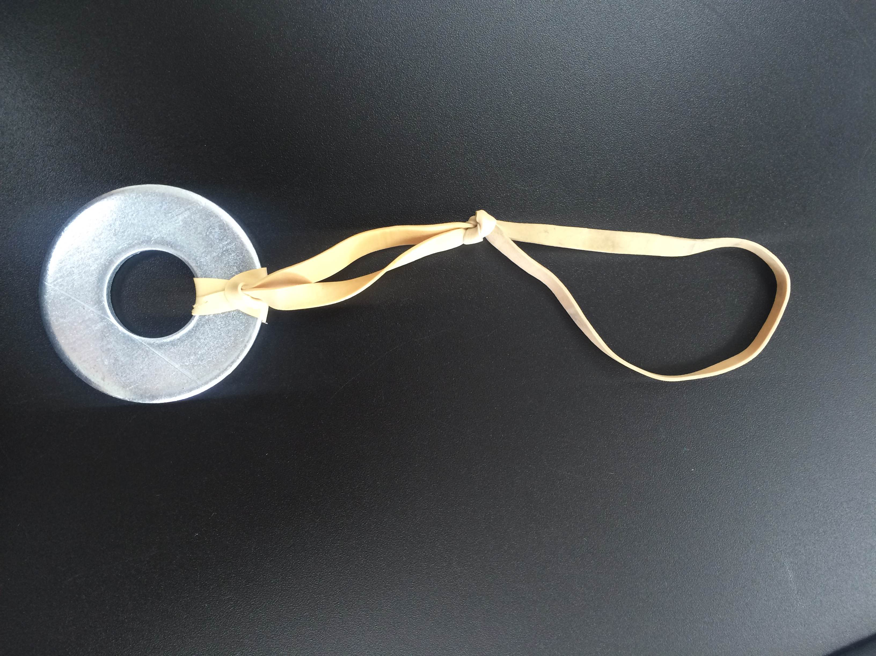

- With two rubber bands now attached to Washy, hold the end of the rubber band with one hand at the jump line (top of the measuring tape) and Washy with the other hand. Drop Washy from the jump line and have one of your groupmates mark the lowest point Washy reaches. If your partners do not agree on the lowest mark location, run several trials and find the average. Doing this provides you with more accurate data. Accuracy is very important, since Washy’s life depends on it! So even if your partners agree, run several trials for each number of rubber bands. (See photos below.)
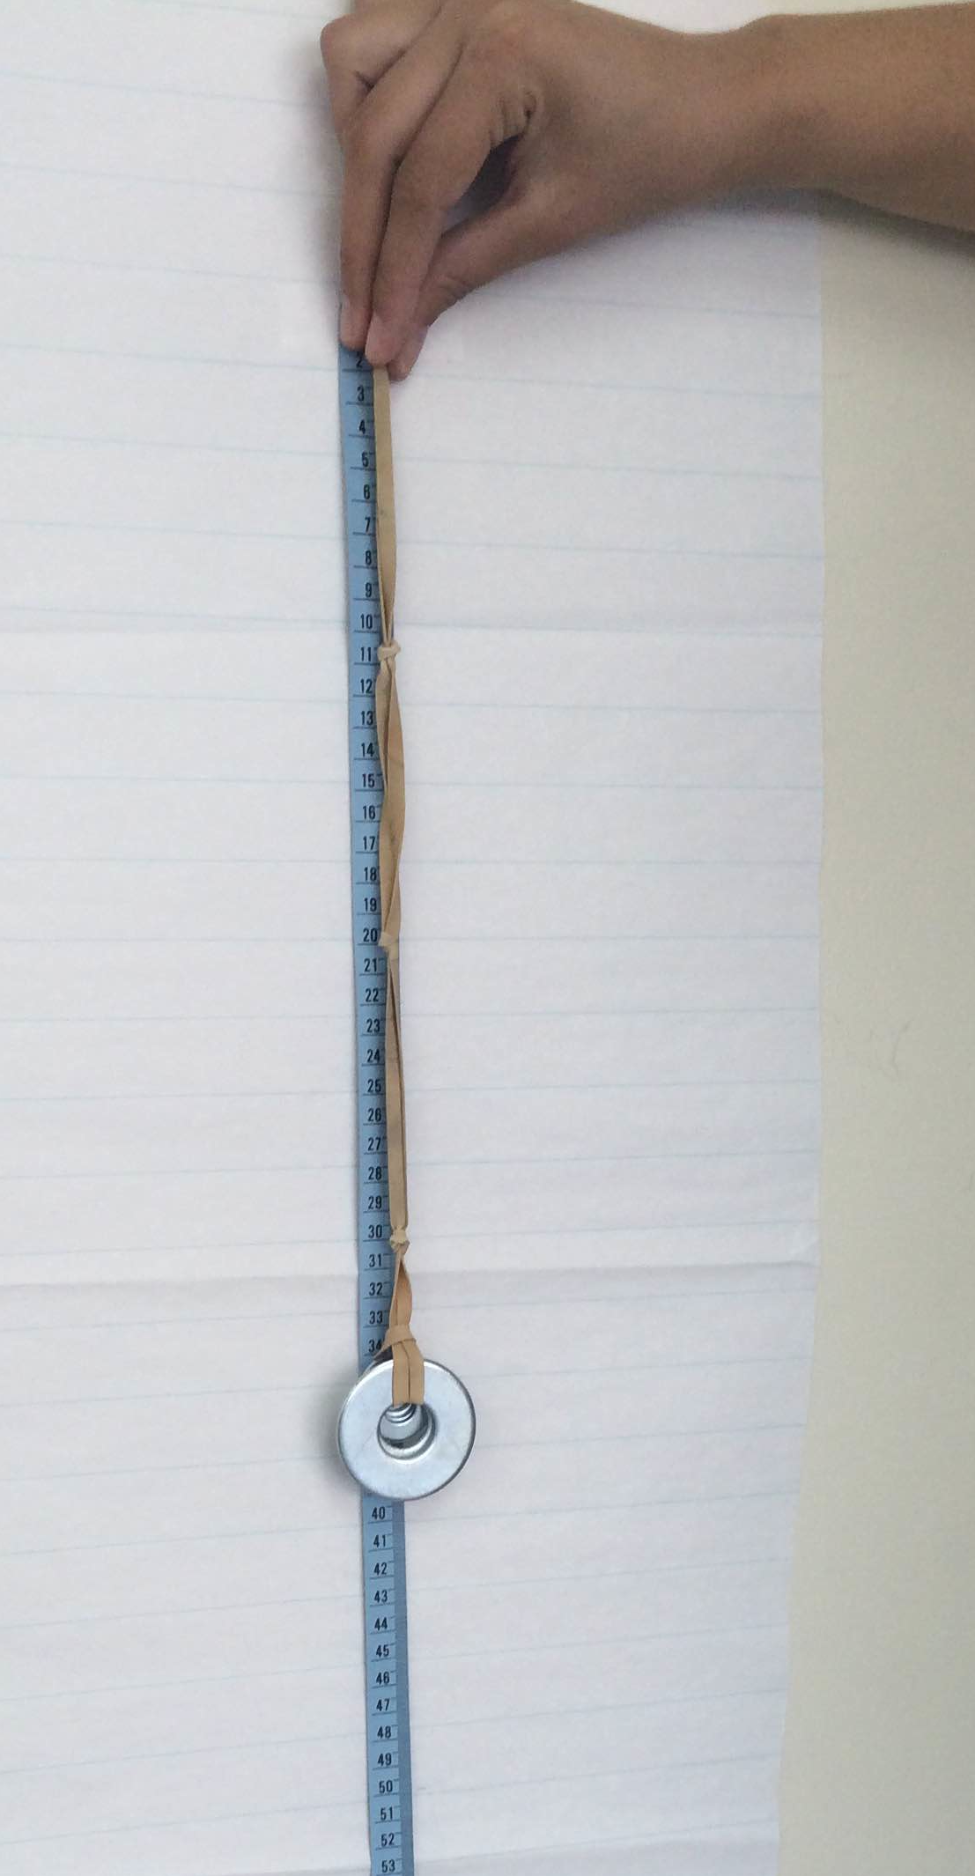

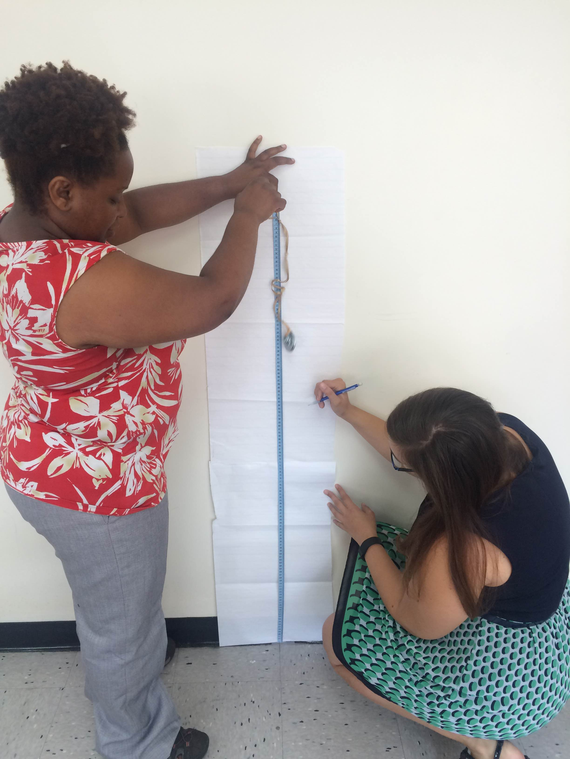
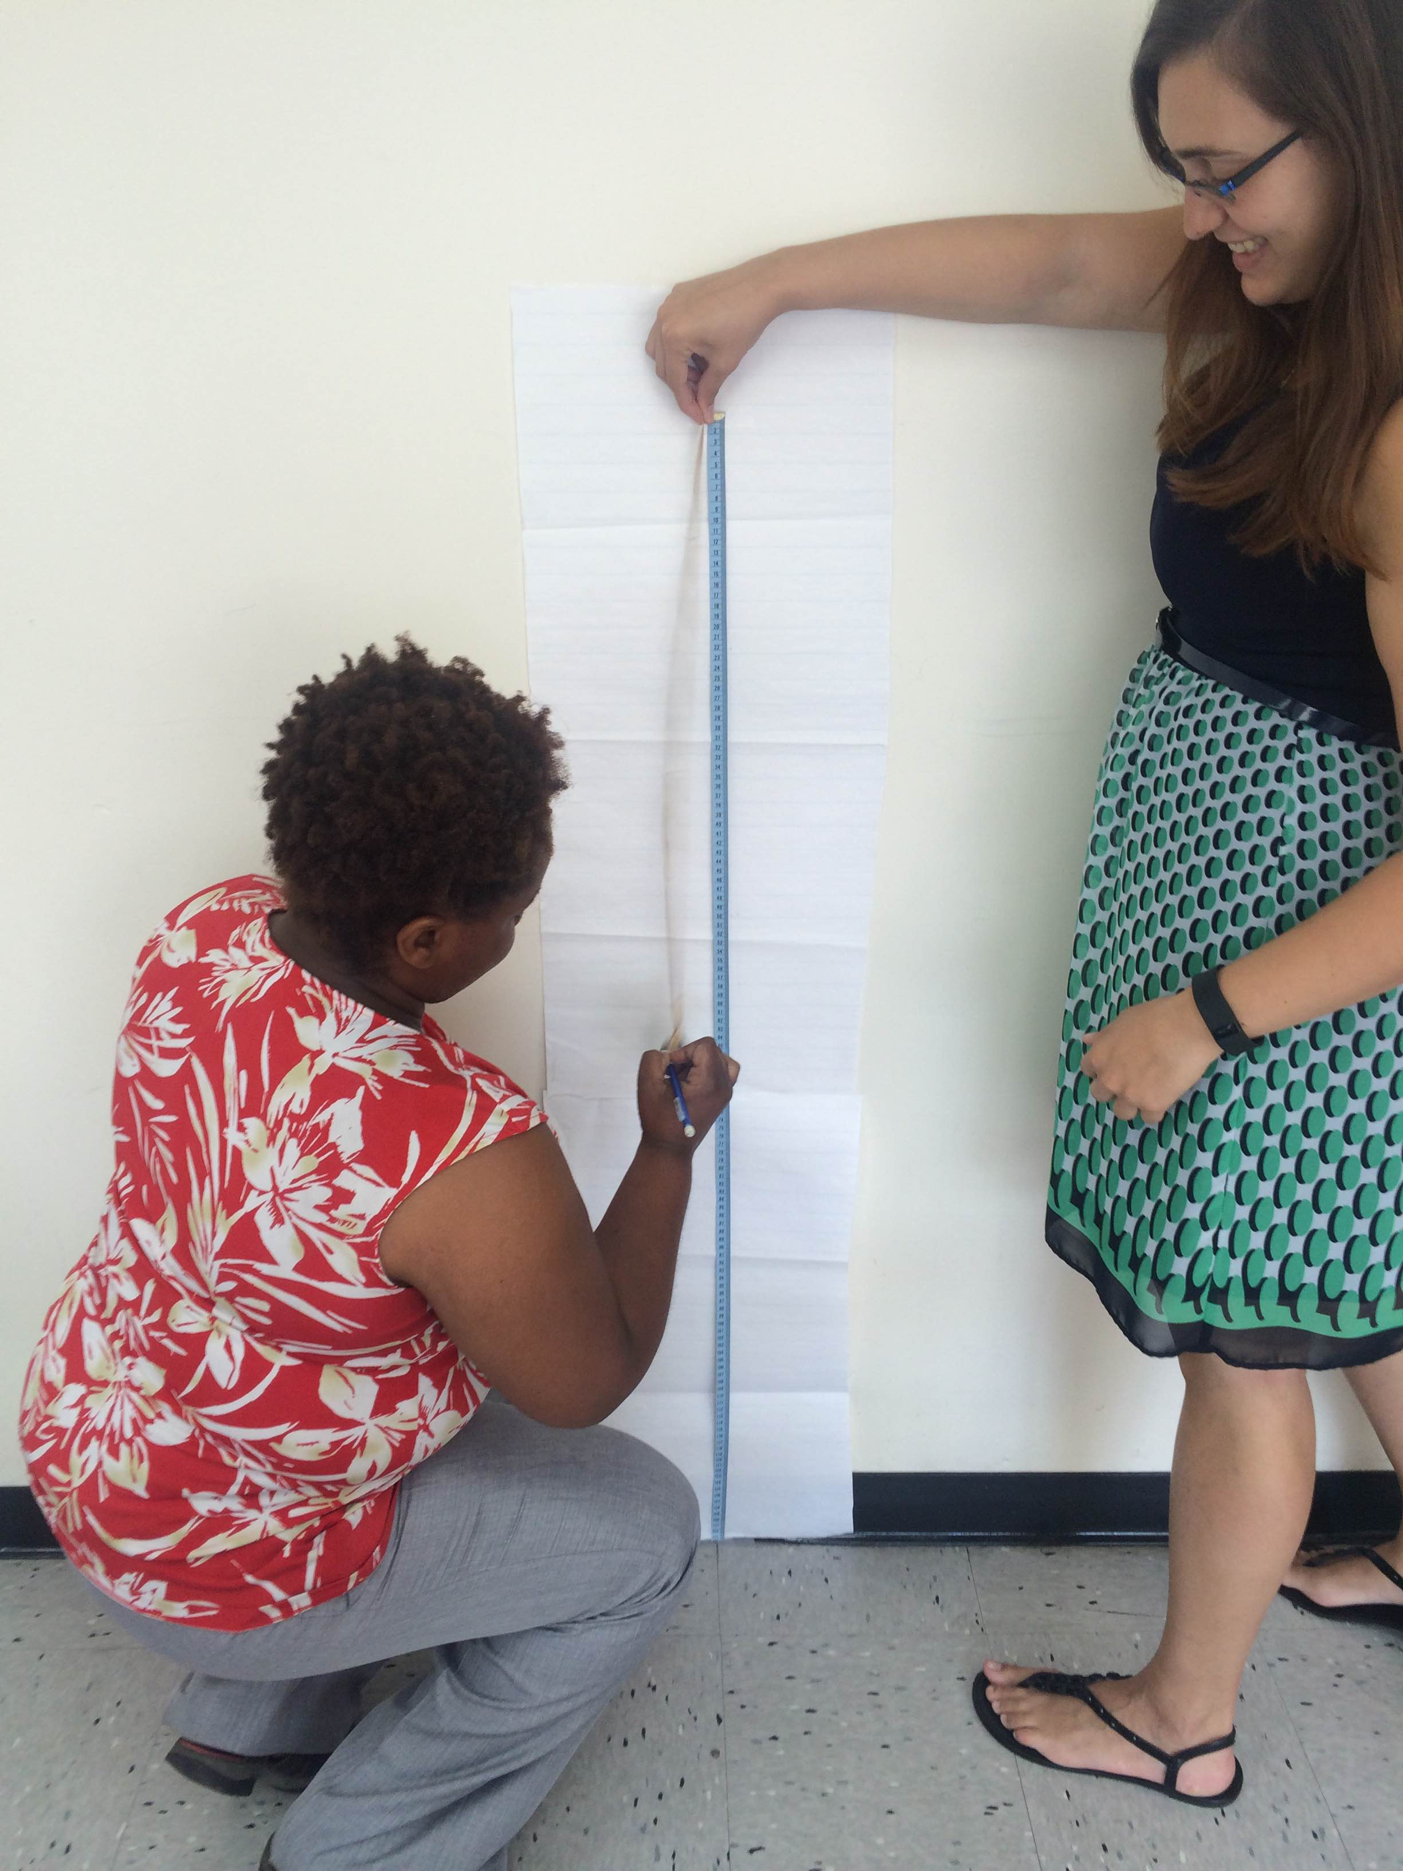

- Record the displacement in centimeters in Table 1, located in the data collection section, below.
- Add an additional rubber band and repeat the bungee jump. Remember to record your data in Table 1.
- Continue to add additional rubber bands until Washy hits the ground, recording your data as you run each trial.
- Calculate the force using weight x gravity and record it in Table 2 for each trial. Gravity, defined as g, is 9.81 m/s².
- Convert the displacement for each trial from centimeters into meters by dividing by 1,000.
Example: 22 cm / 1000 = 0.022 m
Then record your data in Table 2.
- Calculate the spring constant using Hooke’s law for the various forces and displacements. Record your results in Table 2. Note: Hooke’s law is given in Table 2.
- Find the absolute value for the spring constant. This enables you to analyze the relationship between the spring constant and the displacement for each trial. Note: Since we are not changing the weight; the force remains the same.

Data Collection
Table 1
Number of Rubber Bands  (x-values for Table 1) | Displacement (cm)  (y-values for Table 1)
2
3
4
5
6
7
8
9
10
11
12
Table 2
# Rubber Bands | Weight (kg) | Force (N)  Force =  weight * gravity | Displacement (m)  (x-values for  Table 2) | Hooke’s law:  spring constant (N/m)  F_{Spring} = - k * x | Absolute Value of Spring Constant  (y-values of Table 2)
Example: 2 | 0.1015 kg | F = W*g  = (0.1015 kg)*(9.81 m/s²)  = 0.9957 N | 22 cm  >  0.022 m | F_{Spring} = -k * x  0.9957 N= -k (0.022m)  0.022m 0.022 m  45.26N/m = -k  -1 -1  k = - 45.26 N/m | |-45.26|  = 45.26  N/m
Note: The above example is to help you fill in the chart. Do not use the example in your scatter plot.
2 |  |  | >
3 |  |  | >
4 |  |  | >
5 |  |  | >
6 |  |  | >
7 |  |  | >
8 |  |  | >
9 |  |  | >
10 |  |  | >
11 |  |  | >
12 |  |  | >
*** Gravity, defined as g, is 9.81 m/s² ***
Scatter Plot for Table 1
To create a scatter plot for Table 1, plot the points of your data (above) by using the number of rubber bands for the x-values and displacement in centimeters as the y-values.
Scatter plots are a great way to show you if a correlation or relationship exists in the data.
Remember: When making a scatter plot, DO NOT CONNECT THE DATA POINTS!
- Create a title for the scatter plot.
- Label the x-axis and y-axis; include the units for each variable.
Question: Based on your data, what is a good scale for your x- axis and y-axis?
- Plot your data points in the grid below.

Questions
- What type of a correlation does your data represent between the number of rubber bands and displacement (jump distance)?

- Why do you think this type of correlation is present?

Line of Best Fit
A line of best fit is a straight line on a scatter plot that represents the data. The line may pass through all the points, some of the points or none of the points, depending on the scatter plot’s data. Creating a line of best fit enables you to predict values not displayed on the scatter plot using the linear equation from the line of best fit.
To create a line of best fit on your scatter plot (above), refer the examples below as a helpful resource. Once you create your line, check your answer with the teacher before moving to the next step.

Incorrect Line of Best Fit #1 Incorrect Line of Best Fit #2
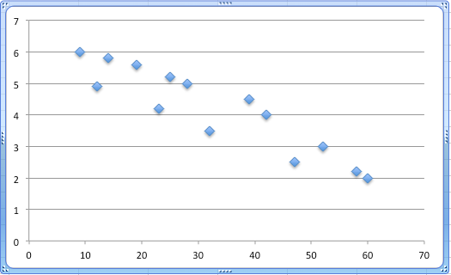

Although this line has approximately the same number of points below the line as above the line, this is not a good line of best fit because the slope of the line does not follow the trend of the data points.
Although this straight line goes through numerous points on the scatter plot, it is not a good example of a line of best fit because the line is below a majority of the points.

Correct Example of Line of Best Fit
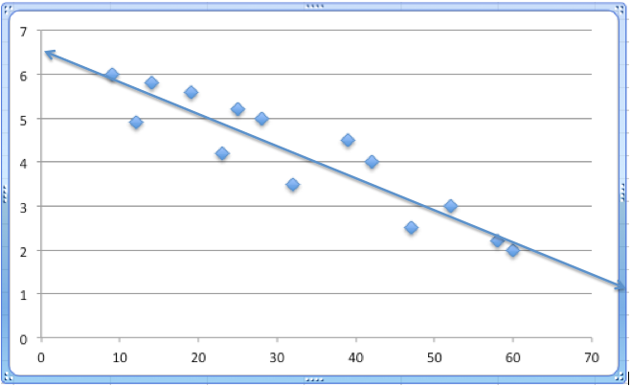

This is a great example of a line of best fit. The line is centered within the data points and the slope of the line follows the trend of the slope of the points.

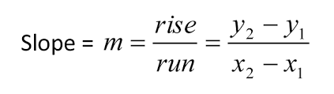
Slope and Equation of a Line
- Calculate the slope of the line of best fit. Recall:

- Determine the equation of the line of best fit using y = mx + b.

- What does the slope represent in this context?

- What is the y-intercept for your line of best fit?

- What does the y-intercept represent in this context?

Interpreting Data
- Based on your data, what was the maximum number of rubber bands that enabled Washy to bungee jump safely? What was the maximum displacement?

- Compare your result to your hypothesis. What prior knowledge did you have, or not have, that guided, or hindered, your ability to make a good hypothesis?

- Based on your line of best fit, predict the maximum number of rubber bands that would enable Washy to bungee jump safely from a height of 300 cm. Show your work.

- Are your predictions reliable? As you justify your answer, consider the methods used to collect, record and plot data.

- Do you think the type and/or width of the rubber band affects the results? How would it?

- Do you think the age of the rubber bands affects the results? That is, what would happen if old rubber bands were used?

Scatter Plot for Table 2
To create a scatter plot for Table 2, plot the points of your data (above) by using displacement in meters for the x-values and the absolute value of the spring constant as the y-values.
Remember: When making a scatter plot, DO NOT CONNECT THE POINTS!
- Create a title for your scatter plot.
- Label the x-axis and y-axis; include the units for each variable.
Question: Based on your data, what is a good scale for your x- axis and y-axis?
- Plot your data points in the grid below.

Questions
- What type of a correlation does your data represent between displacement and the absolute value of the spring constant?

- Why do you think this type of correlation is present? Note: Consider Hooke’s law and the fact that the force did not change in the experiment.

