Design Challenge & Experiment Worksheet
Design Challenge
Tom, a truck driver, was transporting 500 gallons of petroleum oil from New Jersey to New York. After driving for a long period of time, he felt exhausted and accidentally hit the divider on the side of the highway and the truck flipped over spilling oil all across the highway. Luckily, Tom only suffered some minor injuries. You, as young engineers and scientists, are asked to help the city of New York find the most affordable and environmentally friendly way to clean up the oil spill.
Hint: Sand is often used to clean up oil spills by taking advantage of the process of capillary action.
Team Task: Each team receives $300. Your task is to design and build a model to investigate which sand type has the greatest capillary action that would make it the best sand to be used for oil cleanup. Purchase materials of your choice from the 21st Century Engineering Design Shop (see Table 1). Make sure your structure will work to conduct a controlled experiment and make measurements of the rate of capillary action.
- In diagram form, sketch with your team your initial design ideas for how to test and measure the capillary action for different sand types: course, medium, fine and mixed. Refer to the inventory list (Table 1 on the next page) for available materials and their costs, and use the expenditure chart (Table 2 on the page after Table 1) to guide your planning.
- Draw your team’s agreed-upon final engineering design sketch in the box below.
DESIGN SKETCH

- Next, conduct a controlled experiment using your design.
- Record your data in Table 3.

Table 1. Available inventory at the 21st Century Engineering Design Shop.
Materials | Retail Price
One-time application of silicon sealant | $40
One-time application of Elmer’s Glue | $20
8 inches of Teflon tape | $40
8 inches of scotch tape | $20
8 inches of masking tape | $30
8 inches of double-sided masking tape | $50
12 inches of string | $10
Soft bath sponge | $40
Cotton pads | $30
4x4 wire mesh | $20
Clear plastic cup (8 oz) | $40
Clear plastic cup (16 oz) | $50
Styrofoam cup (4 oz) | $10
Styrofoam cup (8 oz) | $20
Plastic drinking straw | $10
Pipe cleaner | $10
Popsicle stick | $10
Poland spring empty water bottle (8 oz) | $50
Poland spring empty water bottle (16.9 oz) | $60
Empty soda bottle (2 liters) | $70
Clear plastic round food container with lid (16 oz) | $80
Clear plastic round food container with lid (32 oz) | $100

Table 2. Expenditure chart.
Materials | Price/Unit | Quantity | Total Price
Total Expenses |  |  | $_______/$ 300

Table 3. Data chart of rate of capillary action in sand.
Time  (seconds) | Water Level Rise (cm)
 | Coarse Sand | Medium Sand | Fine Sand | Mixed
0
10
20
30
40
50
60
70
80
90
100
110
120
130
140
150
160
170
180

- Using the data in Table 3, make a line graph on the grid below.
Remember to title the graph, label the axes, and provide a key.
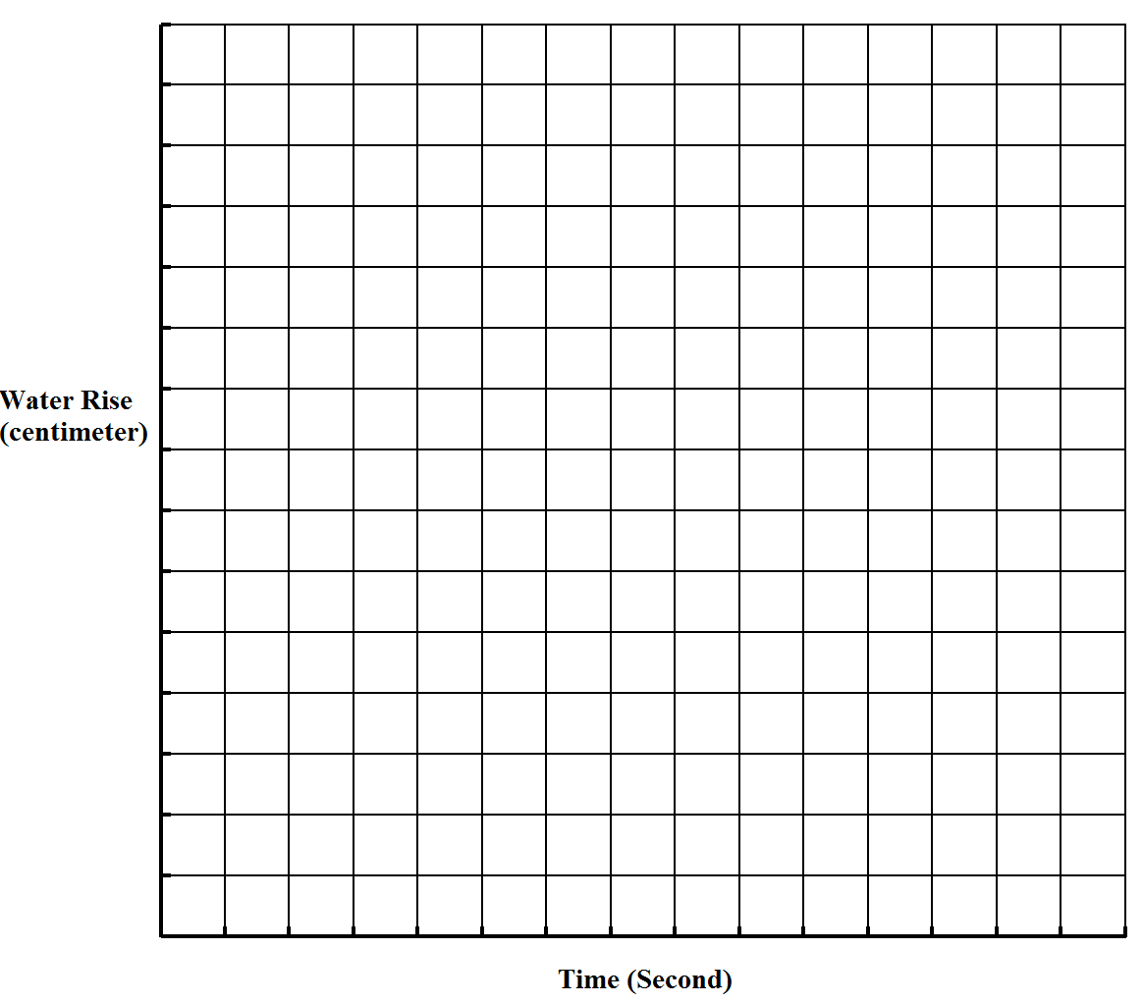
Time (seconds)
Water Rise (cm)

- Formulate a conclusion based on your data. Which type of sand has the highest capillary rise? Which type of sand is the best choice for oil clean-up? Provide an explanation for your recommendation.

