Data Collection Worksheet
- What is the height, length and width of your elevator box? How is the string attached?

- Dimensions and Calculations:
A: What is the diameter of your wheel? What is the circumference? How many degrees are needed to raise the elevator box up one floor (six inches)? How many rotations is this?
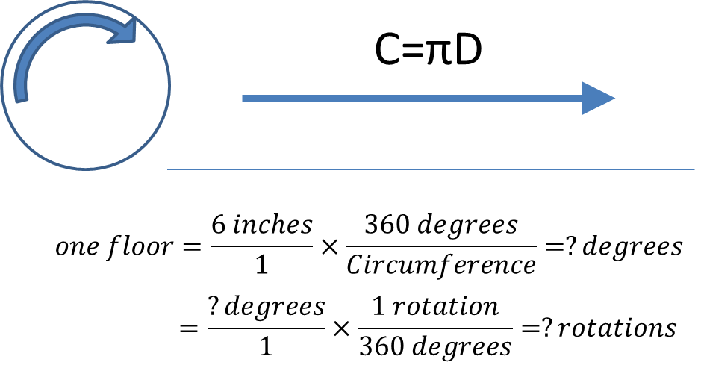
Dimensions | Value
diameter (in)
circumference (in)
degrees
rotations
B. Using a calculator, fill out the table below with the predicted and measured rotations.
Floor | Predicted  Height (in) | Degrees to  Get to Floor | Rotations to  Get to Floor
1 | 0
2 | 6
3 | 12
4 | 18
5 | 24
- Build an elevator box from the supplied materials and attach it to the elevator cable.
- Build the elevator motor according to the instructions handout or follow along with the teacher.
- Turn on the rotary encoder tool on the EV3.
- Measure the height of the floor and number of degrees and rotations it takes to reach that floor. Record these values in the table below.
Floor | Actual  Height (in) | Actual Degrees to Get to Floor | Actual Rotations | Percent  Difference
1 | 0
2 | 6
3 | 12
4 | 18
5 | 24
- Graph your results in the chart below.
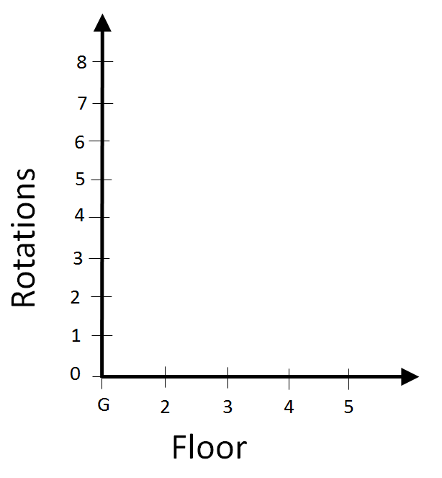

- Did all your passengers reach the top floor safely with the motor program?

- Estimate the degrees to get to the next floor. Turn on the elevator.c program on the LEGO EV3. To the nearest 30 degrees, use the gray buttons to enter in the predicted degree to get to the next floor. Calculate your predicted height. Press the elevator button. Measure the actual height and record the percent difference.
Floor | Predicted Degrees to Get to Floor | Predicted  Height (in) | Actual  Height (in) | Percent  Difference
6
- After measuring the top height again using the elevator.c program, what is the percent difference in this trial? What do you think about the percent difference? Is it acceptable for public use?

- What is the control device used to control elevators and escalators? How are they used by engineers to ensure public safety?

- In your own words, define the term calibration. How does it relate to rotary encoders and the activity you did today?

