Rotary Encoders & Human-Computer Interaction —
Encoder Worksheet – Sample

Class Demonstration: Prediction
- Turn on the LEGO MINDSTORMS EV3 device.
- From within the LEGO MINDSTORMS EV3 brick, turn on the rotaryencoderdisplay.c program.
- Select a target angle (from 0 to 360 degrees), and record this angle as your “Predicted Angle” in the table below.
- Turn the encoder wheel to this predicted value, and record the angle on the Intelligent Brick as the “Computer Angle.”
- Collect data for ten target angles.
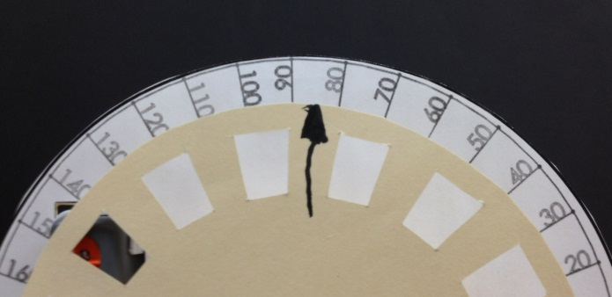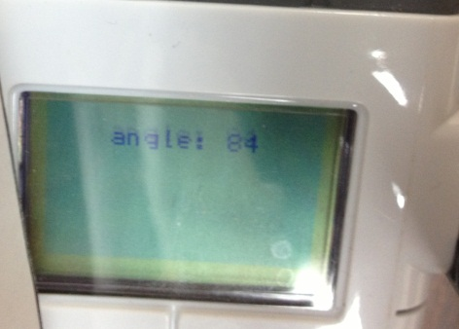

Predicted Angle | Computer Angle
27 | 30
54 | 54
81 | 84
108 | 108
135 | 132
162 | 162
189 | 192
216 | 216
243 | 240
270 | 270

- Select an angle from the table above where the predicted angle is close to 96 degrees. Write it in the table below.
Predicted Angle | Computer Angle
94 | 90

- Compute the percent error using the equation.
$$percent error=\left|\frac{(predicted angle-computer angle)}{computer angle}\right|×100\%$$
- Write your answer: 4.4%
- How do you think this percent error affects an actual engineering design?
A larger percent error generally is undesirable for a measurement. A lower percent
error represents a good measurement approximation of a physical quantity.
Engineering designs need accurate measurements to be reliable and function properly.
Discovery Phase
- Dissemble the computer ball mouse and draw what you see in the computer mouse in the box below. Identify and label the rotary encoder.

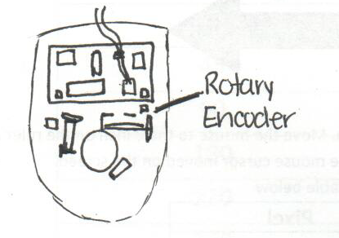

- Reassemble the mouse.
- Connect the mouse to a USB port on the laptop.
- Turn on a web browser and go to the website http://www.fossiltoys.com/pixel-screen-ruler.html
- This online ruler measures in units of pixel. Look at the ruler below, which measures in inches. Line up the mouse cord with the 0-inch mark on the ruler.

 | 0 | 1 | 2 | 3 | 4 | 5 | 6
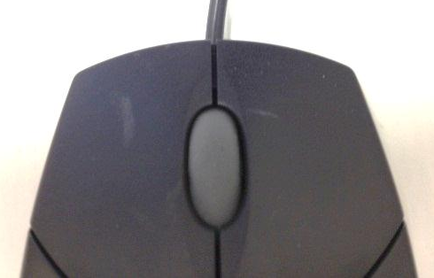
66 inches
- Move the mouse cursor to the 0-pixel location on the laptop screen; if necessary, move the worksheet so that the mouse is still located at the 0-inch on the ruler above. This may require several rearrangements to ensure that the mouse is at the 0 mark on both the worksheet and the laptop screen.
- Slide your mouse to the right, to the 1-inch position. Record the number of corresponding pixels that the mouse cursor moved on the screen.
- Repeat step 7 for the rest of the positions, and record the data in the table below.

Inches | Pixel
0 | 0 (sample only)
1 | 350
2 | 700
3 | 1050
4 | 1400
5 | 1750

- Graph the data in the box below. (Pixels vs. Inches). Be sure to label your x- and y-axes.
