Rotary Encoders & Human-Computer Interaction —
Pre-Activity Worksheet – ANSWERS
- Do you know what a rotary encoder is? If so, please explain what a rotary encoder is as best you can.
Yes, a rotary encoder is an electro-mechanical device that converts the angular motion of an axle to an analog or digital code.

- Have you ever used a rotary encoder? List some examples of devices that have rotary encoders:
Yes. Elevators, computer mouse, escalators, electric wheelchairs, wind turbines, etc.
- How familiar are you with the topic of angles? Rate from 1 (not familiar) to 10 (very familiar) __10__
- What do you think is the angle shown in each picture? (Write the answer in degrees.)
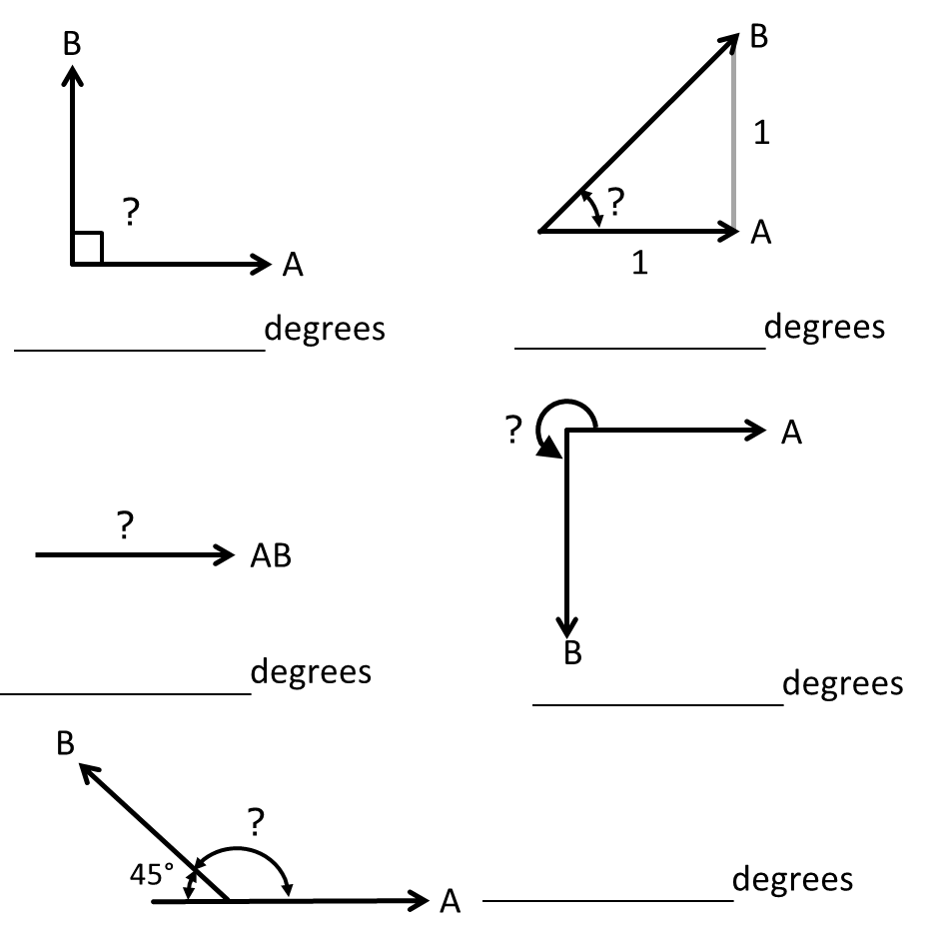
45
90
135
270
0 or 360

