Fat Chemistry Worksheet
The properties of oils used in common foods can be examined through science!
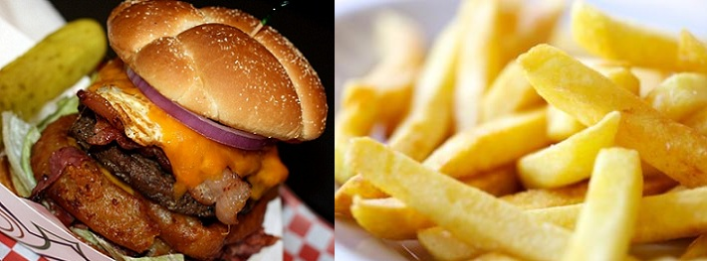

Today we will be learning about the properties of different edible fats. You will design a robot that can measure the melting point of different fat samples. Use this worksheet to collect and organize your melting point data.
Follow the instructions below to complete the measurements:
- Build and set up your robot, following the setup of the demonstration robot.
- Collect melting points of samples 1-9.
- With the aid of your instructor, light your Bunsen burner and place it under your sample.
- With your group, insert the temperature sensor inside the sample and arrange it directly in front of the light sensor. Test one sample at a time by applying gentle heat to the bottom of the test tube.
- Heat until the robot indicates that the sample has reached its melting point.
- Record the melting point on this worksheet.
- Repeated these step for each of the seven samples.

Table 1: Fill in this table with the melting point for each sample. Also record any comments or observations on the sample during the experiment.
 | Sample | composition saturated/trans fat (%) | Melting point (⁰C) | Comments & observations
1 | Olive oil | 11
2 | Butter | 66
3 | Animal lard | 41
4 | Vegetable shortening | 100
5 | Frying fat | 50
6 | Corn oil | 14
7 | Canola oil | 7
8 | Soybean oil | 15
9 | Peanut oil | 18

Plot the melting point of these samples versus the saturated/trans fat content (in weight percent) below.

Use the space provided below to summarize the results of this exercise. Be sure to address the following questions:
- What did you learn about edible fats?
- Are all fats the same chemically or physically? In what ways do they differ?
- What kind of fat is most difficult for our bodies to process and digest? What physical property gives us insight into why it may be difficult for our bodies to process this fat?
- The human body has a temperature of 37 ⁰C. Which of the fat samples you tested today would be solid at this temperature?
- What trend did you observe from the data plotted in the chart? How is melting temperature related to percent composition of trans fat?
- How might the information you learned today help you make wise choices on what foods you eat?

