**Engineering Challenge Worksheet**

**Engineering Challenge:** *Design a gear set that will lift the provided weight the fastest*. From what we’ve observed in the demonstration, we know that a large gear attached to the motor and a smaller gear being driven can lift light objects very quickly, but suffers when trying to lift heavy objects. Conversely, a small gear on the motor and a large gear being driven lifts very slowly, but can lift very heavy objects.

1. First, **design your gear set**. From the chart below, choose which gears you will use, and indicate which one will be attached to the motor, and which will be driven.

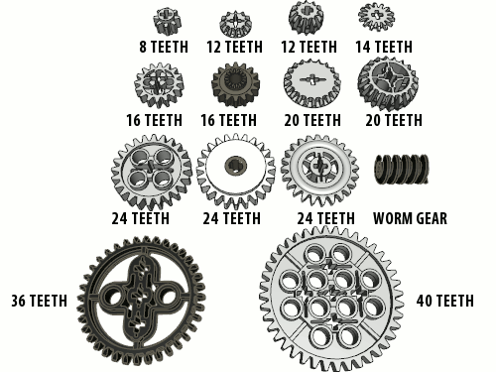

**Attached to motor (driver gear): ____________________**

**Driven by motor: ____________________**

**Gear ratio: ____________________**

**Time to lift binder weight: ____________________**

1. Next, implement your design and write a short performance summary. *If you were to revise your design, what would you change and why?*

__________________________________________________________________________________

__________________________________________________________________________________

__________________________________________________________________________________

1. Visit other groups and inspect their designs. *How do your classmates’ designs compare to yours?*

__________________________________________________________________________________

__________________________________________________________________________________

__________________________________________________________________________________