How to Pull Something Heavy Worksheet
Objective: Determine all the forces acting on the moving object.
Do now:
- What is the connection between the weight of the object and the force of friction?
Give an example or describe it using appropriate concepts and formulas.
The magnitude of force of friction experienced by the moving car on the chosen surface is given by F_{friction} = μ * F_{normal} = μ * W_{car}.
An example of the concept for a moving vehicle: the more weight the vehicle has, the more friction it will encounter during its motion.

- Draw a diagram showing all the forces acting on the car and the block.
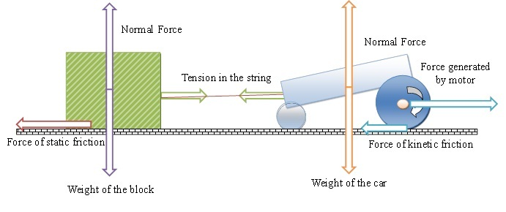

Lab instructions:
- Measure the mass of the vehicle using weight scales.
- Determine the weight of the vehicle.
- Determine the normal force that acts on the vehicle that rests on the solid surface.
- Determine the coefficient of kinetic friction for the solid surface.
- Calculate the force of friction on the moving vehicle.
- Using a Newton spring scale, measure the pulling force of the moving car on a given surface.
- Calculate the force generated by the motor.
(Fill in the table on the next page.)

Data collection: Show all work (that is, derivations, equtions, reasoning).
 | Show Calculations Below | Final Value | Units
mass of the car  1 | Mass was measured on a 5kg weight scale.  Mass of the LEGO car was measured to be 169.2 g  169.2g = 0.1692 kg | 0.1692 | kg
weight of the car  2 | W_{car} = m_{car} * G_{earth}  = 0.1692(kg) * 9.81 (m/s²) = 1.66(N) | 1.66 | N
normal force  3 | The magnitude of a normal force follows from F_{normal} = W_{car} = 1.66(N). The direction of normal force is opposite to the force of gravity. | 1.66 | N
coefficient of kinetic friction for the surface  4 | We choose the coefficient of kinetic friction for rubber on dry concrete to be 0.6. | 0.6
force of friction on the moving car  5 | F_{friction} = μ_{kinetic} * Fnormal = 0.6 * 1.66 = 0.996 | 0.996 | N
pulling force of the moving car  6 | Reading off the force measurement on the spring scale. | 0.8 | N
force generated by the motor of the car  7 | F_{motor} = F_{pull} + F_{friction} = 0.8(N) + 0.996(N) ≈ 1.80 (N) | 1.80 | N
Analyze: Would the pulling force of the LEGO car be enough to pull over a wooden block that weighs 2 Newtons? Assume that the block rests on the same surface as the car.
We know that to pull over a wooden block that, in our case, rests on concrete, the following must hold:
F_{motor –} F_{wheelFriction >} F_{blockFriction}
F_{pull >} F_{blockFrictionr}
F_{pull >} μ_{StaticWoodConcrete *} N_{block}
F_{pull >} μ_{StaticWoodConcrete *} W_{block}
Coefficient of static friction between wood and concrete according to the coefficient table is equal to μ_{StaticWoodConcrete} = 0.62. Hence, to check if the car would be able to pull over a block, we need to check if above inequality holds, that is, if 0.8(N) > 0.62 * 2(N) = 1.24N holds true. Since 0.8N is not greater than 1.24N, the car will not be able to move the block from rest.

