Hot Chocolate Worksheet
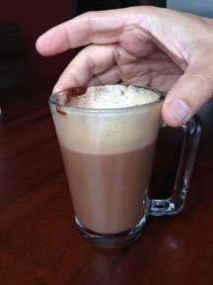
- Prediction: At what temperature would it be BEST to drink hot chocolate?
Make an estimate in ºC.

- Prediction: Assuming you start with boiling water (100 ºC), how long do you think it would take for hot chocolate to cool to that ideal drinking temperature?

- Why did you choose this time? What factors did you take into account?

- After receiving the boiling water, carefully mix the hot chocolate mix into the water. Don’t drink it! Be ready to use a thermometer to measure its temperature at the times listed in the table below. Record your data in the table.
Time After Mixing | Temperature (°C)
0 minutes
2 minutes
5 minutes
8 minutes
11 minutes
13 minutes

- Graph your data on the grid below.
100
80
Temperature (Cº)
60
40
20
2
5
8
11
13
Time after mixing (minutes)

- What do you notice about the graph? What do you wonder?

- How long did it take for the hot chocolate to reach the time you predicted? (It is okay to estimate an answer.)

Research shows that the optimal temperature to drink a hot beverage is 57 ºC.

- Write an exponential regression equation that models the temperature of the hot chocolate vs. time. Round each of your coefficients to the nearest thousandth.

- Find the correlation coefficient, rounding it to the nearest thousandth. Explain how well your regression models your data.

- Determine when, to the nearest second, the hot chocolate reaches 57 °C.

