Linear Equations Quiz
- What is the equation for the slope of a line?

- Identify the slope and y-intercept of Line 2, below.
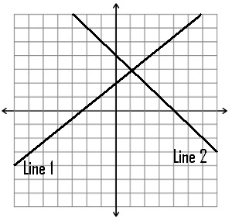
Line 2:

- Without solving, what do you think slope of Line 1 is? Explain your logic.

- If you were in the middle of an ice rink that has “perfect ice” (no friction),
how would you get off the ice rink? Explain your logic.

