A Chance at Monte Carlo Activity —
Monte Carlo Simulation Worksheet
Inscribed Circle
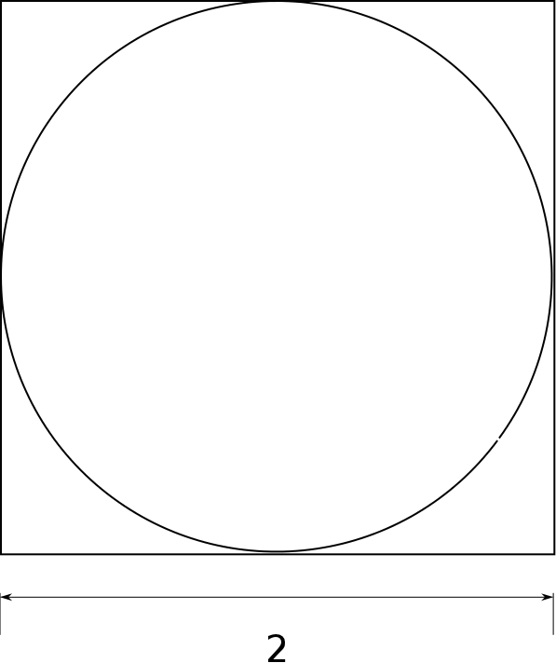 | Area of the square: ______________  Area of the circle: ______________  (hint: find radius first)  Ratio of areas (circle to square): _____________
Single Quadrant
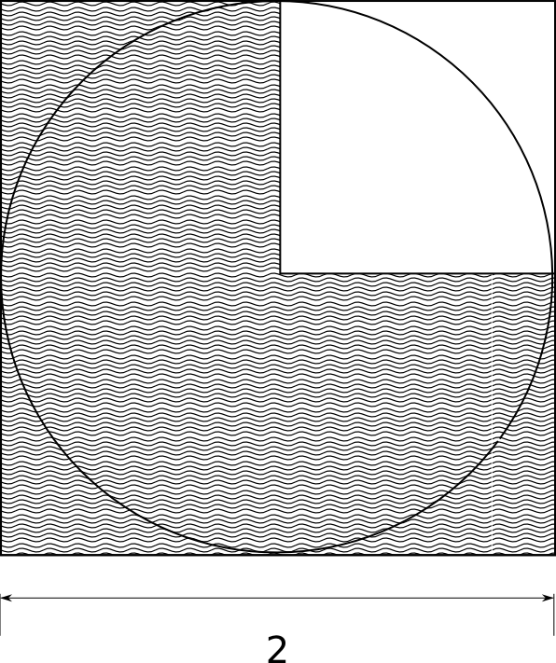 | Both the area of the square and the area of the circle are divided by four.  What is the area of the un-shaded square?  ______________  What is the area of the quarter circle wedge?  ______________  Is the ratio the same as before? (YES or NO)

Estimating the Area
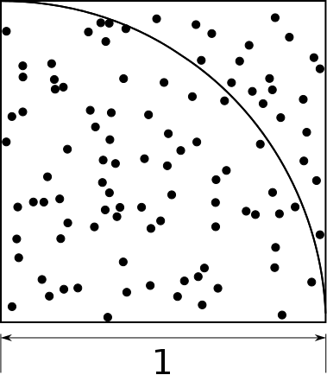 | Find the number of points inside the wedge versus the total number of points (100).  Hint: it may help to count the points outside; for example: N_{in} = 100 - N_{out}  ______________________  If 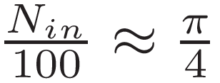, then 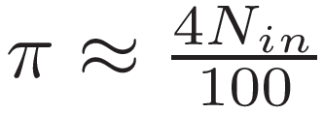  What is your estimate of π? ___________________
Collecting Data
- Use the EV3 program to collect five estimates of pi from 100 simulated points:
____________, ____________, ____________, ____________, ____________
- What is the average estimate 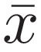: __________
- Below are two ways to evaluate the quality of the estimate. Since we already have a “gold standard” for pi, we can compute the percent error:
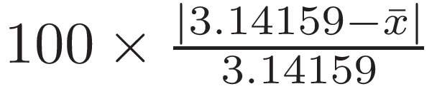
The standard error is a better measure of quality when we do not have a gold standard (when we estimate an unknown quantity). The standard error measures how widely the different estimates differ from the average.
What is the percent error? __________ What is the standard error? __________
- Reset the EV3 program to use 500 simulations.
____________, ____________, ____________, ____________, ____________
The average estimate is: __________
The percent error is: __________ The standard error is: __________________

- Repeat the experiment for 1000 and 4000 simulations.
1000 points | 4000 points
The average estimate is: __________  The percent error is: __________  The standard error is: __________ | The average estimate is: __________  The percent error is: __________  The standard error is: __________
Extra Credit
- Plot the estimation errors versus simulated points.
