Building a Stronger (Sweeter) New Orleans Activity —
Stress vs. Strain Worksheet

Directions
Use the following graph to answer questions 1-7.
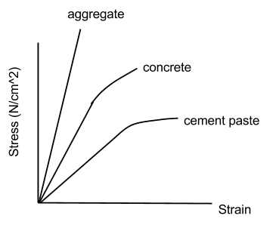
Questions
For each of the following questions, please use complete sentences and explain your answers.
- Research and explain the difference between aggregate, concrete and cement.

- Which of these is a composite material? Explain your answer.

- Which material has the largest value of Young's modulus? Explain.

- Which is the stiffer material? Explain.

- Which of the three materials would you prefer to use for building? Explain.

- The stress vs. strain curve for the cement flattens out at the end. Explain what this means.

- The sample of cement that was used to generate data for the graph above was 5 mm wide and 5 mm long. Imagine that you are given a sample that is wider and longer. Will the graph of stress vs. strain be different for this sample? Explain.

- You are given two unknown materials, labeled A and B. Material A has a Young's modulus of 1 N/cm² and material B has a Young's modulus of 2 N/cm². Each material is initially 4 cm long.
  - In the box below, sketch a graph of stress vs. strain for the two materials on the same set of axes.
- Which material compresses more if a pressure of 2 N/cm² is applied to it? Explain in words or show calculations to support your answer.

