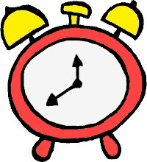
Robo-Clock Post-Assessment Answer Key

- A quarter past 6 PM is 6:15 PM
  - Would the minute hand on the clock move clockwise or
counter-clockwise? clockwise

  - How many degrees would the minute hand move? 90 degrees

- A quarter to 6 PM is 5:45 PM
  - How many degrees would the minute hand have to move from 6 PM to show the new time? In which direction? 270 degrees clockwise or 90 degrees counter-clockwise

- Half past 3 PM is 3:30 PM

- Half an hour to 3 PM is 2:30 PM

- How many minutes are in quarter of an hour? 15 minutes

- How many minutes in half of an hour? 30 minutes

- How many degrees make up 12 hours of the clock? 360 degrees

