Measuring Distance with Sound Waves Activity –
Distance and Time Worksheet – Answers

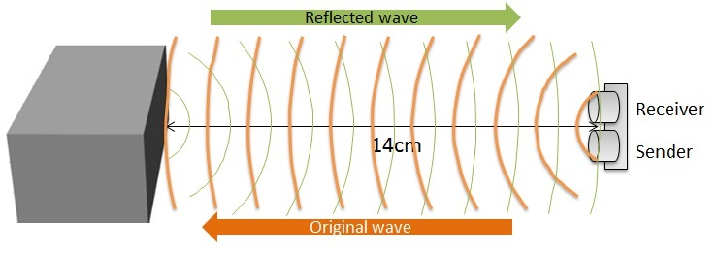
Part I: Distance and Time
- Look around and choose a stationary object.
- Turn on the LEGO® Ultrasonic sensor and obtain ultrasonic measurements in centimeters. Log that distance in Table 1.
- Take two more distance measurements and log them in Table 1, for a total of three measurements (Take 1, Take 2 and Take 3).
Table 1
Distance to object  Take 1 (in cm) | Distance to object Take 2 (in cm) | Distance to object  Take 3 (in cm) | Distance to object Average (in cm)
68 | 69 | 68 | 68.3
- Obtain the average of these three measurements and log it in the last column of Table 1.
- Convert the average measured distance to the object from Table 1 into meters, and log the conversion in Table 2.
- Ask your instructor for a value of the speed of sound at current classroom temperature and log it in Table 2.
- Calculate the time it takes for a sound wave to get from the sensor to the object (one way trip) using the distance formula. Log the calculation in Table 2.
- Calculate the time it takes for a sound wave to travel from the sensor to the object and back (round-trip). Log the calculation in Table 2.
- Convert the round-trip time of a sound wave from seconds into microseconds. Log the calculation in Table 2. Remember that $1 second=1 000 000 microseconds$ or $1 microsecond={10}^{-6} seconds$.

Table 2
Distance to object Average (meters) | Speed of sound (m/s) | Time to the object (s) | Round-trip time  (s) | Round-trip time (microseconds)
0.683 | 343.6 | 0.002 | 0.004 | 4000

Time to the object = Distance between ÷Speed of sound = 0.683(m)÷343.6 (m/s) = 0.002s
Time round-trip (s) = 2 * Time between = 2 * 0.002 (s) = 0.004 (s)
Time round-trip (microseconds) =
$$0.004 \left(s\right)* \frac{{10}^{6}\left(microseconds\right)}{1\left(s\right)}=4000 (microseconds)$$
Part II: Frequency
Recall that the frequency of a wave is defined as a number of cycles a wave completes in a second. For example, if the frequency of the wave is 10 Hz, then we can say that this wave completes 10 full cycles in 1 second. We also know that the wave completes 1 cycle in 0.1 seconds or 100,000 microseconds. We can figure this out by phrasing the problem as follows:
A wave competes 10 cycles in 1 second, hence 1 cycle is completed after x number of seconds.
Set up a proportion $\frac{10(cycles)}{1 (s)}=\frac{1 (cycle)}{x (s)},$ solve for x, and convert into microseconds to get the above result. Since it takes 100,000 microseconds for a wave to complete 1 cycle, then after 4,000,000 microseconds, the wave completes 40 cycles.
Questions
- How many cycles does the LEGO® Ultrasonic sensor wave make in 1 second? Note that the frequency of a LEGO Ultrasonic sensor wave is 40 000 Hz. 40,000 (cycles) The answer to this question is based on the definition of Hertz.
- Calculate the time it takes for LEGO Ultrasonic sensor wave to travel one cycle?
25 (microseconds) Note: methods of solving this question may vary. A wave competes 40000 cycles in 1 second, hence 1 cycle is completed after x number of seconds. Set up a proportion and solve for x.
$$\frac{40000 (cycles)}{1 (s)}=\frac{1 (cycle)}{x (s)}$$
$$x=\frac{1\left(s\right)*1\left(cycle\right)}{40000 \left(cycles\right)}$$
- How many cycles does the LEGO® Ultrasonic sensor wave go through, traveling from a sensor to the object and back? To answer this question, use the calculated round-trip time in Table 2.
160 (cycles) Note: methods of solving this question may vary. It takes 4000 microseconds for a wave to travel from LEGO Ultrasonic sensor to an object and back. In question 5 we discovered that it takes 25 microseconds for LEGO Ultrasonic wave to make 1 cycle. Hence,
$$4000 \left(microseconds\right)*\frac{1 \left(cycle\right)}{25 \left(microseconds\right)}=160 (cycles)$$

