LEGO® MINDSTORMS® NXT
Measurement Instructions

For the Science of Spring Force activity, there is no additional programming needed for the LEGO® MINDSTORMS® NXT brick. The necessary activity device is built by attaching an ultrasonic sensor onto the MINDSTORMS® NXT brick so that it points downward. An example of one setup is shown in Figure 1.

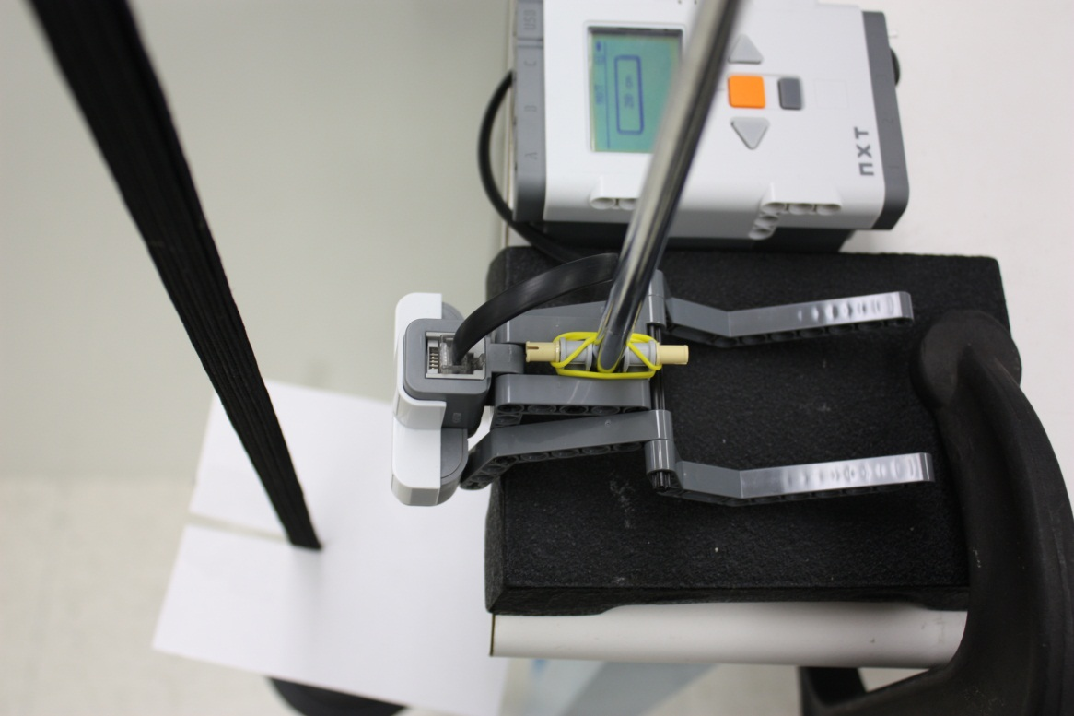
Figure 1: Alternate NXT sensor setup, with brick and attached ultrasonic sensor.
In order to view real-time measurements using the sensor and NXT, turn the NXT on using the orange button. At the start menu, use the grey arrow buttons to scroll to the “View” menu, as shown in Figure 2. Press the orange button to select the “View” submenu.

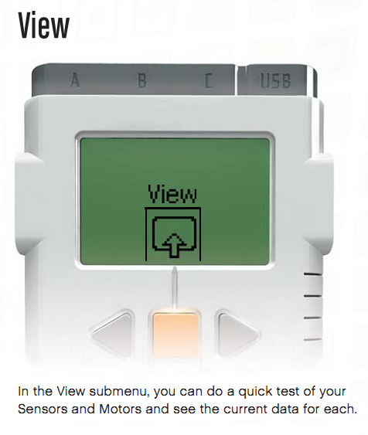
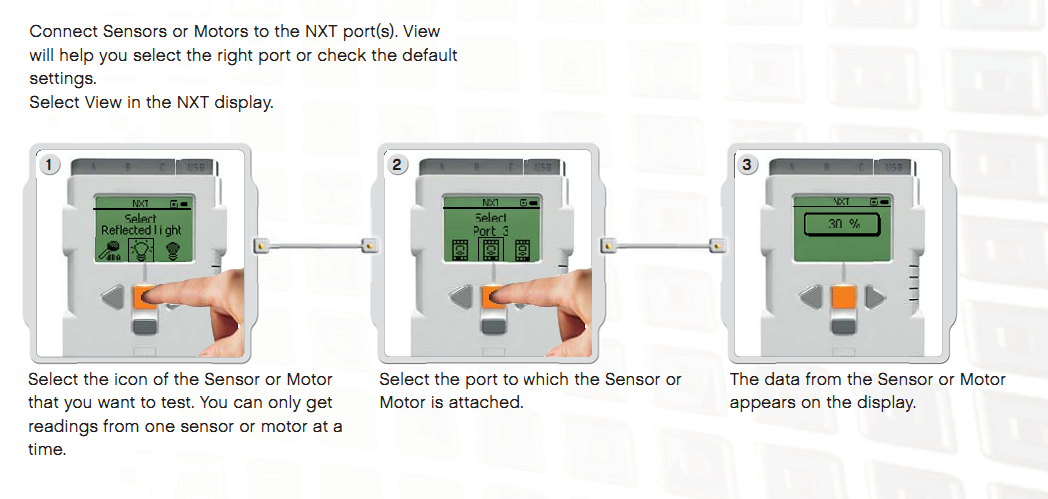
Figure 2: “View” menu introduction, taken from the LEGO® MINDSTORMS® NXT user guide.
In this submenu, scroll to “Ultrasonic cm” in order to view measurements using the ultrasonic sensor in centimeters. There is also an option named “Ultrasonic in,” which allows the user to view measurements in inches. However, smaller units have better measurement resolution, so for the purposes of this activity, use centimeters.

Next, as shown in Figure 2, select the port to which the sensor is connected. If it is not connected already, connect the ultrasonic sensor to one of the bottom sensor ports by using the black wires included in the kit. Make sure that the selected port corresponds to the port to which the sensor is physically connected.
Once this is done, the user should be able to read values measured by the NXT. Objects, preferably flat objects, can now be detected by the sensor, and the distance from the object to the sensor can be read out by the NXT. Make sure that the object is positioned directly above the sensor for a proper measurement.

To recap these instructions, view Figure 3.

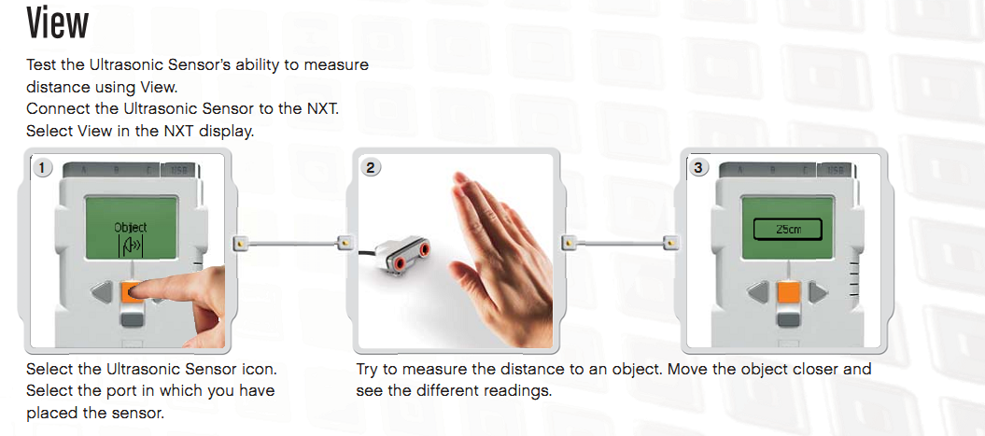
Figure 3: Ultrasonic sensor activation, as taken from the LEGO Mindstorms NXT user guide.

