Alternative fuel: Natural Gas Answer Key
Instructions: Read this webpage https://afdc.energy.gov/vehicles/natural_gas_emissions.html and then answer the questions below.

Natural Gas Vehicle Emissions:
What are the benefits of using natural gas vehicles?
Natural gas helps reduce some engine emissions.

Life Cycle Emissions and Petroleum Use:
What do CNG and LNG stand for?
CNG = compressed natural gas & LNG = liquified natural gas

What is the difference in emissions between CNG and LNG?
CNG and LNG are very similar, one difference is that CNG production uses less petroleum and emits fewer GHGs because compressing gas requires more energy than liquifying it.

What is RNG?
RNG = renewable natural gas

Use the GREET excel database to complete the chart below:
- Open this link: https://greet.es.anl.gov/greet_1_series
- Click the link underneath “GREET 1 Series (Fuel-Cycle Model) or this link GREET_2020rev1.zip
- Open the GREET folder
- Select “GREET1-2020”
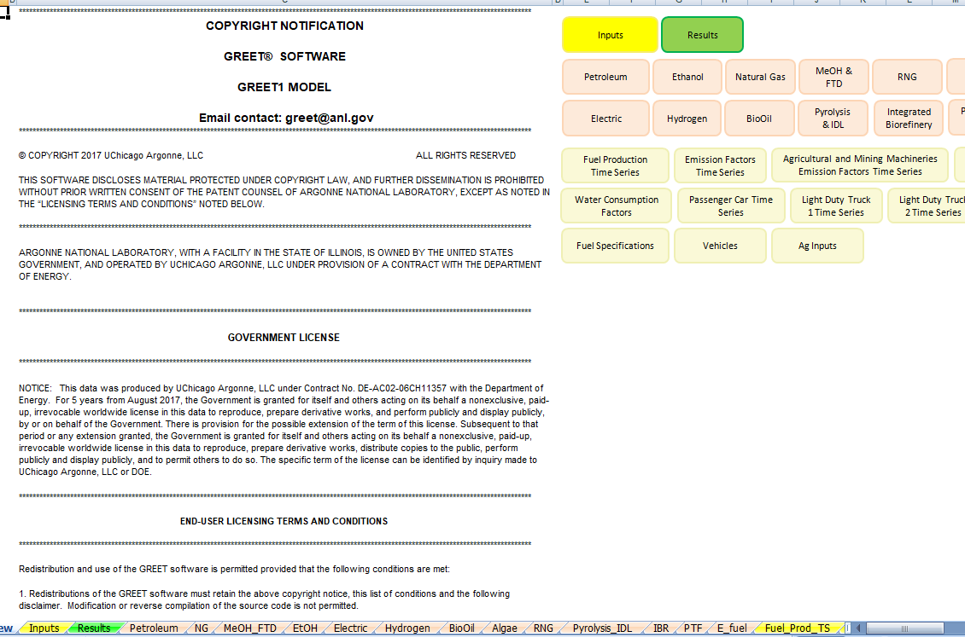

- To use the GREET database, you have to click on the tab at the bottom of the screen. Natural gas is abbreviated NG, so click the “NG” tab. The red arrow above is pointing to it.
- There is a lot of information on this database. Scroll all the way down to 4) Summary of Energy Consumption, Water Consumption, and Emissions. Record the data listed in table 4.1 for “Natural Gas as Stationary Fuels”. This table tells you the energy use, water consumption, and total emissions for what are the units? Each gallon of ethanol? (it says Btu or Grams per mmBtu of fuel)
- Because we are interested in reducing carbon emissions and climate change, you will be looking at the values for methane (CH4), carbon dioxide (CO2), and nitrous oxide (N2O). There are other variables in this chart, but we will focus just on these three. There is a red box around them in the table below.
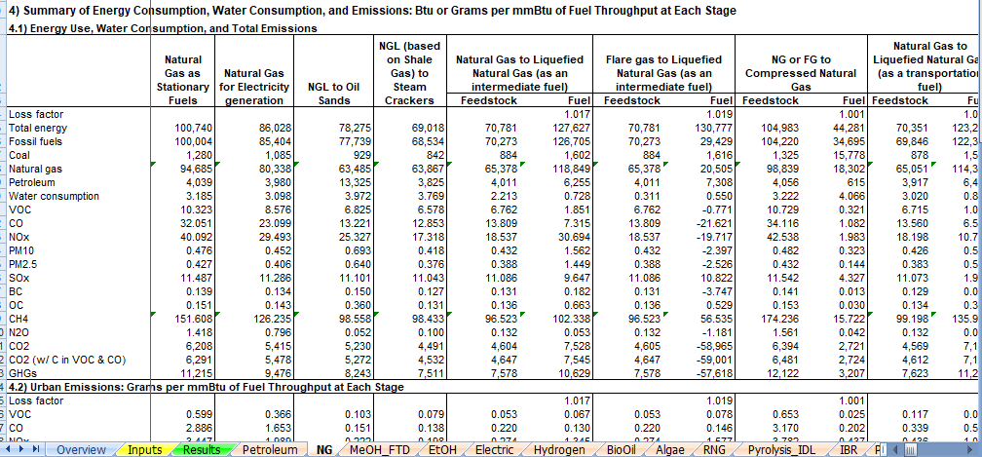

- Record the amount of CO2, N2O, CH4 in the emissions for the “Natural Gas as Stationary Fuels” in the table below. If you would like to move through the data table to see the other data that is collected, use the arrow that has the red circle around it in the picture above.

Natural Gas
Type of emission | Total amount of emission
CH₄ | 151.6
N₂O | 1.4
CO₂ | 6,208

The abbreviations in GREET are defined below:
VOC = volatile organic compounds
CO = carbon monoxide
NO_{X} = nitric oxide
PM10 = particulate matter with a diameter of 10 micrometers or less
PM2.5 = particulate matter with a diameter of 2.3 micrometers or less
SO_{X} = sulfur oxides
BC = black carbon (particulate matter/ soot & contributes to climate change)
OC = organic carbon (respiratory effects)
CH₄ = methane
N₂O = nitrous oxide
CO₂ = carbon dioxide

- In the table below, fill in the row for natural gas.
- When everyone is finished learning about the energy sources, share what you have learned with the group. Each individual should summarize the questions they answered and share the GREET emissions that were calculated. Notes should be taken in the table below so that the information can be shared with your poster group.
- Circle the energy source you will use to heat your building (remember that we are assuming that the technology for this will be in place) and complete the information below the table.
Answers will vary based on student presentations.
Energy Source | Information about energy source | GREET values
Ethanol
Electric
Biodiesel
Natural Gas
Propane
Hydrogen

Type of fuel that will be recommended for use in heating your building structure:
The expectation is that they will choose hydrogen, but it does depend on students’ presentations.

Evidence and reasoning for this recommendation:
Evidence used would be the low greenhouse gas emissions.

- Return to the “Energy Source” document and continue to step 2.

