Carbon Cycle Worksheet Answer Key

Group roles: There are three people in your expert group. Each member should choose one of the following roles to make sure your group works productively:
- Timer - keeps track of time and keeps the group work moving forward.
- Reader - reads the instructions and rubrics for the group.
- Ambassador - asks questions that the group is unsure of.

Instructions: As a team, watch this video (https://www.youtube.com/watch?v=jOht6qmuG-k) which introduces the human impact on the carbon cycle. Next read the information provided at this link (https://scied.ucar.edu/learning-zone/earth-system/biogeochemical-cycles) to learn about the carbon biogeochemical cycle and then individually answer the questions below. Once each team member has answered these questions, discuss your answers as a group. If needed, additional research links are provided at the bottom of this document.

- What is a biogeochemical cycle?
Biogeochemical cycles are the pathways a substance takes in the ecosystem as it moves between being in the environment, then being in a living thing, and then back to being in the environment.

- When does carbon move from a biotic factor to an abiotic factor?
One possible answer: Carbon moves from biotic to abiotic when organisms exhale as a result of cellular respiration.

- When does carbon move from an abiotic factor to a biotic factor?
Carbon moves from abiotic to biotic when plants take carbon dioxide in during cellular respiration.

- As a group, draw a picture of the carbon cycle. Each group member should contribute to the poster, for example: one member draws the images, one member writes the labels, one member draws the arrows. Arrows showing the movement of carbon in your poster should be drawn in brown. The poster should include:
- Label the following terms on your poster: photosynthesis, cellular respiration, carbon dioxide, glucose
- The following images need to be included on your poster: plants, animals, sun (please add more images as you see fit)
- Identify carbon moving from a biotic factor to an abiotic factor
- Identify carbon moving from an abiotic factor to a biotic factor
- Include pictures and labels for at least three ways humans impact this cycle
- Brown arrows showing the flow of carbon in the cycle

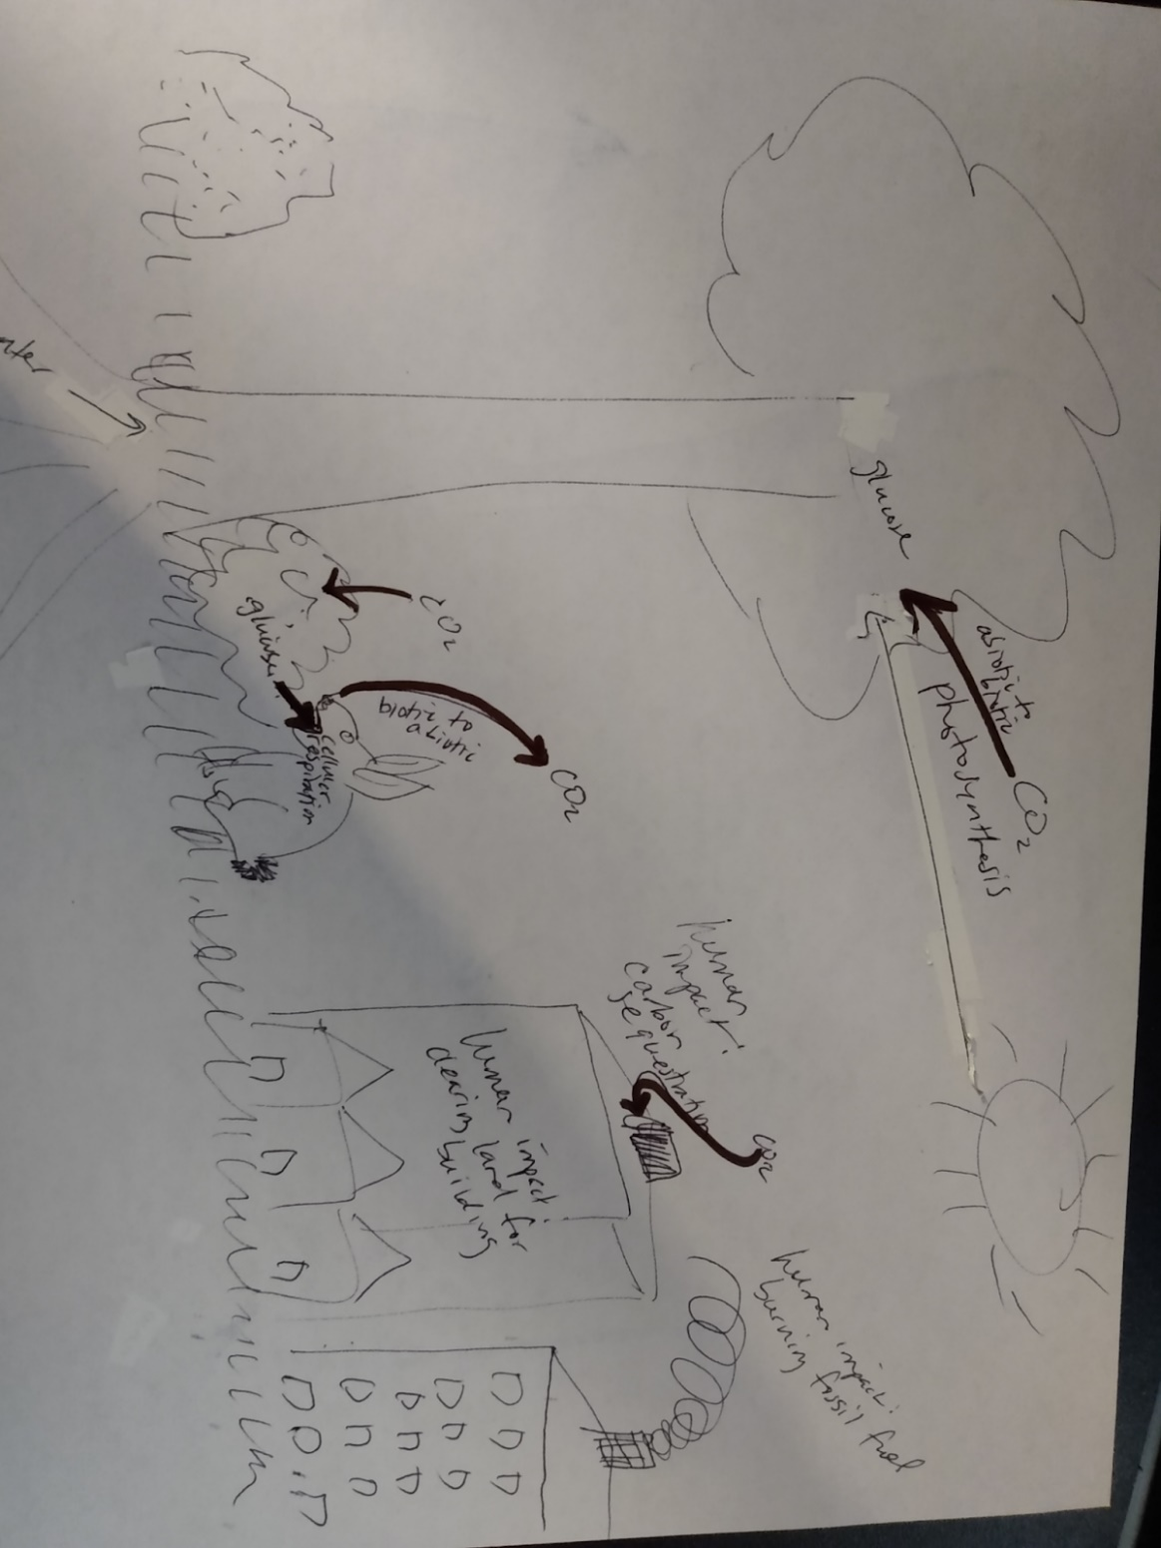
Answers vary. Example below.

- Answer the following questions individually and then discuss your ideas with your group.
  - Describe how a building/structure could fit into the carbon cycle - you have creative license; this can be realistic or hypothetical. You should have at least 3 examples in the description.
Answer varies, depends on the building students design

  - Write an example and explanation for at least 3 ways humans can reduce their impact on the carbon cycle. How does your building design decrease human impact on the carbon cycle?
Students have creative license. They can be factual and discuss carbon sequestration and actions that are available now to reduce carbon footprint. They can also be creative and come up with their own ways to reduce carbon emissions - maybe the building itself takes in carbon and does artificial photosynthesis.

  - Identify any Intersections between the carbon cycle and other cycles.
Possible responses: Carbon dioxide dissolves in water. Nitrate and nitrite (nitrogen compounds from fertilizer) help plants grow, when the plants grow they absorb carbon dioxide.
Links for extra carbon cycle research:
https://nca2014.globalchange.gov/report/sectors/biogeochemical-cycles
https://courses.lumenlearning.com/biology2xmaster/chapter/biogeochemical-cycles/
https://openoregon.pressbooks.pub/envirobiology/chapter/3-2-biogeochemical-cycles/
Cycle and human impact video

